Alfred Frisby, Sr., Alfred Frisby, Jr., and Isaiah Frisby

Three of the people buried in the NCCH Cemetery are members of the same African American Frisby family of Glasgow, Delaware, originally from Cecilton, Maryland. The three, a father and two of his sons, died as the result of a terrible car accident in the early morning hours of July 17, 1927. The accident was described in great detail in the local newspapers, and is summarized here – the original newspaper articles are provided in the linked Word document.
James Alfred Frisby, Sr., who went by Alfred, age 58, and his three sons – James Alfred Frisby, Jr., age 24, John, age 20, and Isaiah, age 15, along with a friend named Edward Munson, were returning to Glasgow after a night of revelry in Wilmington. Apparently all the adults were drunk. Alfred Jr. was driving at a high rate of speed. They came upon a car stopped in the southwest-bound lanes, because of a flat tire, about one mile east of Glasgow. The car was sitting with “all four wheels of (the) automobile parked on the concrete.” In other words, he had not moved his vehicle off to the shoulder. The Frisby vehicle, described as a “Ford touring car,” swerved to the left and first sideswiped the stationary car on the right, then was hit by a third car travelling in the opposite direction. The Ford touring car was destroyed. Alfred Sr., Alfred, Jr., and Isaiah were killed instantly from skull fractures and other massive injuries. John was thrown from the car and had only very minor injuries. Edward Munson (or William Munse/Munce) had one of his hands amputated. Several people in the other cars were injured.
All three Frisbys were buried in the New County Castle Hospital Cemetery. Three funerals at once would have been a financial burden for any family, and the bodies were all quite mangled, so quick funerals would have been necessary.
After the accident, the driver of the stopped car was arrested and charged with manslaughter for not having moved his car off the road. John Frisby was held as a material witness and later charged with perjury for telling the coroner under oath that he was the only one who had been drinking, and that the car was not going more than 10 miles per hour. Witnesses, and evidence at the scene, including the total destruction of the car and liquor bottles strewn about the crash site, belied both claims.

James Alfred Frisby, Sr. was married to Ida Jane Freeman Frisby, from Cecilton, Maryland. Ida Jane was the daughter of Richard and Jane L. Freeman. She was born in January 1875. We know she had several children who carried the last name Freeman, before she married James Alfred Frisby, Sr. Those children were:
- Bertha Freeman/Frisby, born in August 1890, who had a daughter named Susie and later several more children; died in 1960
- George Samuel Freeman, born in September 1892, died in 1965
- William Henry Freeman, born in November 1894; has a World War I registration card, but after that cannot trace because there are many men with the same name
- Philip Freeman, born in December 1896; last documented in 1910 census, age 13

Ida Jane and James “Alfred” Sr. were married sometime before 1899 and had six children:
- Henrietta “Henny” Frisby, born in November 1899, married Mr. Andrew Sewell in Cecilton, also married to William Munce, had 3 sons and a daughter with surname Munce; William Munce may be the man who had his hand amputated in the 1927 car accident; Henrietta died in May 1974
- Emma Louise Frisby, born in 1902, had a son named Clarence Frisby, then married Fred Nichols Johnson (1889-) and had two more children; died in 1993; she had lived at the Governor Bacon Health Center for the last 28 years of her life
- James Alfred Frisby, Jr., born in 1904, died in the 1927 car accident
- John Frisby, born in 1907 or 1908, uninjured in the 1927 car accident; in 1940 he was working for the WPA at Ft. Dupont; married to Mrytle; died in 1976
- George E. Frisby, born in 1909, died in 1967 at the VA hospital
- Isaiah Frisby, born in 1913, died in the 1927 car accident

In the 1900 census, Alfred and Ida were living with her first four children and their daughter Henrietta next door to Ida’s parents in Cecilton, Maryland. Alfred was working as a farm laborer. In 1910, all of Ida’s children were still living with them, along with their children and Bertha’s daughter Susie. In 1920, the household consisted of Alfred (48), Ida J. (42), all six of Alfred and Ida’s kids, Bertha, and four grandchildren – Susie, Haywood, Mary, and Blanche Freeman. Ida died of tuberculosis in 1924, and then Alfred Sr., Alfred Jr., and Isaiah all died in 1927. It isn’t clear when the family moved from Cecilton, Maryland to near Glasgow, Delaware, or if they were related to the Frisby clan who lived near Summit Bridge.
Their son John, age 20, survived the accident, and his younger brother George, age 19, was not in the car. George E. Frisby is mentioned frequently in the Wilmington newspapers through the 1930s, 1940s, 1950s, and 1960s, either being accused of assault on others, or being the victim of assault, including two shootings. He was in and out of jail and the workhouse numerous times. He died in 1967.
James Alfred Frisby, Sr. and his wife Ida Jane Freeman Frisby left a number of descendants.

The word document is linked HERE and includes the newspaper accounts of the accident, certificates of death and obituaries for the people involved or related to those who died.

Where did the Freemans and Frisbys come from?
We know that Alfred and Ida lived in Cecilton, Cecil County, Maryland, at least through the 1920 census. Ida was the daughter of Richard (1835-1915) and Jane Freeman (1840-?) of Cecilton. Richard was born ~1835 and can be found in the census records as a free black as far back as the 1850 census. He is listed in men registered to serve in 1863 in the Civil War from Cecil County. He and Jane appear in the 1870, 1880, and 1900 census records. There are many families named “Freeman” living in Cecil County, Maryland at this time. Neither Richard nor Jane’s parents are known. Ida was the 6th of their 9 children.
James Alfred Frisby is a little more difficult to trace. In the 1880 census for Marlboro, Prince George’s County, Maryland, we find one Benjamin Freeman, mulatto, age 35, with his wife Mary S., 25, black, their infant daughter Suzy, born in January of 1880, and 3 of Benjamin’s siblings: brother William, age 13, sister Mary, age 11, and brother James, age 7. This young James could be the child who grew up to be Alfred Sr. In the 1870 census for Districts 1 and 2, Queen Anne’s County, Maryland, we find a 2 year old William Frisby living with Thomas and Mary M. Frisby, ages 50 and 58, respectively, and many other children named Frisby. He might be a grandchild, although his relationship to Thomas and Mary Frisby is not given. The Frisbys were also free blacks, as least as far back as 1870. Thomas Frisby was a hospital steward during the Civil War and received a pension. He died in 1879.

Other Frisbys at the NCCH Cemetery and DSH Cemetery
- John Frisby, African American, male, age ~80, an “old wood chopper” was found dead in Marshall J. Jordan’s woods, his ax nearby in a stump. It is assumed that he died of heart disease. Died on April 4, 1892, buried at the NCCH Cemetery.
- Annie Frisby, African American, female, age 80, died of apoplexy on June 4, 1921 after three days at the Almshouse. She was a servant. She was buried in the NCCH Cemetery.
- Joseph Frisby, African American, male, age 49. Died of acute alcoholism on August 19, 1931. Buried in the NCCH Cemetery under marker #2160, in the same grave as “Infant Cole,” who died of prematurity.
- Clyde Frisby, African American, male, age 48. He was not a patient at DSH, but was brought there after death from a ruptured bladder for an inquiry and autopsy. He was then buried in the DSH Spiral Cemetery, under marker #461.

James Alfred Frisby, Sr.’s World War I registration card.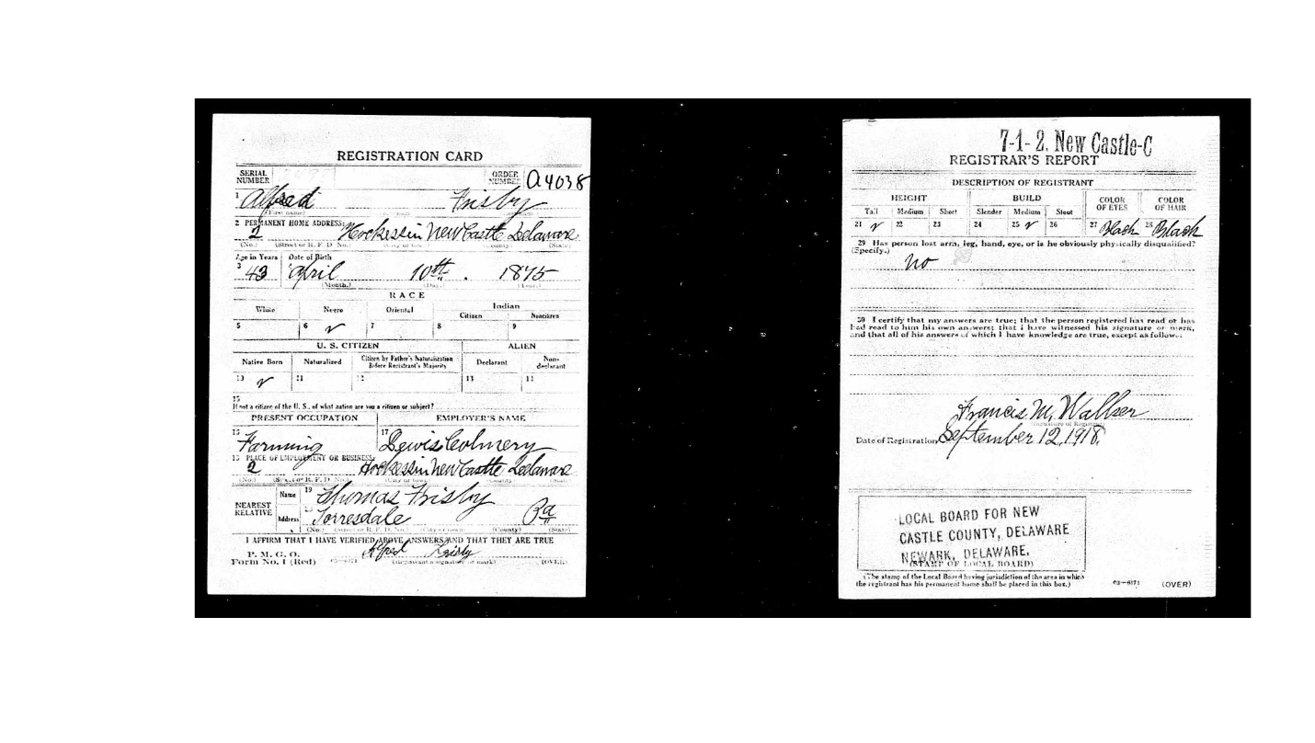
Death certificates for Alfred Sr. and Alfred Jr.
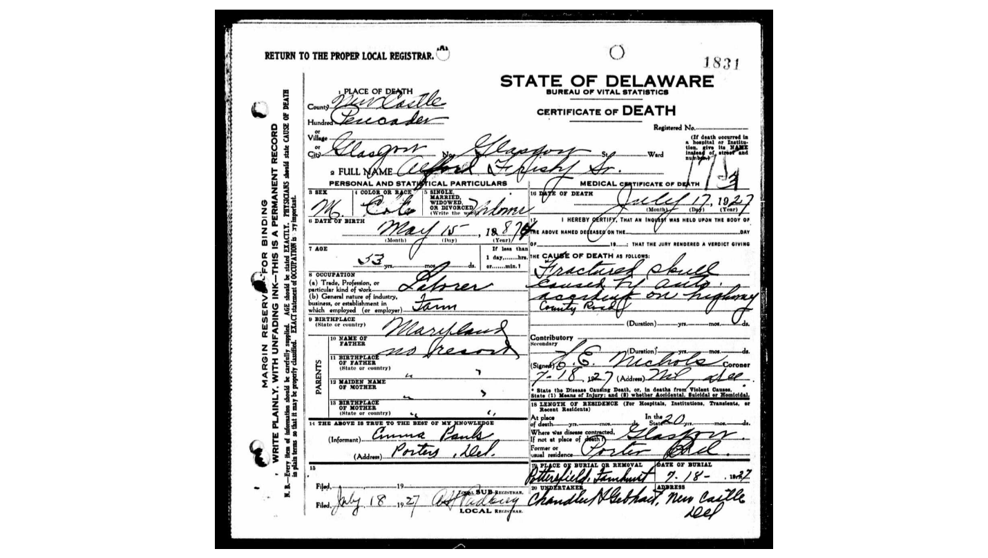
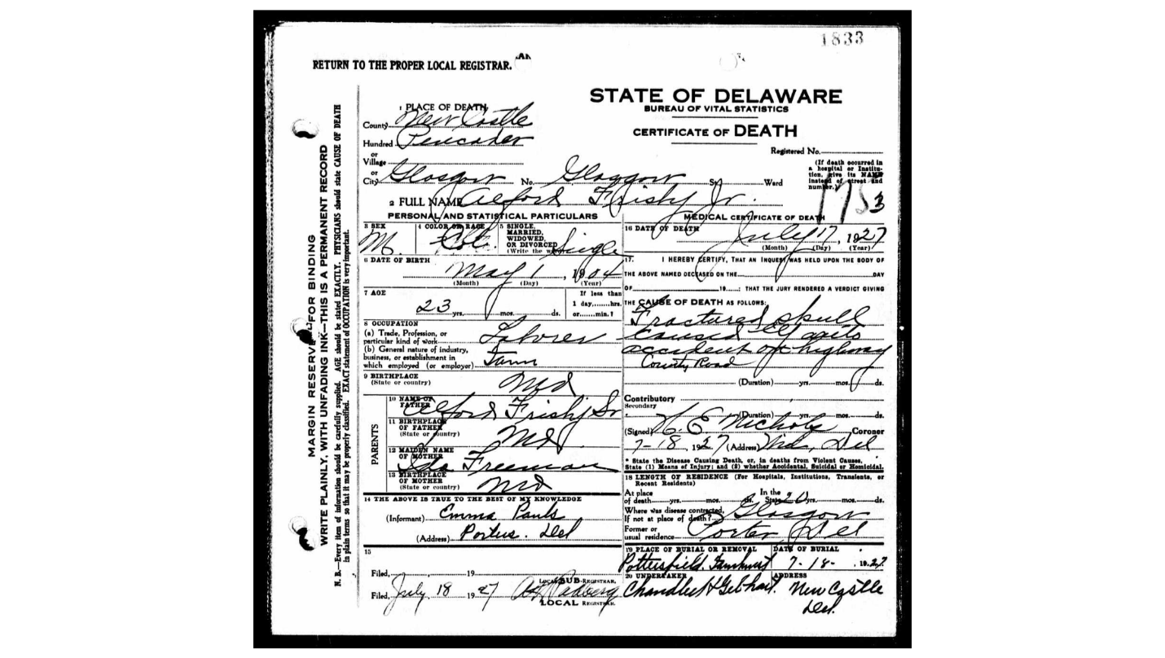

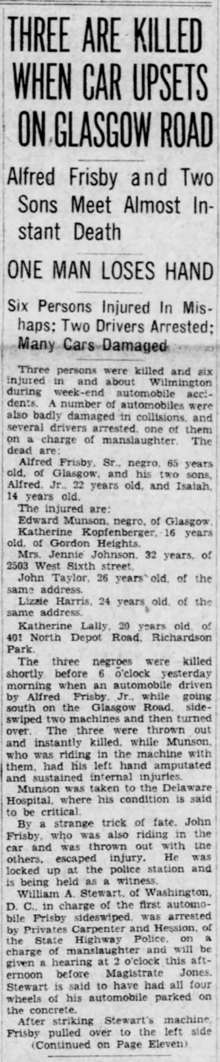 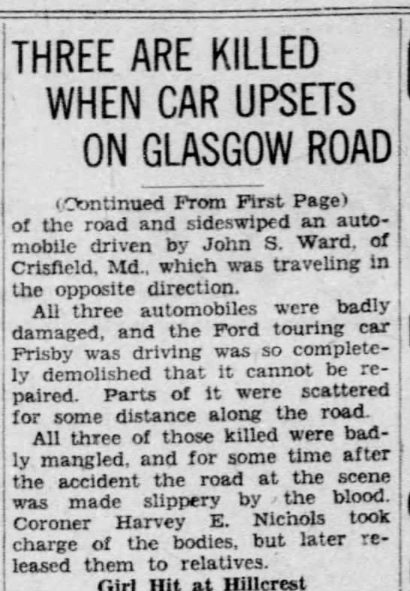 Morning News, 7/18/1927

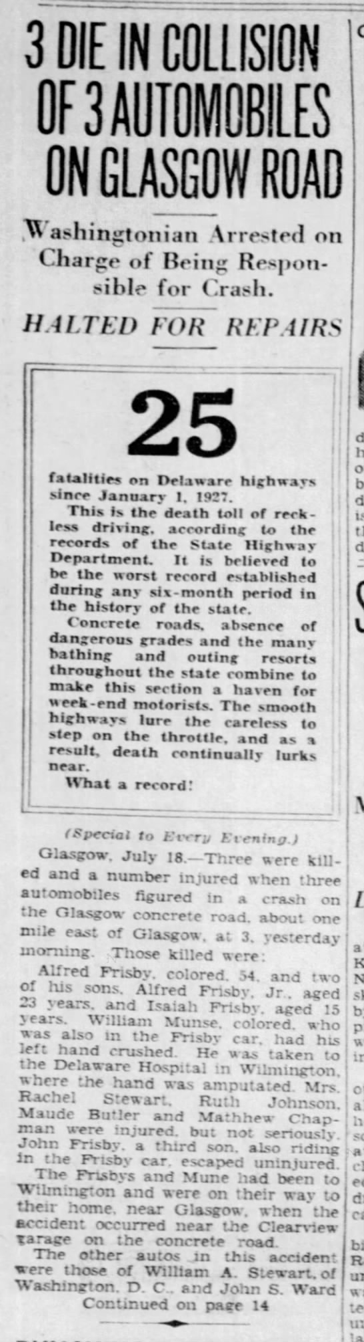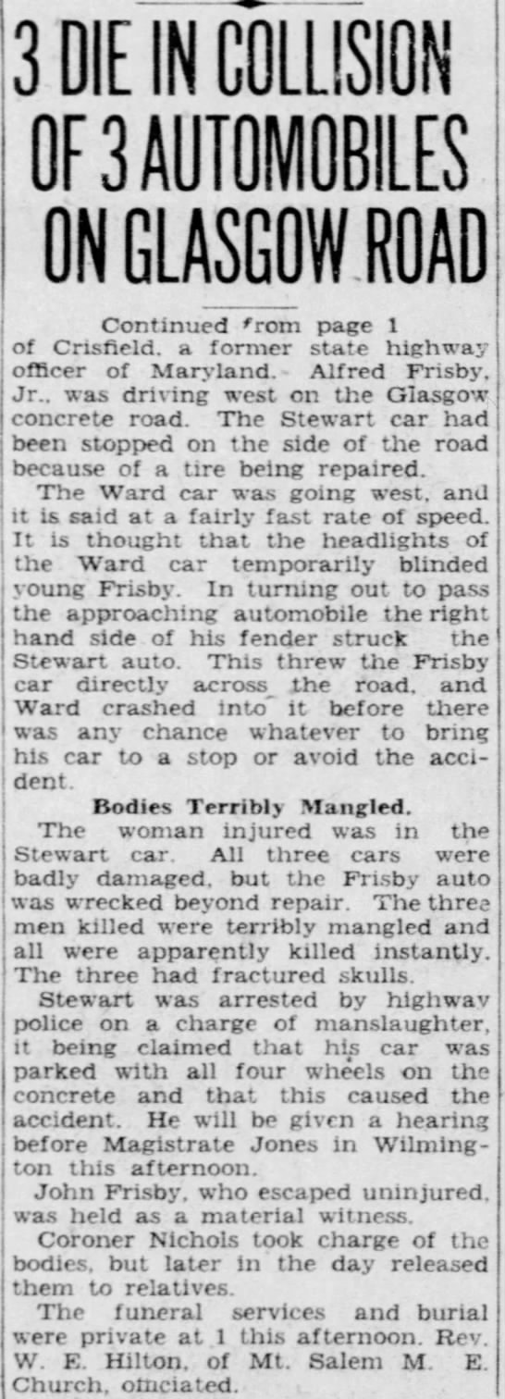

News Journal, 7/18/1927
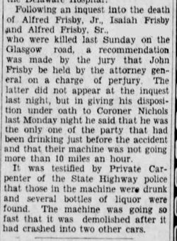 Morning News, 7/22/1927

Ida’s death certificate from 1924 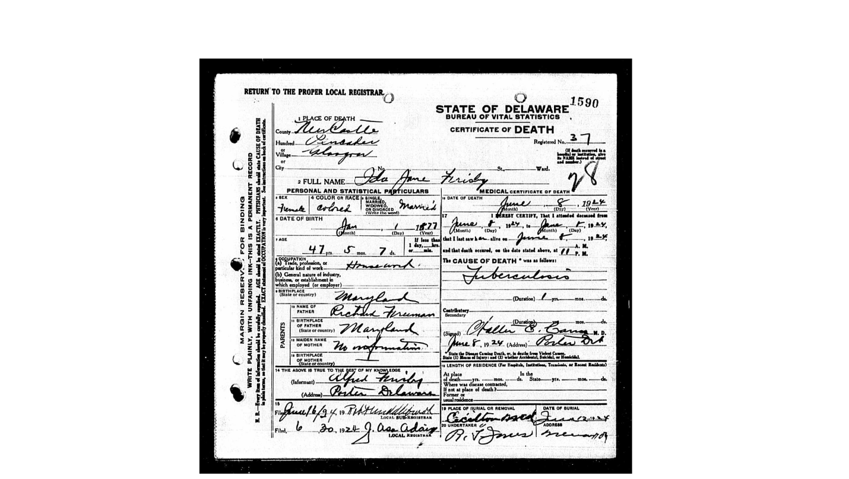

Bertha Frisby’s OBIT, Morning News, 11/11/1960

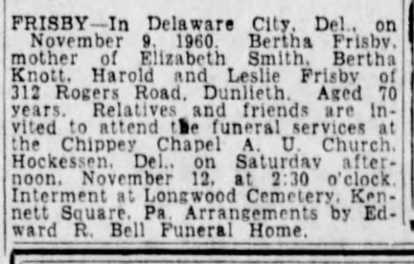

George “Samuel” Freeman’s OBIT, News Journal, 6/19/1965

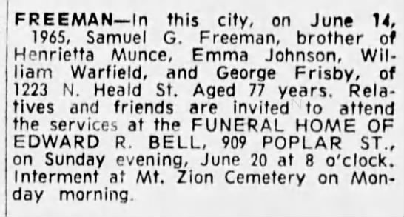

George E. Frisby’s OBIT, Morning News, 12/19/1967

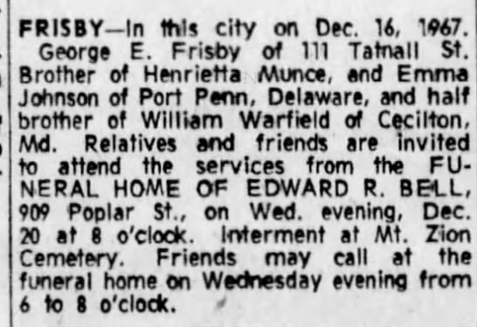

Emma Louise Frisby Johnson Davis’ OBIT, News Journal, 11/1/1995

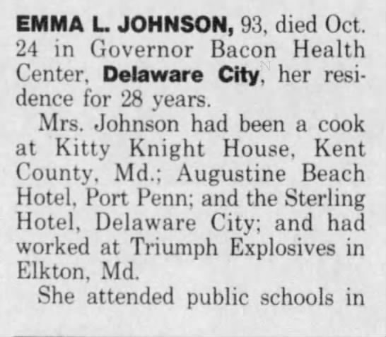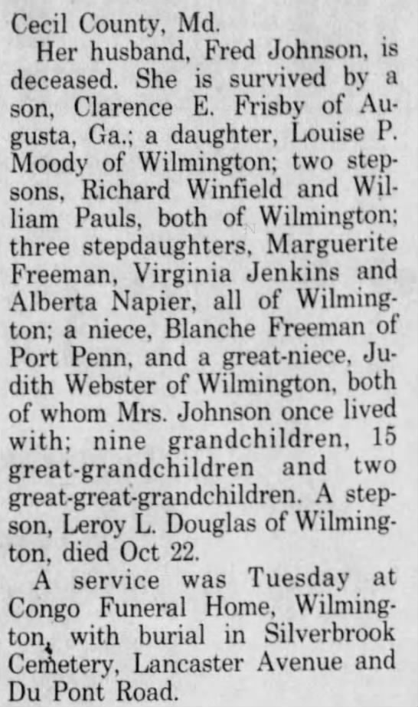

John Henry Frisby, WWII reg. – wife Myrtle Frisby
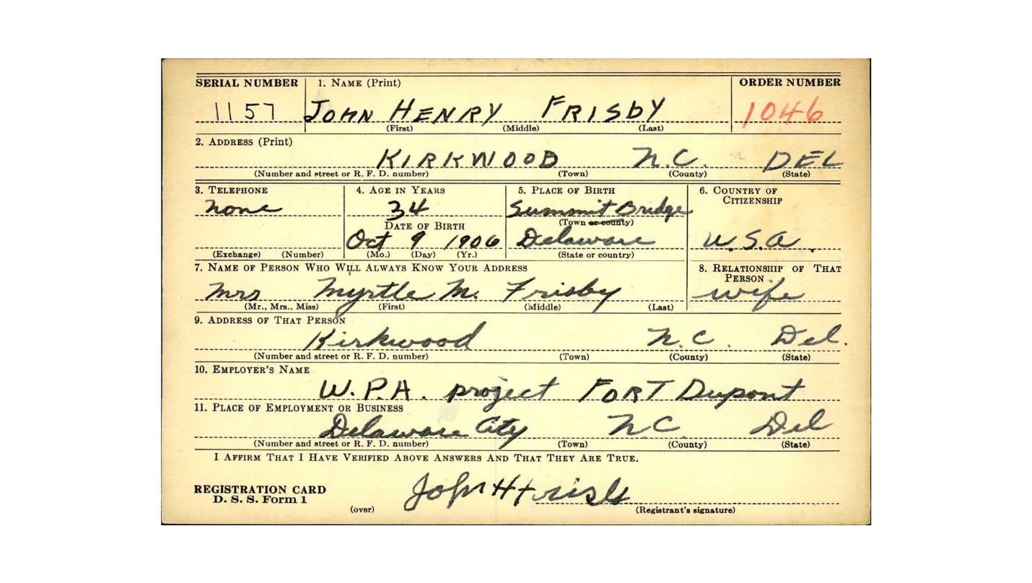
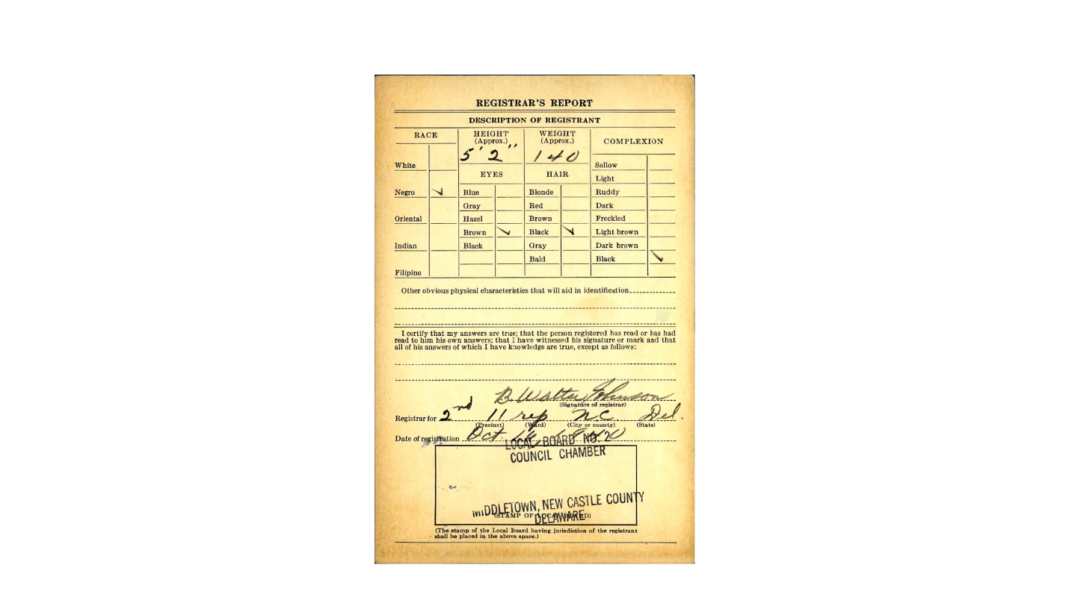

John H. Frisby death information

Name: | John H. Frisby
Birth Date: | 9 Sep 1907
Death Date: | 26 Feb 1976
Cemetery: | Mount Pisgah UAME Church Cemetery
Burial or Cremation Place: | Summit Bridge, New Castle County, Delaware, United States of America
Has Bio?: | N
URL: | https://www.findagrave.com/memorial/59421514/john-h.-frisby

Death certificate of George E. Frisby

Emma Louise Frisby and Fred Nichols Johnson’s marriage certificate

Alfred and Ida’s daughter Emma had a son named Clarence Frisby

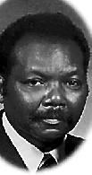 AUGUSTA, Ga. - Sergeant (Ret.) Clarence E. Frisby, Sr. entered into rest Tuesday, May 1, 2012. Sergeant Frisby was a native of Wilmington, Delaware and a retired veteran of the United States Army. He was preceded in death by his wife, Ruby M. Holmes Frisby. Funeral services will be conducted Tuesday, May 8, 2012 at 12:00 noon from Mount Zion Missionary Baptist Church, 2526 Lumpkin Road, Augusta with Reverend Thomas Walker officiating. Interment will be in Hillcrest Memorial Park with full military honors. Survivors are his daughter, Sophia (Darryl) Cogle; a son, Clarence Edward Frisby, Jr.; two grandchildren, Jiauna and Zayvian Cogle; sister-in-law, Mary A. Hudgeon; brother- in-law, Leroy Glover; other relatives and friends. W. H. Mays Mortuary, 1221 James Brown Boulevard, Augusta, GA 30901 (706) 722-6401.
Published by The Augusta Chronicle from May 3 to May 6, 2012.

John Frisby’s OBIT Delaware Gazette and State Journal, 4/14/1892

