Antonio Piacentini was born around 1852 in Italy, and died in Delaware on March 10, 1932 of chronic interstitial nephritis (kidney disease) at the age of 80. He spent the last 3 weeks of his life in the New Castle County Hospital, and was buried in the hospital’s cemetery under marker #2220 (now under the I-295 ramp). There is basically no information available about Antonio Piacentini. His death certificate indicates that he was a widower in 1932, and implies that he had been living in Stanton, Delaware. The rest of what we know comes from forms filled out by his son Joseph.
In 1918, when Joseph Piacentini filled out his World War I registration card, he was 33, living on S. Kentucky Ave. in Atlantic City, New Jersey, and working as a merchant, in business for himself. He is described as being tall and slender, with gray eyes and black hair. He listed his date of birth as September 8, 1885, in Italy.
In 1920, Joseph Piacentini filled out an application for a passport. He says he was born on September 8, 1885 in Italy, and immigrated to the United States on June 3, 1903, from Naples, Italy. He had lived in the US for 17 years. His father’s name is listed Antonio Piacentini, who lives in Wilmington, Delaware. His mother’s name is listed Felicia and she was living in Alife, Italy. He became a naturalized citizen on November 28, 1917. He needed the passport in order to travel to England and France for pleasure, and to Italy to visit his mother. His passport application, including a photo, are included below.
On his World War II registration card, he is living at 26 S. Virginia Ave., and lists Mr. James McGrath as his contact. Mr. McGrath was the head of the boarding house where Joseph lived off and on over the years. This time, his birth is given as September 10, 1885.
Over the years, Joseph Piacentini lived in a number of places in Atlantic City, all in the same general neighborhood, and worked at a variety of occupations, including managing a Columbia Granfonola Parlour (an early version of the internal horn phonograph), and working as a musician, a bartender, a salesman, a hotel or apartment manager, and a real estate agent. He was married to a woman name May or Mae, who was born in Connecticut around 1885. She first appears as his wife in the 1922 city directory for Atlantic City. She usually worked as a saleswoman in shops that sold women’s clothing and accessories. She is listed as his wife in various city directories from 1922 to 1957, at various addresses all in the same neighborhood in Atlantic City. Interestingly, in both the 1940 and 1950 census records, they are listed as married, but living at separate addresses. In the 1940 census, they are mere blocks apart, but in the 1950 census, Mae apparently had moved to Philadelphia to run a boarding house.
Joseph Piacentini and his wife Mae never had children (at least I could find no evidence of them). He died on April 6, 1963, and was buried in the Holy Cross Cemetery and Chapel Mausoleum in May’s Landing, New Jersey. He was 77 years old. Mae’s fate is unknown.

Antonio’s Certificate of Death
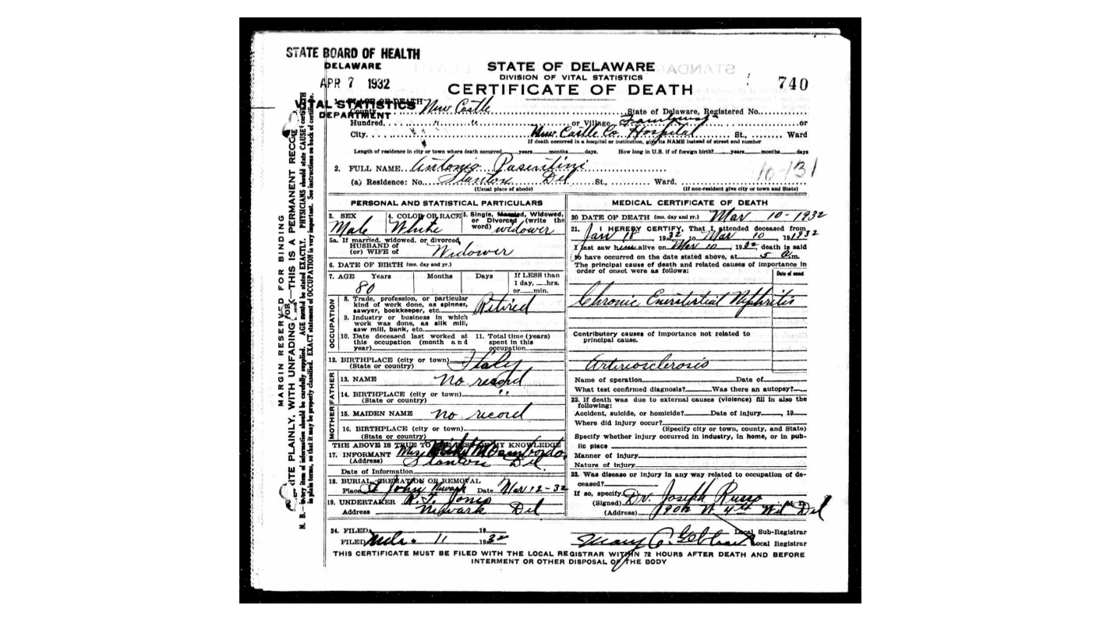

Joseph’s World War I military registration card
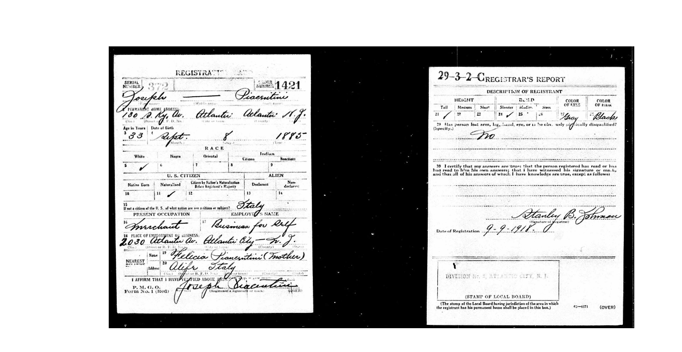
Joseph’s World War II military registration card
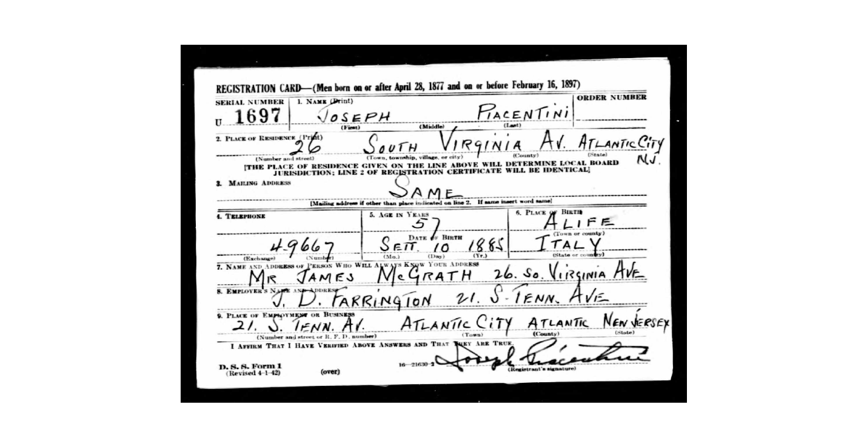

Joseph’s passport application, 1920, right hand side of first page, left hand side of second page, with photo
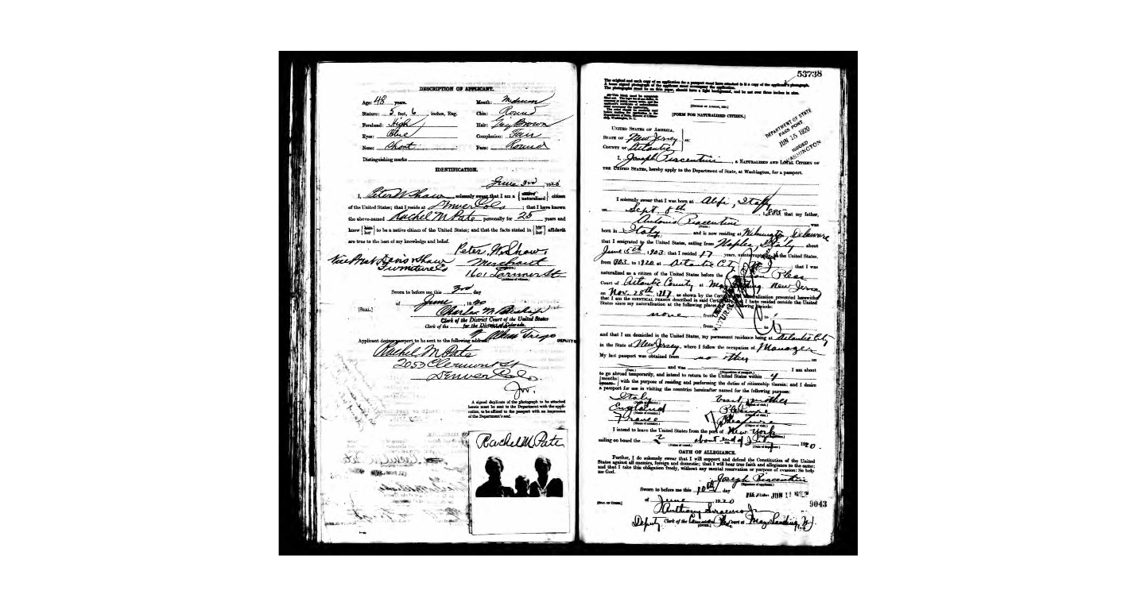
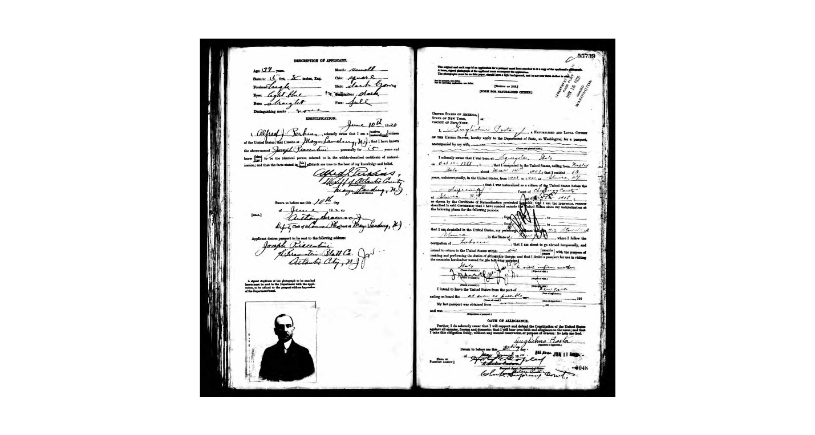

Timeline of Joseph and Mae/May Piacentini in Atlantic City, New Jersey
Year | Jos, Mae, both | Address | Occupation | Source | Etc.
1913-14 | J | 130 S. Kentucky Ave |  | City Directory
1916-18 | J | “ – work was at 1326 Pacific Avenue | Manager, Columbia Granfanola Company Parlor | “
1920 | J | “ |  | “
1921 | J |  | Manager, St. Clair apartments | “
1922 | J & May | “The Nixon” | Manager | “
1926 | J & May |  |  | “
1928 | J & May |  | Musician | “
1931 | J & May | 23 S. Virginia Ave | Salesman, Lighthouse real estate | “
1935 | J & Mae | 28 S. Virginia Ave | Bartender | “
1940 | J (age 54) | Near S. Virginia, lodger (James McGrath, proprietor) | Real estate salesman | US census | Same place in 1935
1940 | Mrs. J (age 55), born in CT | 117 S. Virginia, lodger (Alberta Ludy, proprietess) | Retail women’s speciality shop | US census | “
1941 | J | 26 S. Virginia | Clerk | City directory
1946 | J | 19 S. Virginia | Salesman
1950 | J |  | Salesman | City directory
1950 | J (age 59) | 29 Virginia Ave | Real estate salesman | US Census
1950 | M (age 65) | Head of boarding house in Philly, working in retail women’s wear shop |  | US census | Maybe not her?
1954 | J & Mae | 120 S. Penn Ave | Salesman for John Kleckner | City directory
1955 | J | 23 S. Tennessee Ave | Resident manager Penn-Alto Hotel, 120 S. Penn Ave | “
1956 | J & M |  |  | “
1957 | J & Mae | 19 S. Virginia Ave | Real estate | City directory

