Elijah Hoy

I was unable to find much information about Elijah Hoy, who was born around 1854 and died on December 6, 1908. We know that he was white, and single, and that his official cause of death was opium poisoning from drinking too much laudanum. Other than that, information about him is very scarce.
In August of 1866, there is mention of an 11-year-old runaway indentured servant boy in advertisements placed in the local newspapers, including the Daily Republican, by one Frederick Klair, a farmer from Mill Creek Hundred. Mr. Klair was offering a reward of 6 cents for the return of his farm hand. “6 Cents Reward. Runaway from the Subscriber, in Mill Creek Hundred, on the 9th inst., an indentured boy, named Elijah Joy, aged about 11 years. He is a full-faced heavy-set boy, and has rather a downward look. All persons are cautioned against harboring or trusting him on my account. The above reward will be paid for his return but no charges. FREDERICK KLAIR.”
We can’t be sure if this is the same Elijah Hoy, although the age fits. There is no follow up information about whether the missing boy was found and/or returned to Mr. Klair. We do know from other appearances of Mr. Klair in the newspaper that he was a well-to-do farmer, admired for his cows and his corn, and the kind of person whose daughter’s wedding made the society pages. An ode to his fine cows is reprinted in the Word file that goes along with this profile.
Elijah Hoy does not appear in any census records, and only appears once more in the local newspapers as a result of the rather peculiar circumstances surrounding his death. I provide a summary here, and reprints of the newspaper stories can be found in the Word file.
In early December of 1908, Elijah Hoy was staying at the Commercial Hotel, on the corner of 2nd and Market Streets in Wilmington. He had been at the hotel since November 16th, paying for his room in advance, and had gotten change for a $10 bill at the hotel on Thursday, December 5th. On Saturday night, December 5th, he was discovered by the police sitting on the steps of a building on the northeast corner of 2nd and French Streets, just a few blocks from the hotel. He seemed to be in a stupor. The police thought he was drunk, and had a police wagon take him to the station. There he began to vomit and had difficulty breathing. A search of his pockets revealed a broken half-pint flask in one, and an unopened bottle of laudanum in the other. As his condition deteriorated, the police took him to the Delaware Hospital.
At the hospital, medical personnel tried to insert a stomach pump, but their efforts were thwarted. The uppers of a set of false teeth were found obstructing his esophagus. They were removed with some difficulty and the pump was successfully employed, but Mr. Hoy died about 1 am. After his death, the lower set of false teeth were found deep in his trachea (windpipe). Several different theories were developed about the manner of his death – suicide from drinking laudanum, accidental overdose from laudanum, or choking to death from swallowing his dentures, either as a result of an accident, or from being assaulted by a person or persons unknown. It was noted that he had no money on him, even though he had just changed a $10 bill a few days before, and his customary watch was missing, lending credence to the notion of an assault. He was not known to drink alcoholic beverages. He had only a small amount of laudanum in his stomach, and he didn’t have any bruises or contusions consistent with an assault. He may have fallen and dislodged his dentures and then accidentally swallowed the upper set and inhaled the lowers. The official conclusion of the coroner’s office was “opium poisoning.”
After his death, Oliver Foote, a well-known farmer from Stanton, said that Mr. Hoy had been employed on his farm, and living there, for the past six years (1902-1908). No relatives could be found, and his friends could not (or at least did not) pay for his burial elsewhere. His body remained unclaimed at the coroner’s office for several days, and was then taken to the Potter’s Field at Farnhurst for burial.
Mr. Hoy is often mentioned in same newspaper stories with Felix Bell, an African American man from Norfolk, Virginia. Mr. Bell’s body was also unclaimed, and he was buried next to Mr. Hoy at Farnhurst.

Morning News 12/7/1908

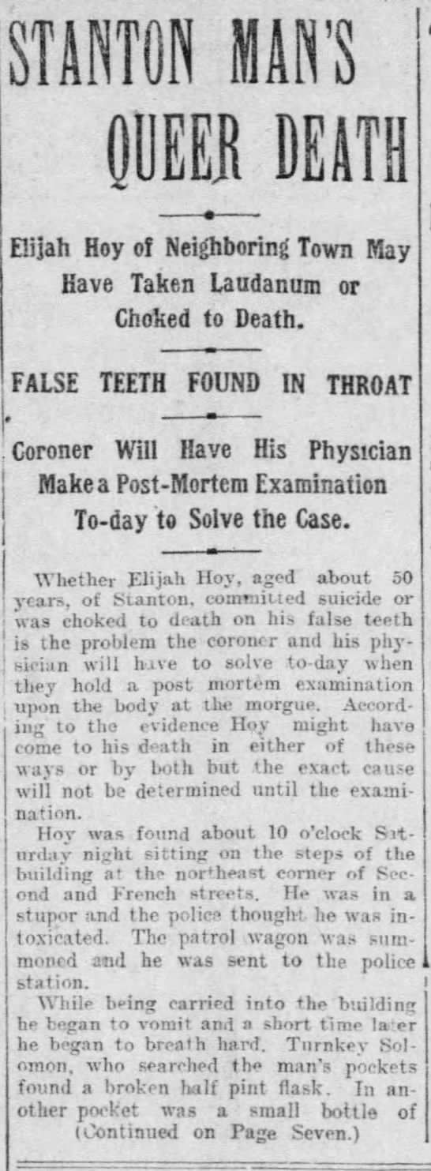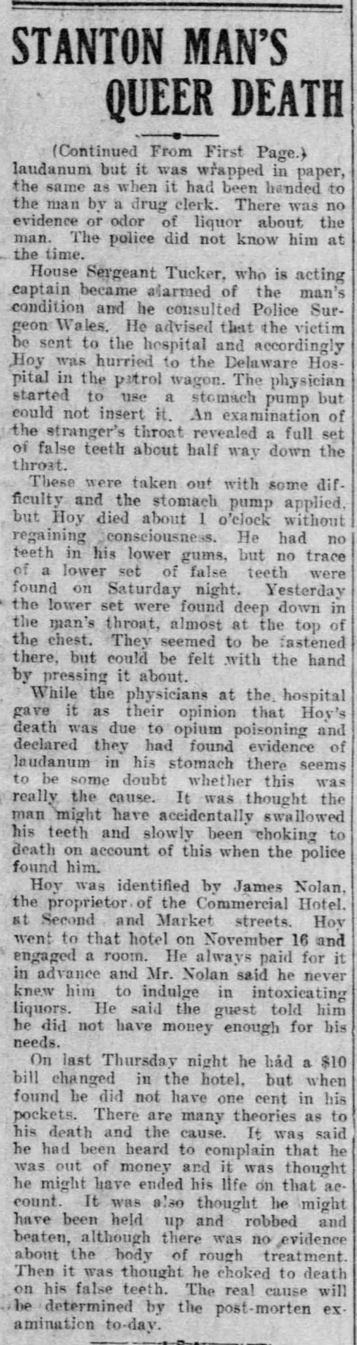

Evening Journal 12/8/1908

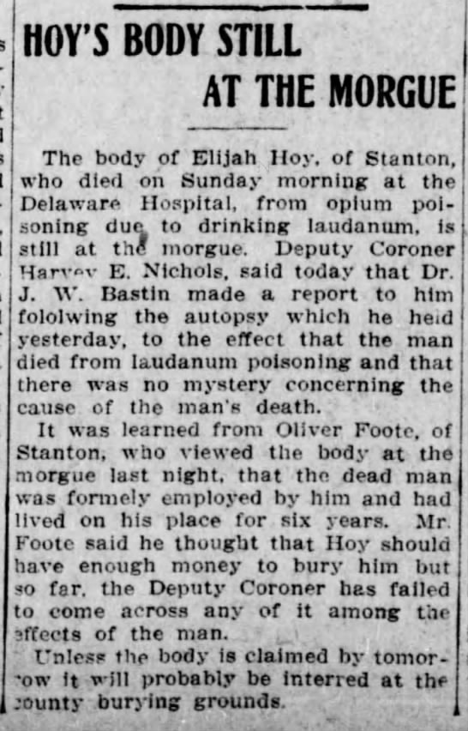

Morning News 12/8/1908

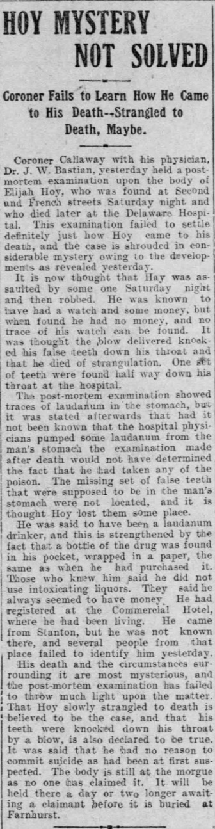

Daily Gazette 8/26/1873

