Felix Bell

Felix Bell was from Norfolk, Virginia, an African American about 32 years of age, who was hit and killed by a train from the Pennsylvania Railroad in the West Yard on December 9, 1908. According to newspaper accounts, Bell and a companion were walking along the track in the West Yard when he was struck by an engine and tossed several feet in the air, with major damage to the top of his head resulting in immediate death. His companion notified railyard authorities and told them the dead man was from Norfolk, Virginia, but then he disappeared. The body had no identification, but a loaded revolver was recovered. His body was taken to the morgue and several newspaper articles noted the death of the unidentified black man from Norfolk. The following day, Bell was identified by an acquaintance from Norfolk (William Pierce, also “colored”), who happened to be visiting Wilmington, and read about the accident, and went to view the body at the morgue. The acquaintance reported that Bell’s mother was living in Norfolk. The coroner’s office supposedly sent a telegram to Bell’s mother in Norfolk, but no one came to claim his body and he was sent to Farnhurst along with Elijah Hoy.
The census records show that in 1900, an African American man, age 25, named Felix Bell, was living in the Virginia Penitentiary in Richmond City, Virginia. This person was born in Maryland, in June of 1874. Other information comes from newspaper accounts of Felix Bell’s numerous criminal charges.
On May 5, 1895, we find one Felix Bell being charged with being in a bar while underage. The charge was dismissed once it was discovered that he was there with his parents’ permission. A few weeks later, he was convicted of stealing a pair of pants from S. Kahn on Church Street, and sent to jail for four months (Norfolk Landmark). In February of 1896, he got four months in jail for larceny. In July of 1896, “Felix Bell was called to answer the charge of vagrancy, and not giving a satisfactory account of his occupation and business here was taxed $4. He had evidently forgotten to bring his pocketbook and in default of security was given ten days on the chain gang.” (Norfolk Virginian, 7/4/1896).
On July 19, 1896, we find this report of his shenanigans: “Felix Bell, colored, was accused by his brother Noah with having stolen a pistol which the latter had in his possession. When the case was called the family had evidently talked the matter over together, for not one of them knew a thing about it. So Felix was discharged.” (Norfolk Virginian, 7/19/1896).
Just a few days later, Felix made the newspaper yet again for his criminal activities. “Felix Bell Arrested: He is a Side Partner of Lewis Ward and a Desperate Character. Felix Bell, a notorious colored man, seen more frequently before the bar in the Police Court than in church, was arrested on the corner of Moseley and Pulaski streets last night by Detective Arrington. He is charged with being a partner of Louis Ward, who was arrested Monday for stealing a pair of shoes from Mike Byrne’s shop on Queen street, and assaulting Louis Byrne [son of Mike] and his mother [Mike’s wife]. It develops that Bell is the man who kicked Mrs. Byrne, who is now in a critical condition as a result of the assault. The case has been worked up against these two men who have the reputation of being very desperate characters. Both have been identified and each will be confronted this morning in the police court with charges of theft, felonious assault and highway robbery.” (Norfolk Virginian, 7/23/1896). In another news story, the victim of this assault is referred to as “a small Italian named Vurne.” Bell tried unsuccessfully to escape from police custody after his conviction.
On January 25, 1899, Felix Bell – reportedly the alias of William Edwards (or vice versa) -- was convicted of housebreaking and sentenced to three years in the penitentiary. He is reported to have broken into the store belonging to Captain John T. Brady (Norfolk Landmark). On March 5, 1902, Bell was charged with assaulting Lottie Foreman, a colored woman, and sentenced to 3 months in jail. The very next day, March 6, 1902, he was sentenced to six months in prison for stealing a hat and a pair of shoes from Noah Bell (Norfolk Landmark). In June, he was fined $20 and costs for “creating a disturbance in the city jail,” where he was a prisoner. In August, he was charged with striking another prisoner by the name of Henry Smith, and sentenced to an additional year in jail.
There are no more mentions of Felix Bell in the Virginia newspapers after August of 1902. He next appears, dead, in the Wilmington, Delaware rail yards in 1908.

Interestingly, there is a Noah Bell from Norfolk, Virginia, born June 25, 1876, who registered for the World War I military. He says he is employed as a machinist by Mr. Walter A. Edwards. Recall that “William Edwards” was Felix Bell’s alias. Noah Bell is described as having lost an eye, thus disqualifying him from military service. His closest relative is named as Little Bell. Noah died February 27, 1919 and is buried in Calvary Cemetery in Norfolk, Virginia.
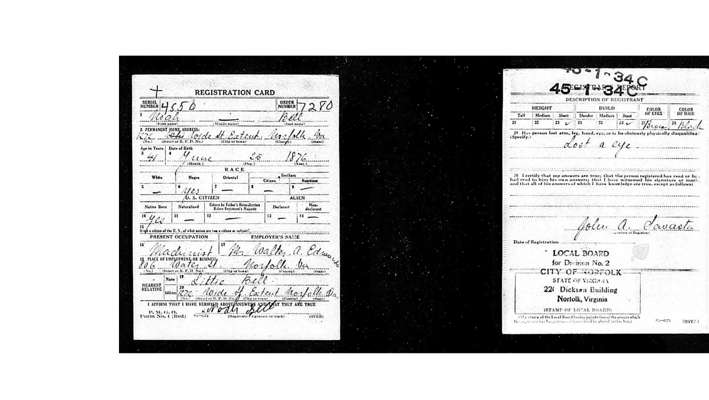
Searching for “Little Bell” we find a slave by that name, owned by one Jacob Bradwell, listed in the 1860 slave census for Wakulla, Shell Point County, Florida. Little Bell was one of 37 slaves owned by Bradwell. In 1860, Little Bell was 21, born about 1839. He does not appear in any other records that I could find. This could perhaps be the grandfather of Noah and Felix? There’s no way to know for sure. Jacob Bradwell was the local postmaster.

Norfolk Virginian, 7/23/1896

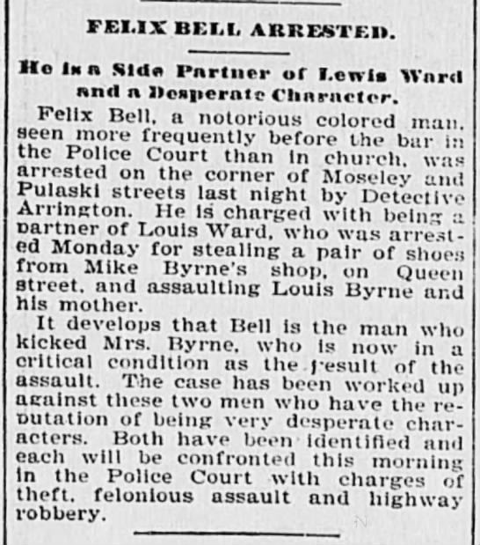

Evening Journal, 12/8/1908

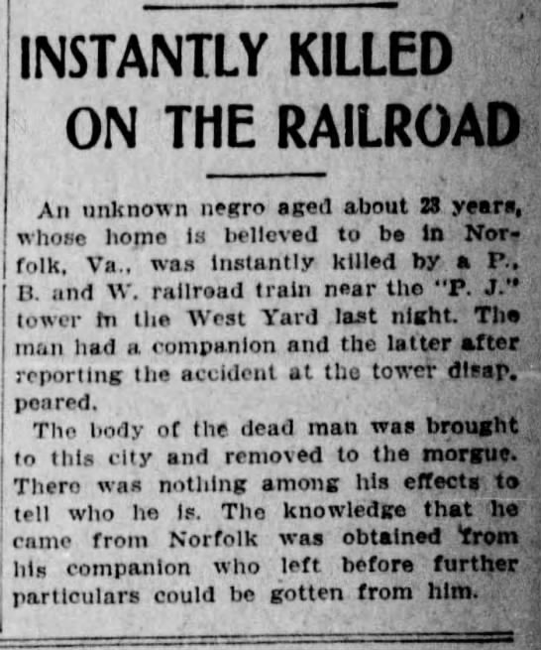

News Journal, 12/8/1908

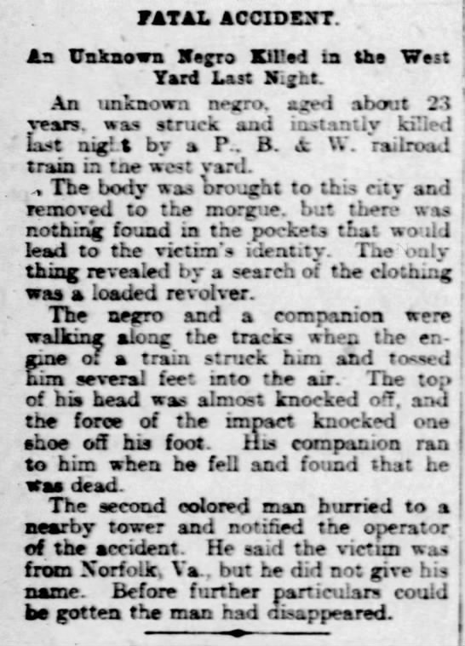
News Journal, 12/9/1908

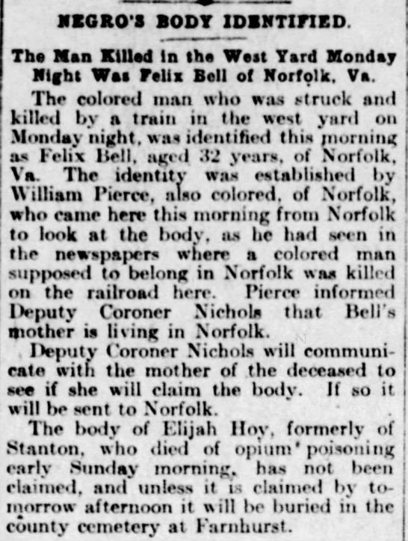

1860 slave census for Wakulla, Shell Point County, Florida
