HARRIET A. CHADWICK 1853-1921

I originally selected elderly, single, white, “Hattie Chadwick” as the subject for a “Profile in Obscurity” simply because she was supposedly 96 years of age at her death, and described as a “cripple” who had never walked. At first, I could find almost no information about her. It turns out that she is listed in the online records as “Harriet A. Chadwick,” and was only 68 years of age at death, not 96 years. With her full name and approximate year of birth, I was able to find out a little more about her, and eventually stumbled onto a treasure-trove of stories about her parents. Although she was “crippled,” lived as an “invalid,” and never married or had children, she lived a rather remarkable life with her colorful father. We begin with the basic facts of her life.
Harriet A. Chadwick was born in May of 1853. Her parents were William Henry Chadwick (~1828-1883) and Matilda Hague Chadwick (~1827-1875). According to census records, both of her parents were born in Lancashire, England, but they married in the US and their four children were all born in Delaware. Harriet was their first child (b. 1853), and she was followed by Hannah (b. 1857), Matilda Granville (b. 1860), and William George Washington (b. 1862). The family lived at 207 Fourth St. in Wilmington, where Harriet grew up. It isn’t clear if Harriet was “crippled” from birth, or if her physical condition was the result of an illness or accident. Additionally, I could find no reference that would shed light on her cognitive abilities.
Sometime after her mother died in April 1875, Harriet, age 22, moved with her father to Atlantic City, New Jersey, where she stayed at least until his death in 1883. According to her Certificate of Death, she moved into the New Castle County Hospital (Almshouse) in 1889, residing there for 32 years before her death. She is listed as an “inmate” of the NCCH in the 1900 census, but I could not find her in the 1910 or 1920 census records. She died at the age of 68, on July 29, 1921, of “senile debility,” and was buried in the hospital/almshouse Cemetery.
There is very little mention of Harriet except in reference to her parents and siblings, so we really know almost nothing of her daily life, or how it was limited by her inability to walk. However, her father was a well-known man, a “character” of some notoriety, both for his occupation(s), and for the events which led to his trial on charges of murdering his wife, Matilda (for which he was acquitted). Let us take a closer look at her parents.
According to the available records, William Henry Chadwick was born in Lancashire, England around 1828. It isn’t clear when he immigrated to the United States, how, through what port, etc., but we know that by 1850, he was living in Christiana Hundred, Delaware, working as a machinist, in the household of one Stewart Hunter, a manufacturer of some sort. In July of 1851, he married Matilda Hague. Her parents were John and Hannah Hague, also of Lancashire, England. Her father was a cotton spinner, and had moved his family to Christiana Hundred, Delaware, by the time of the 1850 census, where he is listed as a “manufacturer.” It isn’t clear if the Chadwicks and the Hagues knew each other in Lancashire, or only met when they lived in Christiana Hundred in 1850. Their first child, Harriet, was born in 1853.
William H. Chadwick became a United States Citizen on May 20th, 1856, swearing allegiance to the United States and severing all ties to the Kingdom of Great Britain and Northern Ireland. As part of his application to become a citizen, he had to attest that he had lived in the US for at least five years, and in Delaware for at least one year.
From a newspaper article written in 1883 after his death, we learn that when William H. Chadwick first moved to Delaware, he worked as a machinist at Bancroft Banks, keeping the cotton machinery in working order. Note that Lancashire, England, where both William and Matilda’s families were from originally, were centers of cotton fabric production. After his time at Bancroft Banks, Chadwick “had a place at Delaware and Pennsylvania Avenues” in Wilmington, in an area known as Sparksville. (Sparksville is mentioned in an 1859 census as being a suburb of Wilmington, with 66 residents; other suburbs in the report are McDowelville, Washingtonville, and Brandywine Village; today there is a CVS pharmacy and apartment buildings at the location, just west of I-95). He then moved to the Fourth Street location, where he built his museum, hotel, and ice cream garden.
The earliest mention of Chadwick’s establishment at 207-209 Fourth St. in Wilmington (between Orange and Tatnall) is a notice in the newspaper of a lecture by Dr. R. Jennings, Professor of Anatomy at the Veterinary College of Philadelphia. He was slated to give a lecture on the “Diseases of the Horse” at W.H. Chadwick’s Fountain Hotel, opposite the city spring, at 7 ½ o’clock on June 30, 1859. By this time, Chadwick’s business ventures seem to have been well-established. They included a hotel, known as the “Fountain Hotel” for its location across the street from a deep cold-water spring that provided water to the city for many years. The spring was located some feet below street level, accessed by a staircase, and protected by a railing. [There are several articles in the Word file that describe the city spring, and its fate.]
In addition to being the “gentlemanly proprietor” of the Fountain Hotel or Fountain House, Chadwick is described as being a veterinary surgeon, and stocked and sold various items for use in the care of livestock, including educational books and pamphlets, ointments, powders and unguents for horses and cattle, harness supplies, coal oil burners, and “Dr. Duprey’s wonderful remedy for cold feet and leather preserver” (sic). At some point, Chadwick open his eclectic museum, as well as an Ice Cream Garden.
Chadwick’s Museum was a compendium of more than 25,000 objects, including many different and rare natural history items, life-sized wax figures of famous/infamous people, and other curiosities. It seems to have been a combination of the later establishments known as Ripley’s “Believe It Or Not” emporium, Madame Tussaud’s Wax Museum, and a natural history museum. It was known throughout the region as a wonderful destination for a family outing, followed by a trip to the ice cream garden next door. It isn’t clear when or how William Chadwick obtained all the items that he displayed in his museum, but it was clearly an important part of his life. Some of the newspaper articles describing this unique and marvelous establishment are transcribed below, along with links to the stories behind the some of the notorious wax figures on display. In 1874, the establishment was named in the newspaper as “Chadwick’s Museum and Fountain Ice Cream Garden and Saloon.”

A description of Chadwick’s Museum from 1873

“Family Resort – Chadwick’s Museum and Fountain Ice Cream Garden are now in full operation. There is no one who, when taking a walk in Spring or early Summer, on seeing a bounding animal, or beautiful birds fly across his path like a meteor, has not wished to know its name. By visiting Chadwick’s museum, you will be able to perceive the innumerable beautiful differences in the animal or feathered creation. – It contains over 20,000 of the rarest curiosities from all parts of the world, consisting of birds, animals, reptiles, relics, &c.; also, extraordinary and marvelous freaks of nature and life size wax figures of notorious characters in war, crime, and history. It is the only place of amusement in the city where persons can visit any hour of the day or evening from 7 a.m. to 11 p.m. The ice cream garden is the coolest and most pleasant family resort in the city. The self-acting swing is free to visitors. The garden will be illuminated every evening; W.H. Chadwick, No. 207 and 209 West Fourth Street, opposite City Spring, Wilmington, Del.” Daily Republican, Wilmington, Delaware, 19 Jun 1873

In 1863, William H. Chadwick was registered for military service to fight on the Union (US) side in the Civil War. Rather than go off to fight, William paid for a substitute to serve in his stead for 3 years. In 1867, the Chadwick’s youngest child, their son William, was hurt in a fall. According to an article in the newspaper, “He was about opening the shutters of the chamber in the second story, when he pitched out of the window and alrighted (sic) on the pavement on the top of his head. He was taken up in an insensible condition and Drs. Askew and Treacy called in. The skull was compressed, not broken, and the little fellow lay in an unconscious state on Saturday, taking however a little water at intervals. He is a fine little boy, aged five years, and the accident is a source of great regret.” [Delaware Weekly Republican, August 8, 1867).

A description of the museum from January 1875

“THE GREATEST ATTRACTION IN DELAWARE! CHADWICK’S DELAWARE MUSEUM! 207 and 209 WEST FOURTH STREET, Opposite the City Spring, Wilmington, Del.

Has re-opened to the public with a large collection of new curiosities, highly interesting and wonderful freaks of nature. Also, a large addition of noted life-size Figures. Correct likenesses, the best ever seen on exhibition has been added by Prof. Repett, among which are Antoine Probst, the cruel murdered of the Deering Family; Daniel Dancer, the noted English Miser; Tim Bobbin, the noted Lancaster poet; Negro Benny, the runaway slave; Wm. Burke, the murdered of 40 persons; Mathias Shupinchi, murderer of the peddler boy; Arthur Spring, the murderer of two sisters; also the son of Arthur Spring; Jacob Lahman, the murdered peddler boy; Gibbs, the notorious pirate; Lieut. Montroville, the betrayer, by his side stands poor Charlotte Temple; Crazy Nora from Philadelphia; Witch of Endor in the forest. Also 25,000 Birds, Animals, Reptiles, &c., from all parts of the known world, can be seen at the museum. Other wonders arriving daily. There is more to be seen for the price of admission than at any other exhibition in the country. Open day and evening, from 8 A.M. until 10:30 P.M. Admission only 15 cts; Children 10 cts, to see the whole collection. W.H. CHADWICK, Proprietor.” Daily Gazette, Wilmington, Delaware, 28 Jan 1875
NOTE: Links to more information about all but one of the “correct likenesses” on display at the museum are provided below.

In April of 1875, a few days after a loud argument both inside and outside their house on 4th street, Matilda Hague Chadwick died. The official cause of death was pneumonia, but neighbors convinced the police that they had witnessed an assault on Mrs. Chadwick by her husband, and it was the injuries caused by his throwing her down the porch steps that led to her demise. A postmortem examination blamed her death on untreated head injuries. William was charged with assault and held in custody beginning on April 28, 1875. The charges were upgraded to murder when she died on May 5, 1875. That November, after a long and contentious trial, floridly described in many newspaper accounts, William H. Chadwick was acquitted of murdering his wife and was released on November 16, 1875 and allowed to resume his livelihood. Rather than continue to live and work in Wilmington, he decided to move.

One of the many newspaper stories about the evidence given at the trial

First Edition, Proceedings of the Court, New Castle County Courts, The Chadwick Trial
First Day’s Session of Court – Judge Gilpin’s Charge – Opening of the Chadwick Trial
The Evidence for the State All In
New Castle, Nov. 15, 1875

“The Court of Oyer and Terminer and General Sessions for New Castle County, opened at 10:30 o’clock this morning, Judges Gilpin, Houston and Wales on the bench.
The commission of John P. Springer as Clerk of the Peace was read, after which the Grand Jury composed of the same gentlemen who constituted that body last term, were called and received the following brief charge:
Gentlemen of the Grand Jury: -- We took occasion at the spring term to deliver to you a charge in regard to the cases in violation to the laws of our State, which you all of course will be guided by the present term. And all we have to say further is, that what we said last term about the increase of crime has been verified by the cases to be laid before. This present term is without parallel in this country. Some seven cases of a capital nature are to be disposed of.
The Grand Jury then returned to their rooms.
The case of William H. Chadwick, charged with the murder of his wife, Matilda Chadwick was called and defendant arraigned at 12:16. The indictment was in two counts, to which the defendant pleaded “not guilty.”
A jury of the following gentlemen was then impaneled: Francis VanDyke, Foreman, Phillip G. Plunkett, William Banks, William Thomas Dyott, Richard G. Alexander, Thos. Deacon, Jr., Levi Moore, Samuel Sharples, John Viele, John W. Reed, Isaac Webster.
At 12:15 pm, the Jury being filled, the Clerk read the indictment, and Attorney General opened the case.
Mr. Pennington opened by saying that the duty which they were called upon to discharge, was one seldom falling to the lot of man. Here was a case of murder between husband and wife, where the relations ought to be of the most sacred character. He then defined murder from the books, showing the distinction between malice express and implied, saying that from the evidence the State expected to prove the verdict would be one of murder in the first or second degree. That fact (sic) as I am reminded are briefly these: About April 26th, of this year, the prisoner, William H. Chadwick, who was then engaged in business in Wilmington, had occasion to go away from home. He was absent all day and returned about eleven or twelve o’clock that night in a state of intoxication.
During that day the wife was engaged in house cleaning. Upon his arrival at home the wife chided him, saying something to the effect that he was away spending money, whilst she was working hard at home to save. – It is but just to say that the wife had a passion for strong drink and that day had sent her out to purchase liquor and in retaliation the prisoner charged her also with being under the influence of strong drink. A quarrel ensued, -- The prisoner struck and choked his wife, beating her until she got out of the house on a porch at the rear of the house, where there are steps, and near these the prisoner struck her saying “Take that damn you.” A cry was heard to emanate from her upon the ground. The result of this altercation was a cut upon the head. A physician, Dr. Fields, was called in, who rendered assistance and prescribed for her. She lingered until the fifth day of May, when she died from the result of the wound produced by the prisoner. This is the statement of facts which the State expects to produce, and we will ask upon these a verdict of “guilty,” if such be warranted.
The State then commenced the examination of witnesses.
Daniel Farra, was first called to testify as to a plot of the premises.
Hannah A. Chadwick, sworn—I am the daughter of the prisoner; was living at home on April 26th; father was in Philadelphia and came home about 11 or 12 o’clock that night; when he came home my mother was in the sitting room; my sister was in bed on the 2nd story. He had been drinking as I could tell by his looks; mother when disengaged when he came in, he said it was a shame Mr. Green going into that house on the corner. He sat down and looked at my mother and said to her “you have been drinking”; she replied, “If you say that again I will raise the neighborhood;” he said it again and she got up and went into the entry; when she got to the door she fell; she then went to rear door and putting both hands on it she screamed “murder;” my father called to her to come back; she left there and went to the door on Fourth street; father followed her, and went out into the street, when he met Mr. Green who said something to him; he said “go away and tend to your own affairs.” Green then struck father and he then put Green upon the ground not striking him; I observed mother’s head bleeding that night and also next morning. She told me to get Papa, and he came and put court plaster on, which stopped the bleeding; she died the following Tuesday week. Friday right after the assault she got to drinking again and said “she wished something would happen,” next morning she was taken sick and she said she had the erypasipelas (sic); my father wanted to get a Doctor she said “no, I would rather die; after persuading her, Dr. Field’s was called in; all the time she was sick, she complained of a severe pain in her stomach. The day father was absent mother had been drinking; she sent my brother for the liquor; mother had been drinking for five or six years; my father had no weapon in his hand; he did not strike her at all, he did not take hold of her rudely. The next morning she asked me what she had been doing the night before that she remembered nothing but a fall. On Wednesday she helped about the house; on Thursday she was moving about and sent for more liquor and on Friday she was preparing flavor for ice cream; on Saturday she went to bed; mother did not fall down the porch steps; she was not out on the porch; she would scream at times when no one was near.
The Court here took a recess until 3 P.M.

AFTERNOON SESSION
Court re-assembled at 3 P.M.
Matilda Chadwick, sworn—Am sixteen and daughter of prisoner, reside with him; on the night of April 26th was in bed; got up in the night don’t know what time; when I came down stairs saw mother and sister in the entry, they were going to the front; father was in the sitting room; mother fell backwards and sister helped her up; mother and sister went out on the street; there was no lamps in the hall and but one lamp in the sitting room; I went out with mother and sister front and I rapped at Mrs. Palfrey’s door; she asked me if a police had charge of my father; I said “no” it was Mr. Green; I heard both mother and sister Hannah cry “murder;” I don’t know what time it was; my lame sister woke me; next day mother helped me wash, (The witness here corroborated her sister’s statement as to her mother helping the work about the house for the rest of the week her fathers kindness in attending to her cut head and testified to her mother’s drinking habits and her continued drinking for the week following the 26th of April.)
Saturday morning, after the 26th, mother had the erysipelas*; Sunday and Monday she was better; Tuesday she was worse and complained of a pain in her chest and coughed; father was attentive and kind to her; she had no marks on her person where he struck her, for he never touched her on the night of the 26th; she died on Wednesday, May 5th, at 1 o’clock. [*NOTE: https://rarediseases.org/rare-diseases/erysipelas/#:~:text=Erysipelas%20is%20an%20infection%20of,from%20the%20skin%20around%20it. “Erysipelas is an infection of the upper layers of the skin (superficial). The most common cause is group A streptococcal bacteria, especially Streptococcus pyogenes. Erysipelas results in a fiery red rash with raised edges that can easily be distinguished from the skin around it.”]
Mrs. Amelia Briggs testified in substance as follows – Lived next door to Chadwick; heard noises during the night of April 26th, between Chadwick and wife, about 11 o’clock; was aroused by cries of “murder” and by bells ringing; raised the back window and saw women on Chadwick’s porch whom I recognized by their voices to be Chadwick’s wife and two daughters; they were screaming “murder, open the door, he’ll kill us tonight;” heard them thumping on the door; Chadwick was inside and I could hear him through the partition wall talking; Chadwick came out three times; twice he came out and each time his wife fell, the girls running to the end of the porch; the third time he came out I saw something thrown over the porch railing to the pavement below, and heard Mrs. Chadwick’s voice saying “Oh,” the voice came from under the porch; I next saw Chadwick out front and his wife leaning against the railing; his daughters were there, and one went and knocked at Palfrey’s door; some men were on Chadwick’s steps remonstrating with him; he ordered them off of the pavement; Mrs. Chadwick said nothing; I saw what I supposed to be blood on Mrs. Chadwick’s face and shoulders; was at my back window some fifteen or twenty minutes; after I heard Mrs. Chadwick’s voice under the porch I heard her again on the porch saying, “Open the door;” “Oh my head;” “Oh my arm;” saw her next leaning against the railing out front, and the was the last time I saw her; the night was neither dark nor light; from the back porch to the pavement is about 7 feet.
Wm. A. Green testified in substance as follows:--Was going along Fourth street, near Orange, on the night of the 26th of April and heard cries of “murder;” when I got opposite Chadwick’s I saw him, his wife and daughter in the entry; they appeared to be scuffling; I stepped on the steps and said “Bill, what’s the matter; he asked me why I interfered in his business and ordered me away; saw Mrs. Chadwick leaning on the railing; he ordered me off his steps, and I went out to the curbstone; Chadwick knocked me down and I fell on my side and shoulder; at this point some strangers came along and took him off of me; saw some blood on Mrs. Chadwick’s face; think there was a light in the hall; I could not recognize any voices in the fall; seemed to be a scuffling noise there when I first came up; did not hear anything they said; I had been drinking that night myself so I could feel it Chadwick was intoxicated.
Albert Richardson and Peter G. Hutchinson and wife were called, but appeared to know nothing of the occurrence.
Hannah S. Walton—Live 217 W. 4th St.; was awakened by a cry of “murder” between 11 and 12 o’clock, on night of April 26th; heard some one scream, “Papa! Papa! Don’t kill Mamma;” did not see anyone; hearing a voice which I supposed was Mrs. Chadwick’s saying “Open the door, he will murder us to-night;” heard her again say “Had been working all day, and he has come home to murder us to-night.”
Adeline P. Walton—Sworn. Was aroused by cries of “Oh! Papa, don’t kill poor Mamma;” recognized the voices as the girls.
King Dolbow—Sworn. Heard noise from Chadwick’s, on night of 26th about midnight; heard women making a noise; I got up and hoisted the window down, but saw no one; the noise came from Chadwick’s.
Dr. Howard O. Ogle—Sworn. Dr. Grimshaw and myself made a post mortem examination of Mrs. Chadwick’s body; found a wound on the right side of the head, below the median line, and one inch and three quarters long; removed the top of the head and found the brain very much congested. I think that death was caused by inflammation of the brain produced by this wound; we examined the whole body, with the exception of the interior of the stomach; her eye lids were discolored, and there was slight abrasion on the elbow; I think the wound on the head might be called dangerous, and was such as would be produced by some blunt object; such a wound might produce erysipelas.
Dr. Grimshaw corroborated Dr. Ogle’s testimony, and further added that he did not think the wound on the head could be caused by a blow from the fist. The woman died from inflammation of the brain, and in his opinion, such cause would produce stupecation (sic) before death.
The State here rested, when Mr. Bayard arose and asked the Attorney General if the State would oblige the defense, to open their case, or would he abandon it? Mr. Bayard claiming the evidence to be insufficient. The Attorney General insisted that the case should take its usual course.
Court then adjourned until 10 o’clock tomorrow.

COURT DAY, THE OPENING OF COURT AT NEW CASTLE – UNUSUALLY LARGE ATTENDANCE.

Yesterday, the County Courts opened at New Castle, and the attendance was larger than every before known on opening day. Part of this unusual attendance was caused by the presence of a special jury, and the large number of witnesses summoned to attend Court. The great interest attached to the capital cases, which first occupy the attention of Court, attracted large numbers of spectators. The morning trains to New Castle were crowded with passengers, and these, together with those who came in vehicles, filled the little city with visitors, and taxed the hotels to their utmost to provide the necessary accommodations.
When Court opened the room was crowded with spectators, and the proceedings were listened to with great attention.
This large attendance will doubtless be continued until all the capital cases are disposed of.”

Daily Gazette, Wilmington, Delaware, 16 Nov 1875

One of the many newspaper stories about the conclusion and outcome of the trial

FIRST EDITION, PROCEEDINGS OF COURT, CLOSE OF THE CHADWICK TRIAL.
THE PRISONER DISCHARGED.

THE COUNTY COURTS – SECOND DAY’S SESSION – THE CHADWICK CASE ENDS WITH THE ACQUITTAL OF THE PRISONER

New Castle, Nov. 16th, 1875.
Through our telegrams to you yesterday, the opening of Mr. Bayard and the examination of Dr. Fields and Mrs. Palfrey was reported. Witnesses on behalf of defense were further called.
David Downs testified substantially as follows: Called on Saturday after the occurrence; saw Chadwick engaged at home with some papers. He said to me, after talking a little while: “Matilda is very sick with the erysipelas; go down stairs and see her.” I went down and found her sitting by the stove, bathing her head; she said she felt very sick; saw her again on Monday night, my wife and myself went in together; my wife sat by her side; holding her head, she asked for a drink; my wife lifted up her head, and for the first time, noticed the wound on her head; she asked what that meant, and Mrs. Chadwick said she had had a fall in the entry. On Tuesday night the girls came for my wife and myself, saying their mother was dying; we immediately went she had just died as we entered the room. Chadwick met me and said “Dave, Tillie is dead, dead!” He seemed very much distressed; have known the family for 22 years; he stopped keeping a bar three years ago, on account of the sad example it set his wife, who had a passion for strong drink; have attended to Chadwick’s business since his imprisonment.
Sarah Downs was then called, and corroborated her husband throughout.
Wm. Chadwick—sworn—I am 14 years of age; am son of the prisoner; have been to school, can read and write; lived with father and mother on April 26. I was in bed and knew nothing of the occurrence until next morning; came down stairs; saw mother washing her head at the zinc (sic); I asked her what was the matter; she said that she had fallen down the four steps in the entry; father sent me for court plaster; mother sent me out on Monday for 3 half pints of whiskey; she drank it all herself and became intoxicated. She sent me on Tuesday for 2 half pints, and on Friday for the same quantity. This was her customary habit for the last 3 years; I was always sent to father for the money, who gave it to me without knowing what it was for; she would threaten to whip me if I told father what the money was for; she would often cry “murder,” when she was intoxicated, without any one being near her.
Matilda Chadwick and Hannah Chadwick, daughters of the defendant, were recalled, and swore positively that no such words as “Papa, don’t kill poor Mamma” were uttered by either of them; that no one was out on the porch.
The defense here closed, and at 12:45 the jury was retired without argument and in a few minutes returned with a verdict of “not guilty.””

Daily Gazette, Wilmington, Delaware, 17 Nov 1875

After his acquittal

At some point after his acquittal in November of 1875, either in 1876 or 1879, per different sources, Chadwick put his museum and ice cream garden up for sale, pulled up sticks, and moved, with Harriet, to Atlantic City, New Jersey. There he rebuilt his museum, which occupied a grand building on the corner of Ohio and Atlantic Avenues until his death in 1883 from typhoid fever (see map and drawing below). After death, his remains were sent back to Delaware, and he was buried in the Mt. Salem Cemetery. The contents of his museum were sold by the younger William G.W. Chadwick. The building in Atlantic City, like the one in Wilmington, no longer stands. We know that Harriet was living in Atlantic City with her father until his death in 1883, and that she didn’t enter the NCCH/Almshouse until 1889.

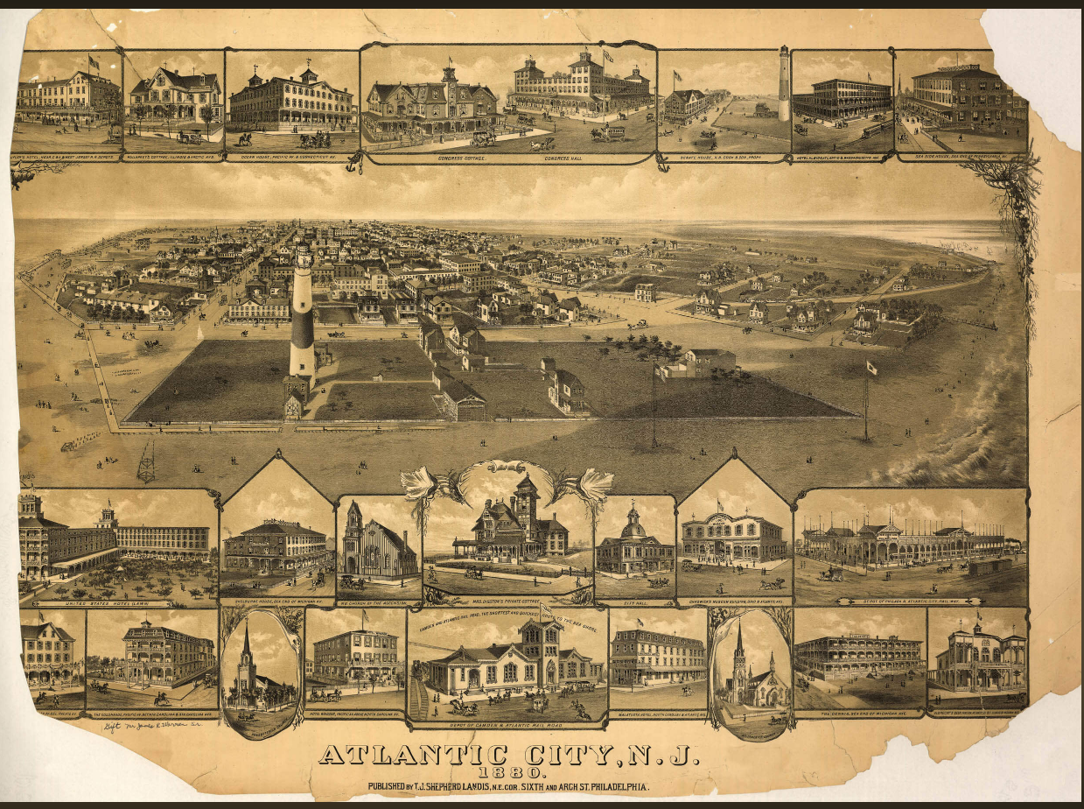

1880 map of Atlantic City, NJ showing Chadwick’s Museum, just above the church on the lower right

https://www.worldmapsonline.com/historic-map-atlantic-city-nj-1880/

William George Washington Chadwick, the only son in the family, would have been 14 years old at the time of the trial. It isn’t clear whether or not he moved to Atlantic City, or when he died. There is an indirect reference to him in a newspaper article written after William H. Chadwick’s death in 1883, which mentions that the older William had four children, three of whom are married, the fourth being Harriet, who lived with him. We know that William G.W. Chadwick was the executor of his father’s estate and held a public sale of the contents of the Atlantic City Museum, in 1884. From the Daily Republican of Wilmington, Delaware, March 25, 1884, we find this article about the disposal of the museum’s contents:

“Sale of a Museum
William Chadwick, administrator of the estate of the late William H. Chadwick, formerly of this city but of late years of Atlantic City, will sell at public sale, in Atlantic City, the contents of the celebrated museum which the deceased kept in Wilmington, but later in Atlantic City. This museum was considered among the best in the country, being well supplied with correct, life-like substitutes of a great number of wild animals and also noted characters. The collection of birds was a real curiosity, and the mineral and coin collections are very valuable. The sale will give the people the opportunity of supplying themselves with a panther, lion, a tiger or a boa constrictor for parlor ornaments, their shelves with birds of brilliant plumage and the cabinets with minerals and rare coins.”

Finally, there is a William H. Chadwick in the 1900 census from Hulmeville, Bucks County, Pennsylvania, born in 1862 in Delaware to parents from England (all of which would match). This William is described as a boarder, age 38, working as a “journeyman barber.” After that, it is not possible to confirm what happened to the younger William Chadwick or his wife.
We also don’t know what happened to Hannah A. Chadwick, who would have been 18 years old in 1875. She is found in the 1860 census, at age 2, and the 1870 census, at age 13. She figures prominently in the testimony at her father’s trial in 1875, but she does not appear in the 1880 census, nor could I find any marriage records for her. Her fate is not documented after 1870 in any of the ancestry.com family trees where the family appears. She may very well have changed her name either by fiat or by marriage after the debacle of her mother’s death and her father’s trial.
Only the third child and youngest daughter, Matilda Granville (Glanville?)* Chadwick, can be traced into adulthood and beyond. Named after her mother, she went by “Tillie,” and grew up and married Ridgeway Jefereys (sic) Clark, who was a chipper in an iron foundry in Wilmington. They married in 1878, when Matilda was 18, and had five children:
- Melvina R., born August 5, 1878 (or 1879), who grew up and married Mr. Chalmers
- John Abram, born September 11, 1882, who grew up and became a minister at the Grace Methodist Episcopal Church in Millsboro, Delaware
- Matilda Glanville, born in 1884, who grew up and married a Mr. Eaton
- Lula May, born in 1888, who grew up and married a Mr. Scott
- Martha Emma, born in 1891, who grew up and married Mr. Jack, and then Mr. Donovan

Ridgeway Clark died in 1922, and Matilda Chadwick Clark died in 1934. At the time of her death, she was living with her daughter Martha E. Donovan, and had 12 grandchildren. There is a lovely photo of Matilda Clark in the Word file, from a story about her 70th birthday, reproduced on her www.findagrave.com memorial.

*Some of the online records say that Matilda’s middle name was Glanville, and some say it was Granville. Interestingly, the town of Lancashire, England was once under the aegis of Ranulf de Glanvill (alias Granville), who died in the Third Crusade in 1190 at the Battle of Acre. Ranulf had a daughter named Matilda, who, along with her husband, William de Auberville, founded the Langdon Abbey in Kent, England in 1192. It was the first religious house to be dissolved by Henry VIII, in 1535.

MORE INFORMATION ABOUT THE NOTORIOUS CRIMINALS ON DISPLAY AS WAX FIGURES IN MR. CHADWICK’S MUSEUM

Story about Anton Probst and the murder of the Dearing family in 1866 south of Philadelphia: https://libwww.freelibrary.org/digital/item/20564 and https://digital.library.cornell.edu/catalog/sat1709

Daniel Dancer, English miser
https://www.lookandlearn.com/blog/12581/daniel-dancer-the-miserly-model-for-scrooge/ and https://www.meisterdrucke.us/fine-art-prints/English-School/517533/Daniel-Dancer,-English-miser-.html

Tim Bobbin, the Lancaster poet
https://www.burnleyexpress.net/news/opinion/columnists/how-burnleys-tim-bobbin-pub-got-its-name-2575558

“Negro Benny” – no info on google

William Burke, murderer of 40 people
https://www.irishtimes.com/news/the-grisly-tale-of-two-irish-anatomical-entrepreneurs-1.312946 and https://en.wikipedia.org/wiki/Burke_and_Hare_murders

Mathias Shupinchi – actually Matthias and Blaese Skupinski, young Polish men, who murdered a young peddler named Jacob Lehman (not Lahman) in Philadelphia in 1852; they were convicted and hung

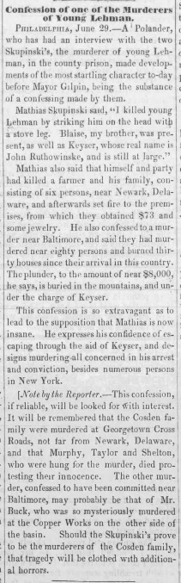 Sunbury Gazette, Sunbury, Pennsylvania, 3 Jul 1852

Arthur Spring, Sr. – murdered Honora Shaw and her sister Ellen Lynch in 1853
http://www.murderbygaslight.com/2013/06/arthur-spring-jr-vs-arthur-spring-sr.html

Gibbs, the notorious pirate – Charles Gibbs, hanged on Ellis Island, 1831
https://www.executedtoday.com/2014/04/22/1831-charles-gibbs-the-pirate/

Lieut. Montroville, the betrayer, and Charlotte Temple
https://www.google.com/books/edition/THE_BEAUTIFUL_AND_ACCOMPLISHED_CHARLOTTE/X1jlWF8FXtcC?hl=en&gbpv=1&dq=%22Lieut+Montroville%22&pg=PA15&printsec=frontcover; originally published in 1794, and a story apparently widely known

“Crazy Nora” of Philadelphia – Honora Powers, a well-known street person in Philadelphia of the 1820s and 1830s
http://hazelhomeartandantiques.blogspot.com/2015/04/crazy-person-of-day-crazy-nora-mid-19th.html

Witch of Endor – a Biblical character
https://en.wikipedia.org/wiki/Witch_of_Endor

Many more of the original newspaper articles, and a wonderful map of Atlantic City from 1880 showing Chadwick’s Museum, are included in the Word document that can be downloaded through the link provided below. The Word document also includes other records related to this case, such as “Hattie” and William’s CODs.

Harriet Chadwick’s COD in 1921

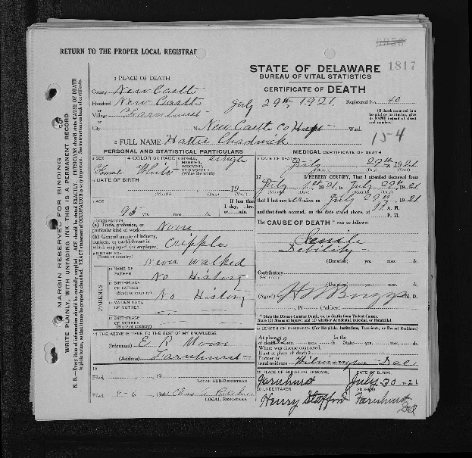

William and Matilda’s marriage in 1851
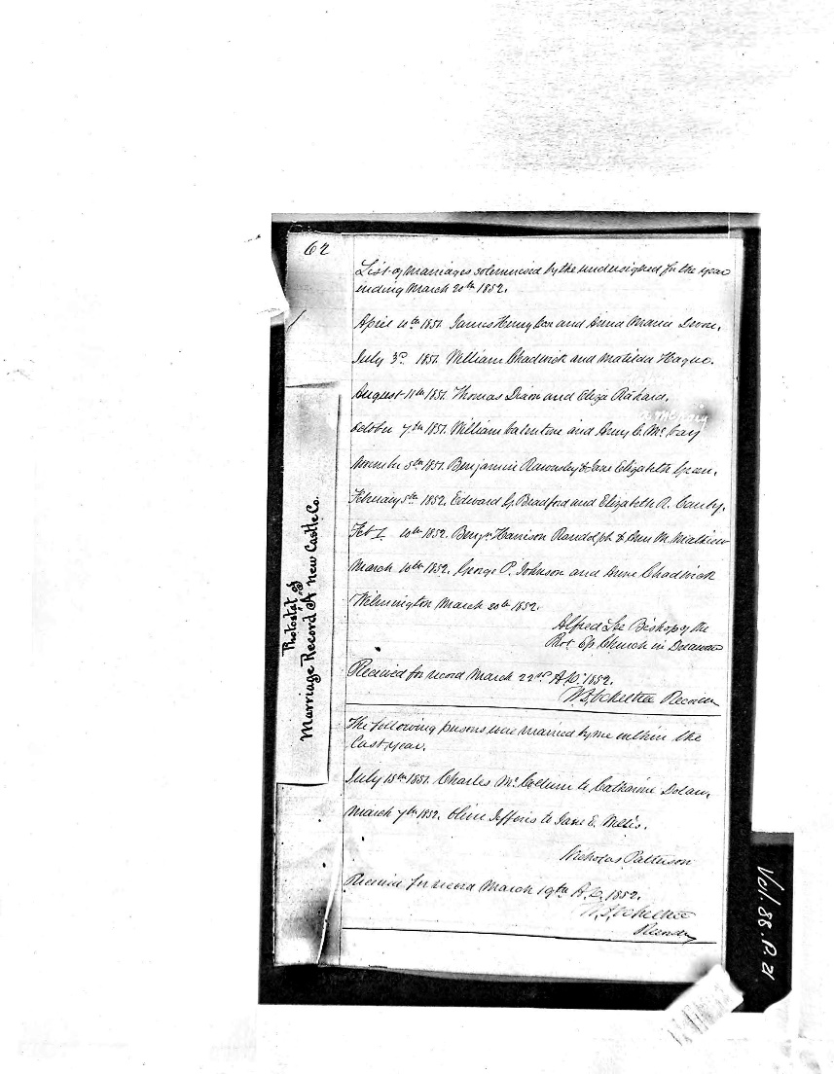

1860 census for Wilmington

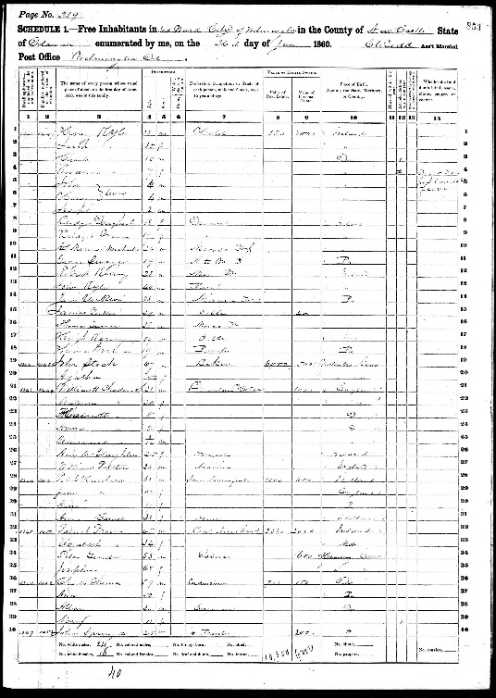

1870 census for Wilmington
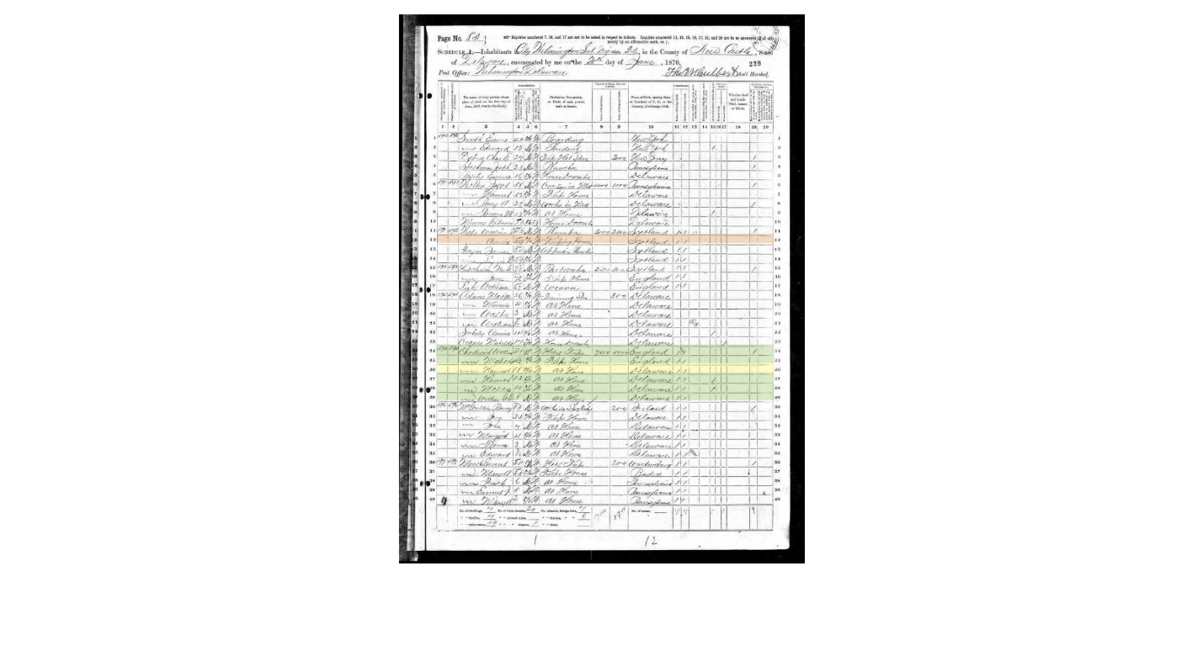

1900 census for the New Castle County Hospital

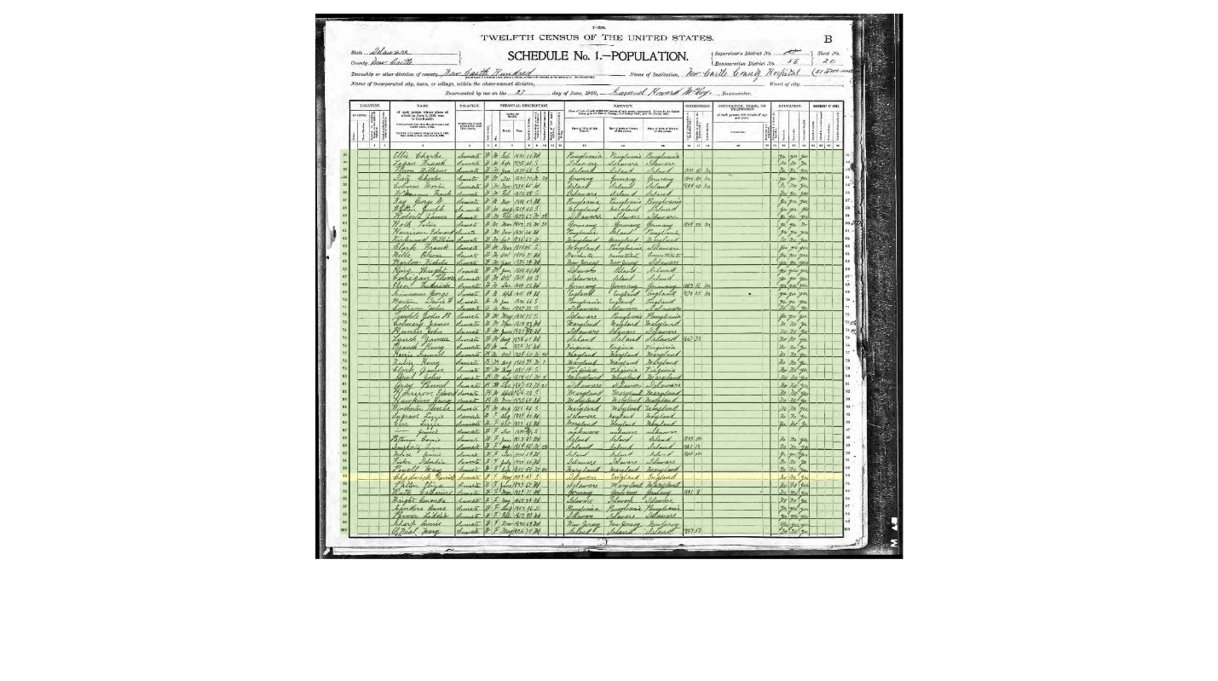

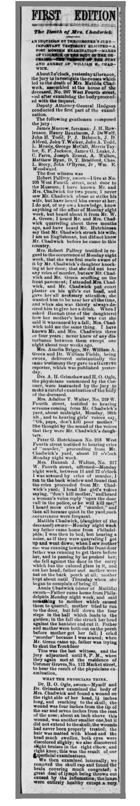
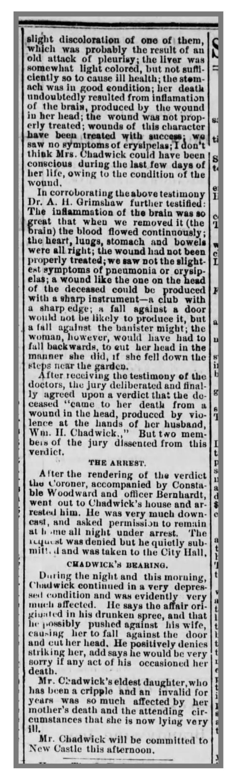
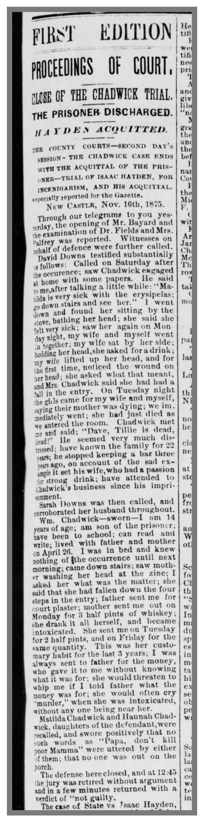 Daily Gazette, Wilmington, Delaware, 17 Nov 1875
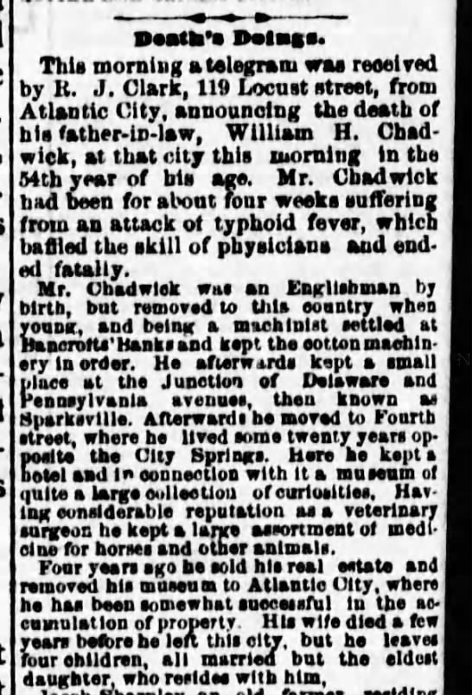

Daily Republican, Wilmington, Delaware, 24 Dec 1883
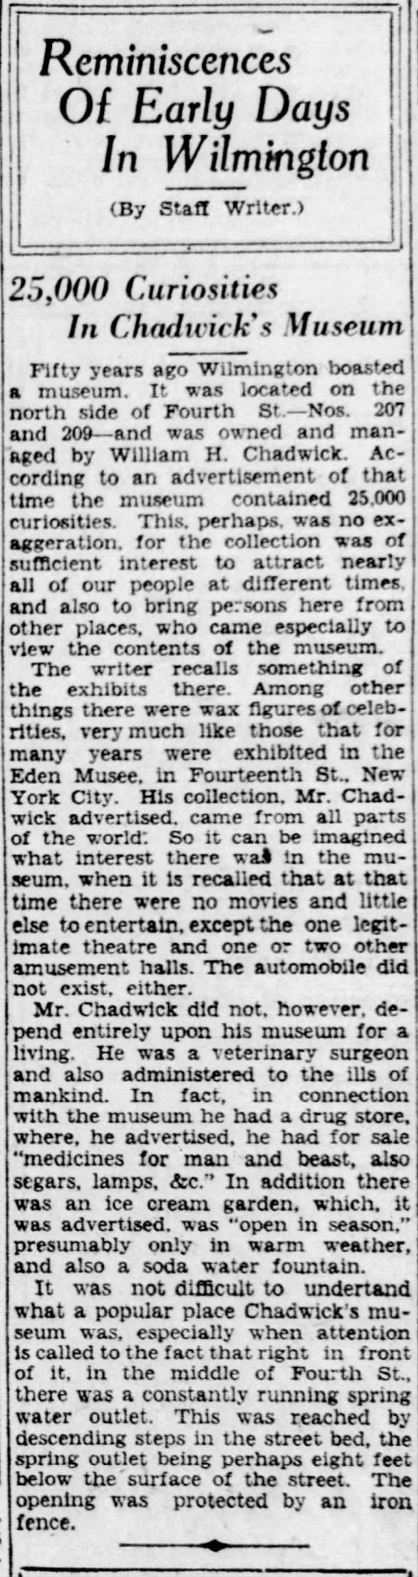 News Journal, Wilmington, Delaware, 8 May 1929

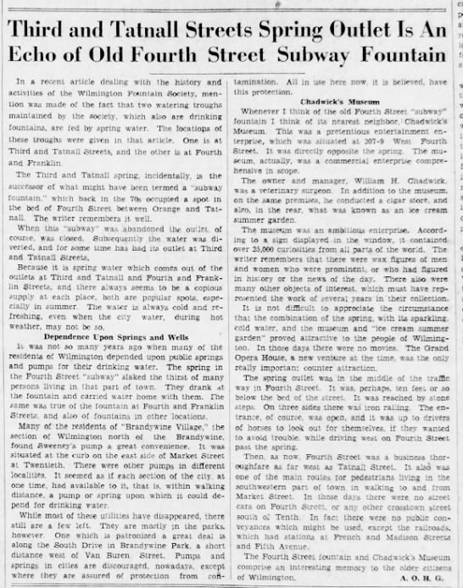
News Journal, Wilmington, Delaware, 10 Apr 1936
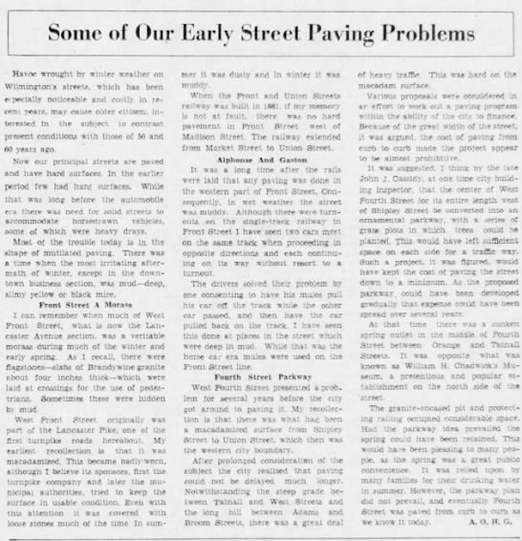
News Journal, Wilmington, Delaware, 27 Apr 1940

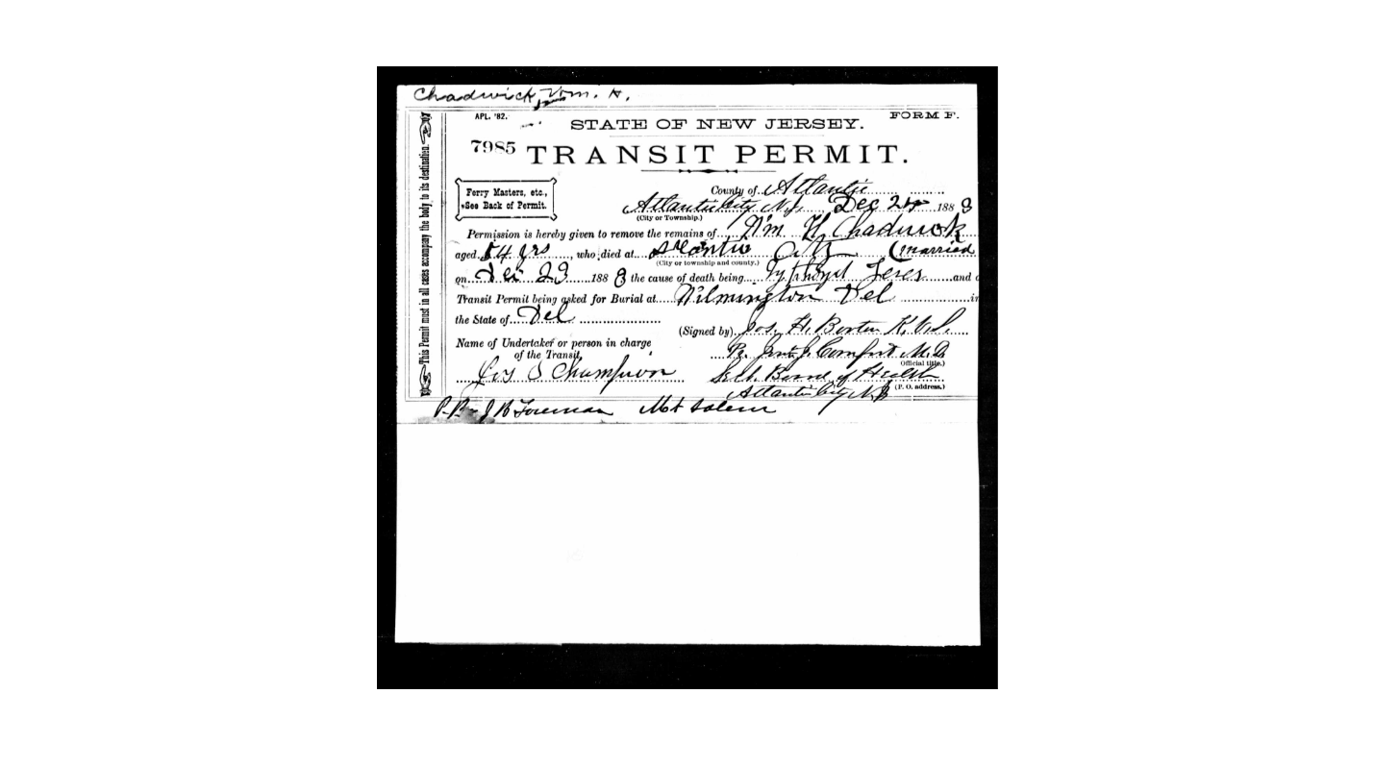
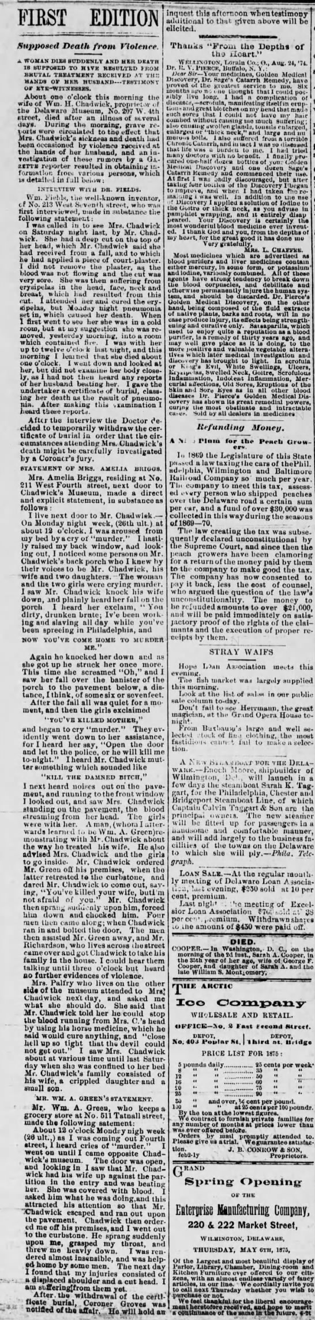 Daily Gazette, Wilmington, Delaware, 5 May 1875

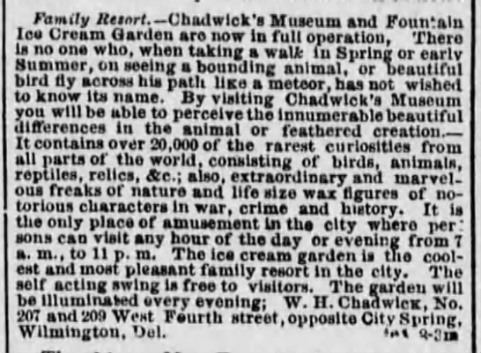 Daily Republican, Wilmington, Delaware, 19 Jun 1873; a bearded lady was added in 1874!
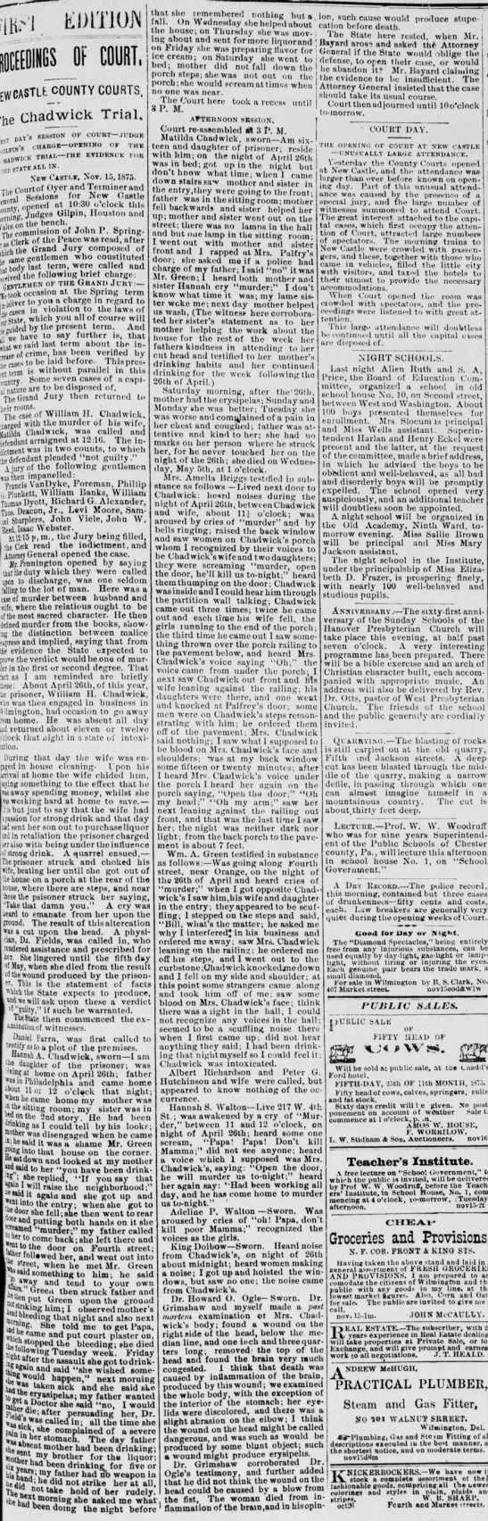 Daily Gazette, Wilmington, Delaware, 16 Nov 1875
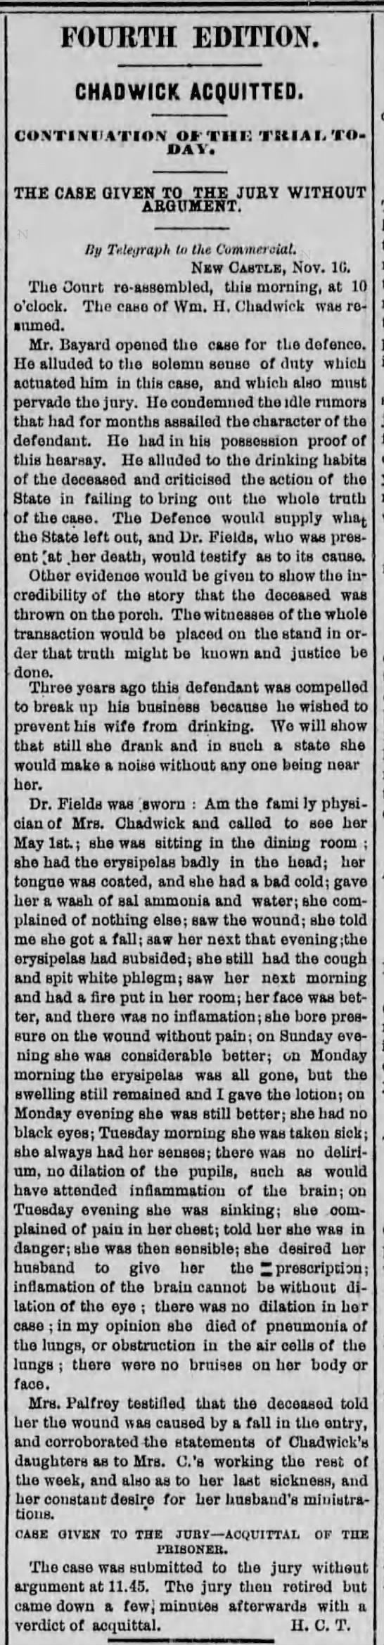 Wilmington Daily Commercial, 16 Nov 1875

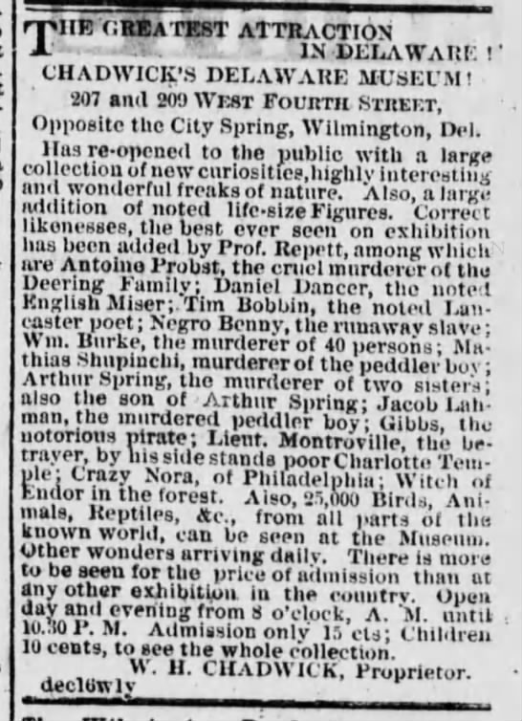 *****

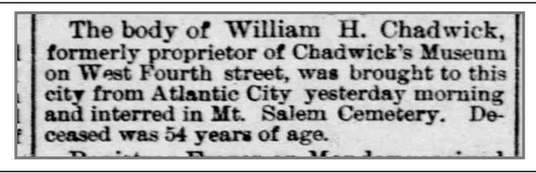
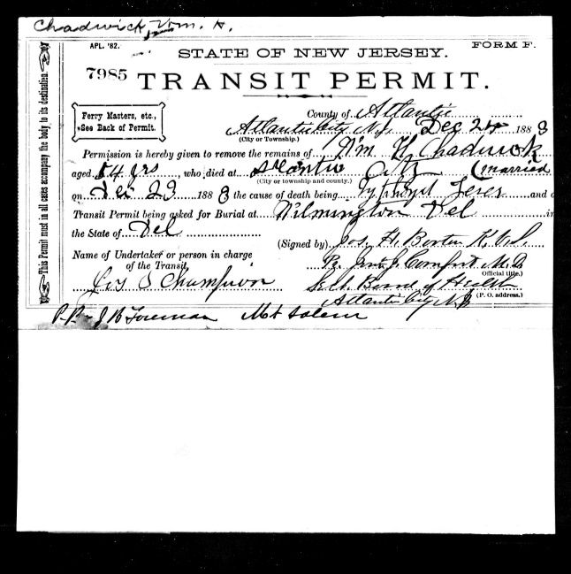
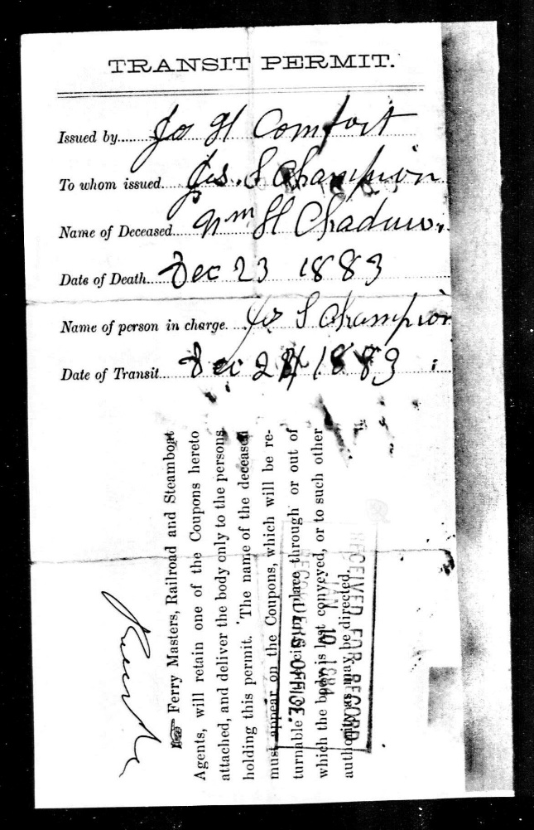
1883 reports of William H. Chadwick’s death in New Jersey
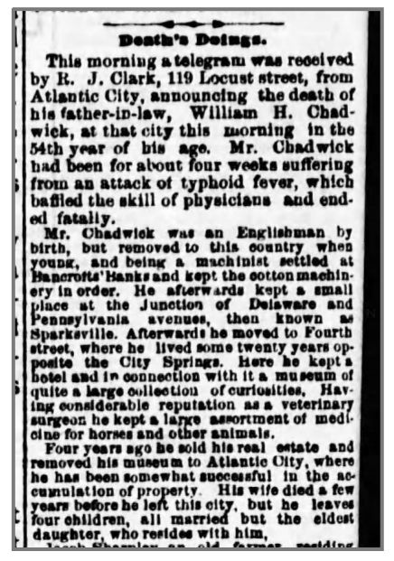

Harriet’s younger sister Matilda Chadwick Clark

