Joseph Bailey

Joseph Bailey was a 25-year-old single, African American man who died on April 28, 1902 at the Delaware Hospital as a result of a gunshot wound (April 15th, Dover). He was a laborer, originally from Maryland. He and Edward Holliday (also African American) got into an argument in Dover, Kent County. The two men apparently knew each other well, and Bailey chanced upon Holliday beating up his (Holliday’s) girlfriend, Emma Harris, on the corner of State and North streets in Dover, Delaware. Bailey tried to stop Holliday from hitting Harris and the two men got into a shouting match, then exchanged blows. Bailey reached down to the ground to get a brick or stone with which to threaten Holliday, and the latter pulled out a handgun and shot Bailey in the hand. Bailed then turned and ran, and Holliday shot him again in the back, seriously wounding him. Holliday then fled the scene. Emma Harris was arrested as being an accessory to the crime.
Joseph Bailey was taken to Delaware Hospital in Wilmington. At first, it was expected he would recover, but despite having surgery, the bullet could not be located and it became apparent that he would die. He was able to make a dying statement explaining the events that led up to the shooting.
The police tried to track Holliday, but he had gone to Maryland, and they kept showing up a day or two after he had been in a particular place. Eventually, they arrested his mother and put her in jail, and when she received a letter from Holliday, they were able to pinpoint his location.
Holliday was captured on Monday, May 5th, 1902 in Sparrow’s Point, Maryland. He was reported to be very contrite and sorry for his actions, and lamented loudly about his fate, especially late at night, annoying residents who lived near the Kent County Jail. He pled not guilty to murder, and early in the trial, a witness for the defense failed to show up. The court decided to postpone the trial for six months. Instead of waiting, Holliday pled guilty to manslaughter in November of 1902 and was sentenced to 4 years in jail and a fine of $4,000. He served his time and survived until at least 1920, when he disappears from the available records.
It was not easy to find information about Joseph Bailey, but both the Bailey and Holliday families were originally from the eastern shore of Maryland, from Queen Anne’s County. Tracing Joseph Bailey’s family, we find that his parents were Jacob Bailey and Indianna C. Bailey (maiden name unknown). Jacob Bailey, in turn, was the son of James and Susan Bailey, who are listed in the 1850 US census of Free Inhabitants of Queen Anne’s County, MD. In that census record, Jacob was 4. By the 1870 census, Jacob is listed as being 25, living in Broad Creek, Queen Anne’s County, working as a farm laborer and living in the household of William Connelly (African American, wharf attender). He was apparently already married at that time to Indianna, who was only 16, and who lived in a different household, that of Thomas Stansbury (African American, farm laborer). The 1880 census for Kent Island, 4th election district, Queen Anne’s County, Maryland, lists Jacob and Indianna C. Bailey living together with their four children, including Joseph E. Bailey, age 3.
By 1899, Joseph E. Bailey had moved to Dover, Delaware. In December of 1899, he was arrested for gambling in the streets, along with Julius and Edward Holliday. They were each fined $6 or 30 days in jail. Only Bailey was able to pay the fine, and the Holiday brothers spent a month in jail.
In the 1900 US census, Joseph was living as a boarder in the household of Levi Holliday and his wife, Mary B. Holliday (Edward’s parents). In the 1900 US census for Dover, Delaware, taken on June 19th, the Holliday household included:
- Levi Holliday, 50, African American, boot black
- Mary B. Holliday, 50, African American, washerwoman
- Joseph E. Bailey, 21, general laborer, lodger
- Julia Evans, 23, stepdaughter

Thus, in 1902, when Joseph Bailey chanced upon Edward Holliday and Emma Harris on the street in Dover, both men would have known immediately who they were arguing with.
We know from newspaper accounts that Mary B. Holliday was the mother of Edward Holliday, who shot and killed Joseph Bailey in 1902, and that Julia Evans was Edward’s sister (although she is listed as a stepdaughter to Levi Holliday in 1900). So clearly the two men knew each other well, and most likely, the families knew each other back in Maryland. It isn’t clear where Edward or his brother Julius were living in 1900.
Other than his descent from several generations of free African Americans, his birth and early life in Maryland, and the fact that he lived with Levi and Mary Holliday in Dover in 1900 and was killed by their son Edward in 1902 after trying to intervene in Edward’s abuse of his girlfriend Emma Harris, we know nothing of Joseph Bailey. He had not married or had children at the time of his death in 1902 at the age of 25. We can, however, find out a little more about Emma Harris, and a lot more about the Hollidays.

Emma Harris. We can’t really say much about Emma Harris. There were several other African American women named Emma Harris living in both Dover and Wilmington, Delaware at the time, and it isn’t possible to confirm if they are the same person as Edward Holliday’s girlfriend, unless the murder is specifically mentioned in connection. However, from one article we do know that Emma Harris was arrested as being an accessory to the crime of Bailey’s death. She was held in jail as a material witness for 6.5 months, and granted a sizeable compensation when she was finally released. Here is a transcript of the newspaper article detailing Emma Harris’ release from jail, from the Wilmington Evening Journal, November 18, 1902:
“This Colored Woman Was Rich. Had Nearly $200 as Witness Fees in the Murder Case of Edward Holliday. Special to the Evening Journal, Dover, Nov. 18: The richest colored person in town is Emma Harris. She was the principal witness for the State in the case against Edward Holliday, for the murder of Joseph Bailey. In order to prevent any tampering with this witness, and to make sure of having her here at the trial, the authorities thought best, on the night after the murder last April, to hold her in heavy bail to appear when wanted before the Grand Jury. Meantime, Holliday had fled the State, and was not located until sometime during the summer. Early last week the case was postponed for another six months, and it looked as though Miss Harris would have to spend a full year in jail. A plea in the case, however, was afterward accepted by the State and, the case over, the clerks began paying off the witnesses. Miss Harris was, of course, released and handed a draft for $195, representing witness fees at $1 per day for every day of her confinement. The woman did not lose her head, but had a mighty good time for a few hours with the cash. She first paid about $50 counsel fees, handed another $40 to a friend to keep for her for a rainy day, and started out with the even hundred. An admiring friend or two accompanied her, and in the tour of the stores that followed, nothing was too good for her. The winter’s provisions were first looked into, and this store was laid up, then some pretty furniture was purchased, (one) piece at a time.”

Levi Holliday. Like the Baileys, the Holliday were “free blacks,” originally from the Eastern Shore of Maryland, where there had long been a substantial and prosperous community of free blacks in Centreville. [There were also white folks named Holliday in Centreville as far back as 1815]. We first find Levi Holliday in the 1850 census record of Free Inhabitants of District 3, Queen Anne’s County, Maryland. His parents were Henry Hollyday, 45, a laborer, and Serena Hollyday, 35. He had an older brother Louis, 6, and an older sister Clementine, 3. Levi is listed as being 1 year of age. Next door are George Hollyday, 11, and Thomas Hollyday, 10, living with another family, but probably Levi’s older brothers as well. By the 1860 census for the same place, we find Levi Hollyday, age 11, and his brother James, age 7, living with the family of Daniel and Evalina Hopper. The Hoppers were white, and Daniel was the postmaster for Centreville, Maryland. It isn’t clear what happened to Levi’s parents.
Levi is missing from the 1880 census, and by 1900 he is living in Dover, Delaware, married to Mary B. Holliday since 1885, along with his stepdaughter Julia Evans, age 23, and Joseph E. Bailey, 21, a lodger. Mary B. had been married before, to Levin C. Evans. It isn’t clear who Julia’s father was (a man named Evans?) or how Edward and Julia are related, although she is referred to as his sister, and Mary as his mother, in newspaper articles.
Levi Holliday turns out to be quite the well-known character, and his life is chronicled in several newspaper accounts. He was for many years the resident boot-black of Legislative Hall in Dover, known to many important people in the state government. A sample of newspaper articles about him are transcribed here, for the light they shine both on his life and on the culture of Delaware and the relationship between blacks and white around the turn of the century:
- 1889, Oct 3rd, Delaware Gazette and State Journal: “Short Diet in Jail. Dover Index. Levi Holliday is not particularly struck upon the way that things are conducted in New Castle jail. He says that the home jail is the better one of the two. He doesn’t know anything about the Sussex jail, but he will doubtless inspect it the first time the Delaware militia holds its encampment upon the proposed target range at Rehoboth. Levi says he was in the New Castle jail for 13 days. He doesn’t want to go there again. He says he had no bed to sleep on, there were 15 persons confined in the cell in which he was quartered and that he was only allowed one loaf of bread, a little bran coffee, ‘wid nuffin in it,’ a little soup in the evening, and the bed-bugs ate up the scraps at night. We think that Levi has had a sufficiency of New Castle justice.”
- 1891, July 9th, Daily Republican: “George Wright, colored, charged with drunkenness, was sentenced to pay a fine of $2 and costs, or break stone for ten days. His companion, Levi Holliday, also colored, was charged with being drunk and disorderly and a general nuisance on Front street. He was sentenced to pay a fine of $3 and costs, or be imprisoned at hard labor for 20 days.”
- 1892, Nov 7th, Evening Journal: “Beniah Watson In It. He is Accused of Causing an Illegal Illustration. United States District Attorney Beniah Watson is accused of getting a colored man illegally registered in this city. The man in question is Levi Holliday, a bootblack, who is a well-known character in Dover, but who has been in Wilmington for several days. He is not on the assessment in either county, but he has been furnished with a tax receipt and placed upon the register as a qualified voter in one of the wards in this city. He was seen in Dover yesterday: When asked by responsible Democrats concerning his Wilmington trip he said. “I wuz registered up dar.” “Why didn’t you register here!” “Wuzn’t on de ‘ssessment.” “Were you on the assessment up there?” “No, but I knowed I couldn’t vote down heah and Mr. Beniah Watson took me to a place in Wilmington and I got a receipt. Den he took me to anudder place an’ I got registered. He tol’ de men I was all right.” “In what ward are you registered?” “You’se askin’ me too much now; ‘deed you is. Hit’s a big city an’ dey’ll show me de place.” If Holliday attempts to cast a ballot in Wilmington tomorrow, he will be arrested.”
- 1893, Apr 13th, Morning News: “”Boss, Be Light On Me.” Levi Holliday Entreats Judge Ball Not to Find (sic) Him Heavily. “Boss, be light on me this time,” remarked Levi Holliday, colored, last evening when arraigned before Judge Ball in the City Court upon the old charge of drunkenness preferred by Officer Massey. “When did you get out of jail?” asked Judge Ball. “Last Saturday,” was the reply. “You told me you were going to your old home in Dover when you got out,” replied his honor. “Well, boss, it was this way: When I got out I came to town and struck a job cleaning out a bar-room. I guess I got too much and then the cops pulled me. They have a pick on me, and bring me up to see you. Boss, be light on me. I’ll go to Dover.” “Two dollars and costs,” said the judge. “How much will that make?” remarked Levi as he was led away to a cell.”
- 1893, June 9th, Evening Journal: “Levi Was Out a “Smart” While. “How long have you been out of jail, Levi?” inquired Judge Ball of Levi Holliday in the Municipal Court this morning. “Been out right smart while,” replied the veteran bootblack whom Officer Kelleher found drunk at King and Front streets last night. “Two dollars or forty days,” responded the judge.”
- 1900, July 14th, Evening Journal: “State House Bootblack Dead. Was One of the Most Eccentric Characters of Dover. Dover, July 14. – Levi Holliday, colored, one of the most eccentric characters of Dover, known all over the state as the State House bootblack, died yesterday, after having over exerted himself in the harvest field of Dr. Roe. Holliday had blackened the boots of every Delaware statesman and politician from the days of John M. Clayton and James A. Bayard, and, during legislative sessions, reaped a rich harvest.”
- 1900, July 14th, The Delawarean: “Levi Holliday, a well-known colored character, who has for years blacked the boots of hundred of Dover citizens and visitors, is dead. He went out threshing wheat with a traction engine outfit on Thursday and some of the men tried to outdo each other at fast and furious work. Levi came home in the evening overheated and “turned in” on the floor to sleep, but his sleep became that from which there is no earthly awakening, for he was found dead yesterday morning. Holliday reaped a rich harvest in his business during Legislative and campaign seasons.”
- 1900, July 19th, several Wilmington newspapers: Several newspapers reported that Levi had died of “cholera morbus” – acute gastroenteritis – after an illness of two days. His COD cites dilation of the heart as the official cause of death. Despite his renown, I could find no record of where Levi Holliday was buried. Note that Levi died just a few weeks after the recording of the census in 1900.

Edward Holliday. I couldn’t find Edward Holliday of Dover in any of the census or other official records, but the newspaper stories about the death of Joseph Bailey and subsequent events make it clear that he was related to Mary B. Holliday (reported to be his mother) and to Julia Evans (reported to be his sister). Most likely, he was well-acquainted with Joseph Bailey, who lived with Levi and Mary Holliday and Julia Evans in 1900. After his arrest and return to Dover, he wept and lamented loudly about his regret for the shooting. One story from this time says: “Holliday prays for forgiveness for his foul deed, and while not feigning insanity, acts like a crazed man, especially at night. Holliday was a well-known colored sport and a professional cake-walker.” Morning News, July 17, 1902.
In 2022, I consulted with Dr. Louis Moore of the Department of History at Grand Valley State University, who researches the history of African American men, and is the author of I Fight for a Living: Boxing and the Battle for Black Manhood 1880-1915 2017. He explained that the phrase “colored sport” might have meant that Edward Holliday was specifically a boxer, or it could more generally have meant that he was involved in sports exhibitions of various kinds, or was known to gamble and visit betting clubs. As for being a “professional cake-walker,” cake-walking was an African American entertainment have a cake as prize for the most accomplished steps and figures in walking. It apparently developed during slavery as a way for slaves to mock their owner’s style of dancing. The Wikipedia entry for Cakewalk includes an amazing video of people performing this strutting style of dance:
https://en.wikipedia.org/wiki/Cakewalk.

After serving his sentence for manslaughter in the death of Joseph Bailey, Edward Holliday continued to occasionally get into trouble with the law:
- 1911, July 3rd, Evening Journal: “As a result of investigations by the Anti-Saloon League warrants were issued against . . . . . and Edward Holliday today charged with selling liquor in Prohibition territory. . . . Fisher, Vincent, and Holliday escaped to cyclone cellars and are not yet apprehended, but the Grand Jury has all the cases.”
- 1911, Oct 16th, Evening Journal: Edward Holliday was again arrested in a raid on speak-easies in Dover. Two days later, he was acquitted of the charges of selling liquor.
- 1912, Feb 27th, Morning News: Edward Holliday was charged with complicity in a Milford jewelry robbery, along with five other men. The outcome of that case was not reported.
- 1912, June 12th, News Journal: Edward was arrested again for selling liquor and held on $800 bail, but was acquitted on July 3, 1912.
- 1912, Sep 17th, Morning News: Now living in Toughkenamon, Pennsylvania (about 14 miles northwest of Wilmington), Edward Holliday was hurt when he was thrown from a wagon carrying furniture when the horse bolted. “Holliday was run over by the wagon and his left leg was broken, his right hip and back were injured, and his head was cut. He was dragged some distance and much of the flesh was torn from his hands and chest.” He was sent to the hospital.
- 1917 – Edward Holliday’s exemption from military service was challenged, but upheld by the courts. At that time, he was living at 3115 Market St. (the house still stands).
- 1920 – In the 1920 US federal census, Edward, age 44, was living in Dover, married to Harriett Holliday, 20, and working as a laborer in a factory. Neither Edward nor his young wife Harriett can be found after 1920.

Julia Evans. Edward’s sister Julia Evans is last heard from in 1910, living as a lodger in Philadelphia, age 34, widowed, with one child born and still alive. She was living on Lombard St., but without her child. Her occupation is listed as laundress.

JOSEPH BAILEY (AND EDWARD HOLLIDAY IN 1902)
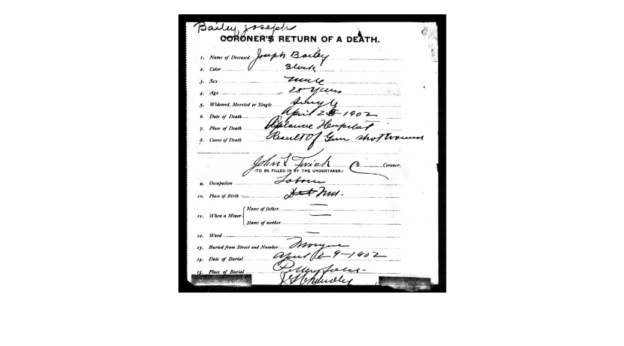
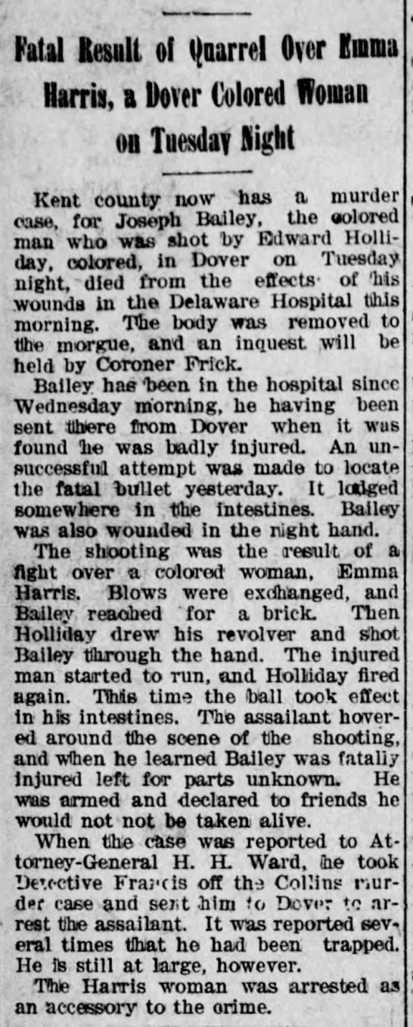 Evening Journal, 8/5/1903

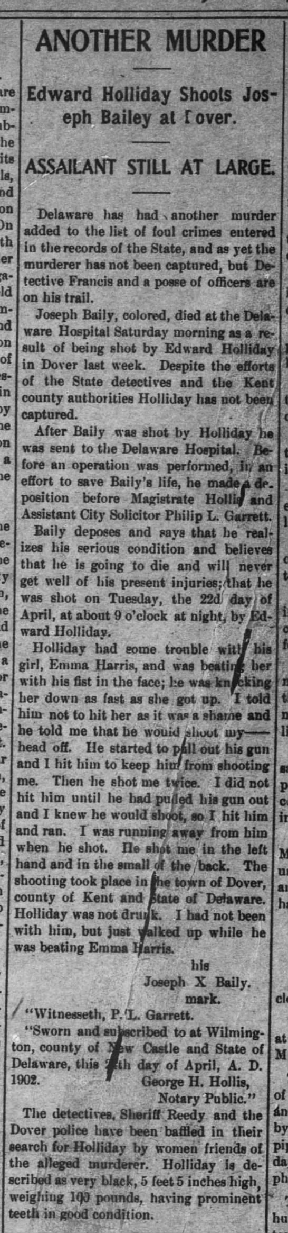 Middletown Transcript, 5/3/1902
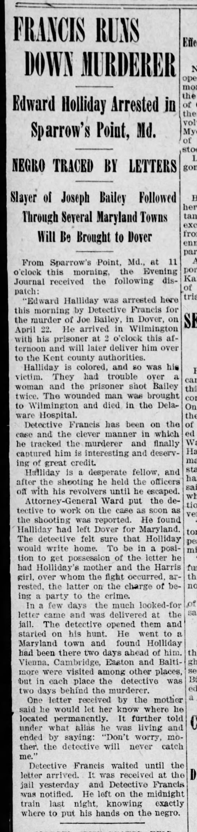 Evening Journal, 5/5/1902

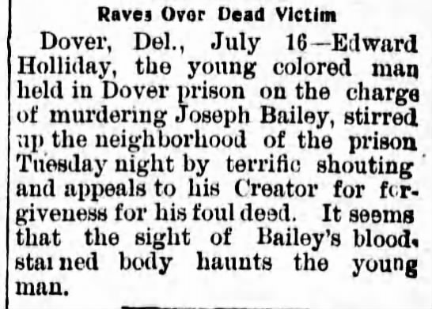 Daily Republican, 7/17/1902

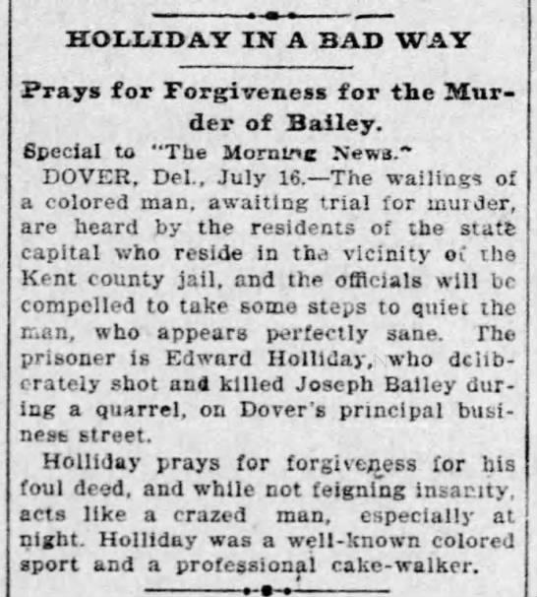 Morning News, 7/17/1902

EDWARD HOLLIDAY IN LATER YEARS

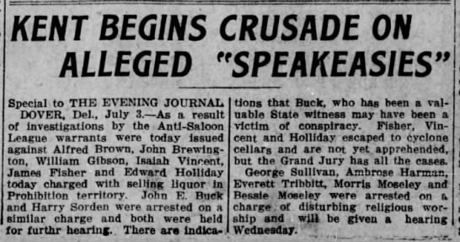 Evening Journal, 7/3/1911

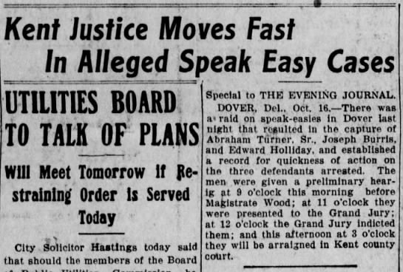 Evening Journal, 10/16/1911

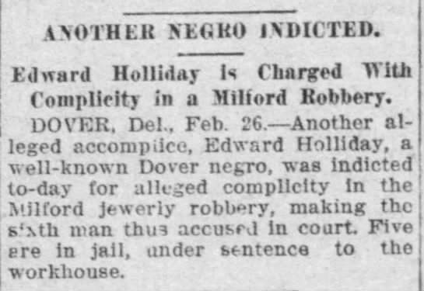 Morning News, 2/27/1912

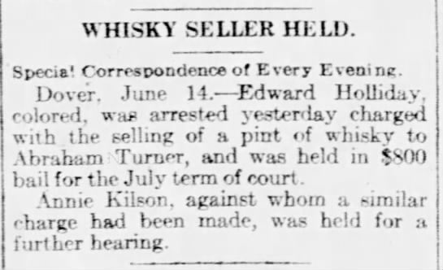 News Journal, 6/14/1912

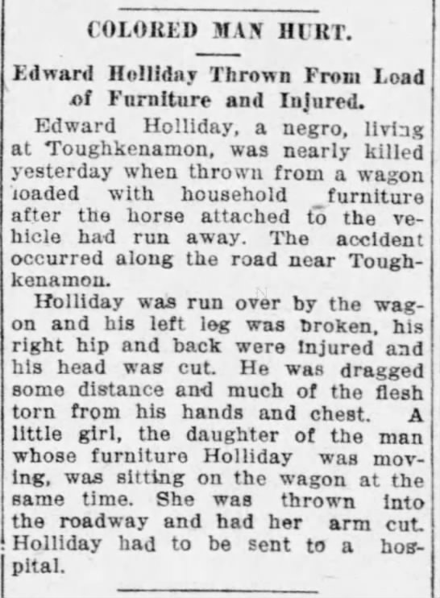 Morning News, 9/17/1912

LEVI HOLLIDAY

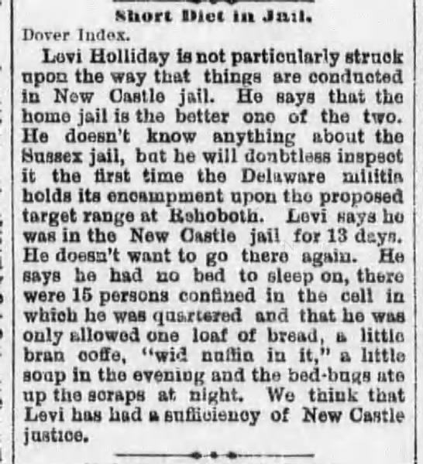 Delaware Gazette and State Journal, 10/3/1889

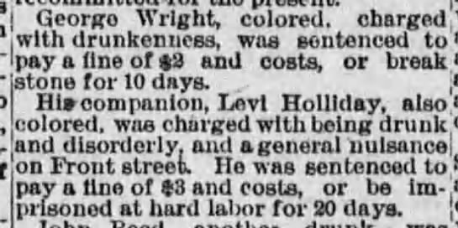 Daily Republican, 7/9/1891

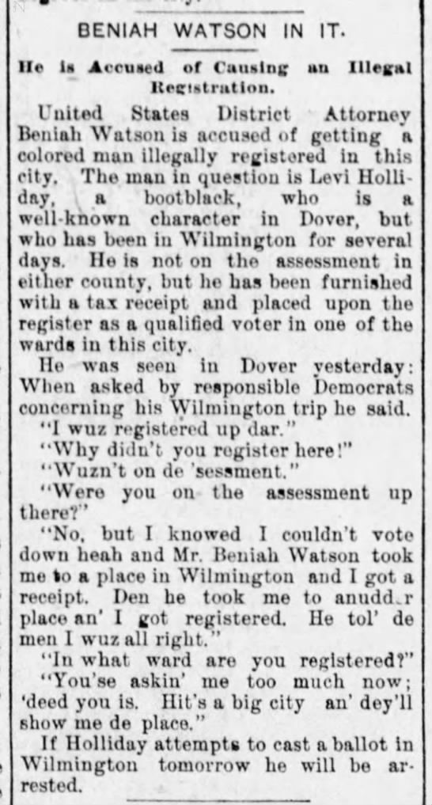 Evening Journal, 11/7/1892

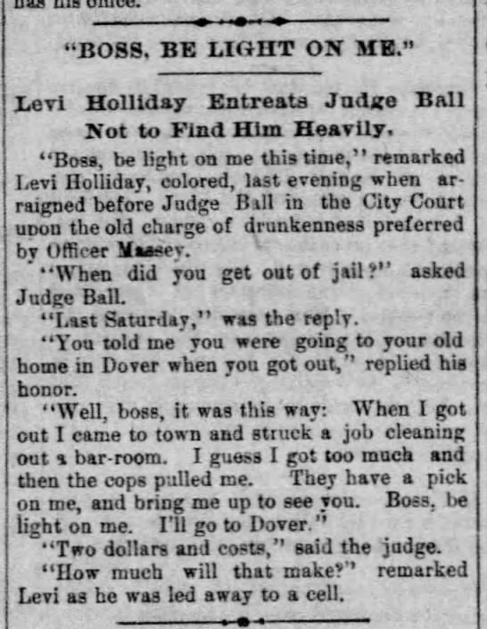 Morning News4/13/1893

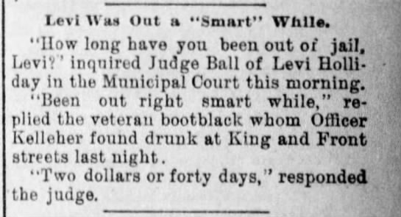 Evening Journal, 6/9/1893

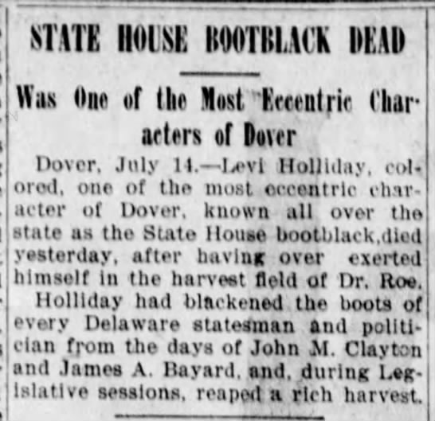 Evening Journal, 7/14/1900

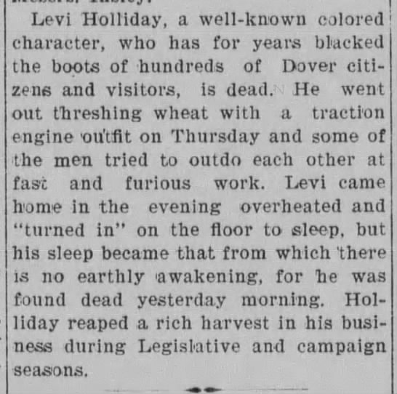 Delawarean, 7/14/1900
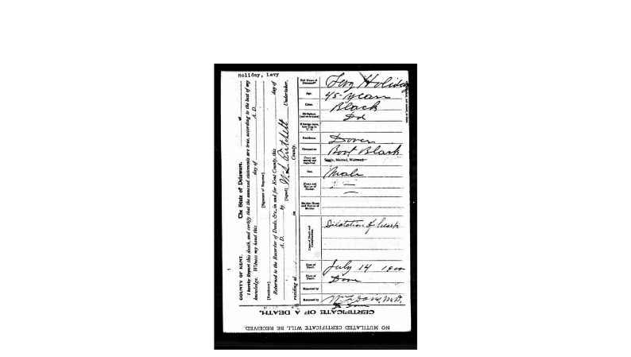

EMMA HARRIS

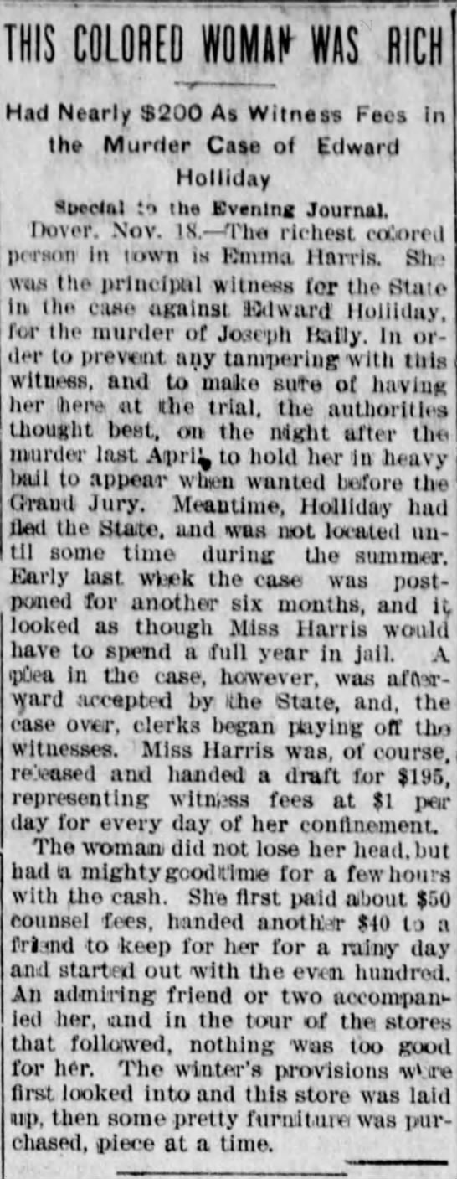 Evening Journal, 11/18/1902

