There is some uncertainty about the information available for Karl Oiderman, who died at the Delaware Hospital on November 1, 1928 of chronic encephalitis, after a stay of two days, and was buried in the NCCH/Farnhurst Potter’s Field Cemetery under marker 2028. He was probably not able to provide any detailed information about himself due to his condition. On his certificate of death, says his surname was Oiderman, which is most likely the correct spelling, and that he was only 40. The burial record for the cemetery says his surname was Oederman, and he was 59. He was probably born in 1877, so he would have been 51 when he died.
Karl Oiderman was a sailor/seaman, usually a boatswain (bosun), who worked on a series of ships crossing the North Atlantic back and forth between north-western Europe (and once from Seattle) and Philadelphia, New York, and Boston in the 1910s and 1920s. In the list of arriving passengers in port as part of a ship’s crew, we find him giving his place of birth as Russia, his nationality as Finnish, Estonian, Russia, or “American” (after 1922). His year of birth varies from 1877-1879. The ships sailed from Cherbourg, France; Rotterdam and Amsterdam, Holland; Antwerp, Belgium; and once from Seattle, Washington. The first ship of record is the St. Charles, in 1912, in Philadelphia, then the Cubadist, in 1917, arriving in Boston, then the Kamesit into New York in 1920 and 1921, and finally the Eastern Dawn, from 1922-1925. During 1923, the Eastern Dawn made four trans-Atlantic crossings with Oiderman serving as the bosun!
On his “Declaration of Intention” to become a naturalized citizen of the United States, he claims that he first arrived in the United States on September 1, 1912. He says he was born in Parnow, Russia. This is almost certainly Pärnu, the fourth largest city in Estonia today. He gives his date of birth as April 13, 1877, and says he arrived in Philadelphia from Rotterdam on the St. Charles. He is described as being white, 5’9” tall, 163 lbs., with brown hair, blue eyes, and a dark complexion. His occupation is listed as seaman. In received his citizenship in 1922 and thereafter is listed as being “American” on lists of arriving crew, except for the last voyage we have record of, the one from Seattle (still the Eastern Dawn), where he is listed as being Estonian.
In November of 1924, while working as a bosun on the Eastern Dawn as it sailed from Philadelphia and New York to Rotterdam, the ship encountered a heavy gale. Huge waves washed over the starboard bow, causing considerable damage to the ship, including the lifeboats. While attempting to secure one of the lifeboats, Karl Oiderman sustained a severe injury to his left ankle. He ended up with a complicated break that required hospitalization and rehabilitation. In 1928, Oiderman sued the captain of the boat, claiming that the captain had negligently not steered the boat on a course that would have minimized the wave damage. The case is described online including details of the accident during the storm. The first paragraph is copied here from the website:
THE EASTERN DAWN, (E.D.Pa. 1928) | 25 F.2d 322 | E.D. Pa. | Judgment | Law | CaseMine
Oiderman’s claim of negligence on the captain’s part was dismissed, as the judge felt no one could ascertain whether the captain could have done more to avoid the waves. However, Oiderman was awarded damages for “cure and maintenance” during the time he was disabled from the accident, which was determined to be 27 weeks (January 15 - August 15, 1925). This included food and lodging, reimbursement for doctor’s visits, an x-ray, Epsom salts, and other expenses. With 4% interest accruing between the time of the injury in 1924 and the decision of the court in 1928, he was awarded $456.06. In today’s dollars, that would be $7,349!! Quite a nice sum. It was also determined that although he still suffered pain in his left foot and ankle, he was able to work from August 15, 1925 onward.
It seems quite remarkable to me that in 2022, one can look up online and discover information about a seaman who was injured in a gale in 1924.
As far as can be determined, Karl Oiderman never married or had children. He was working on the S.S. Delaware as a sailor when his encephalitis became so bad that he went to the Delaware Hospital, where he died. In the absence of friends or relatives to pay for a funeral, he was buried at Farnhurst.
Karl Oiderman’s Certificate of Death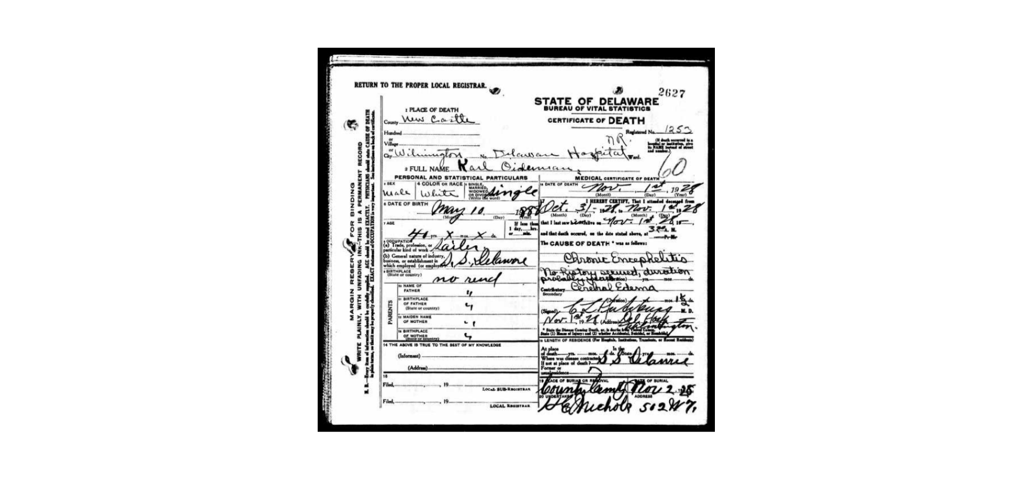 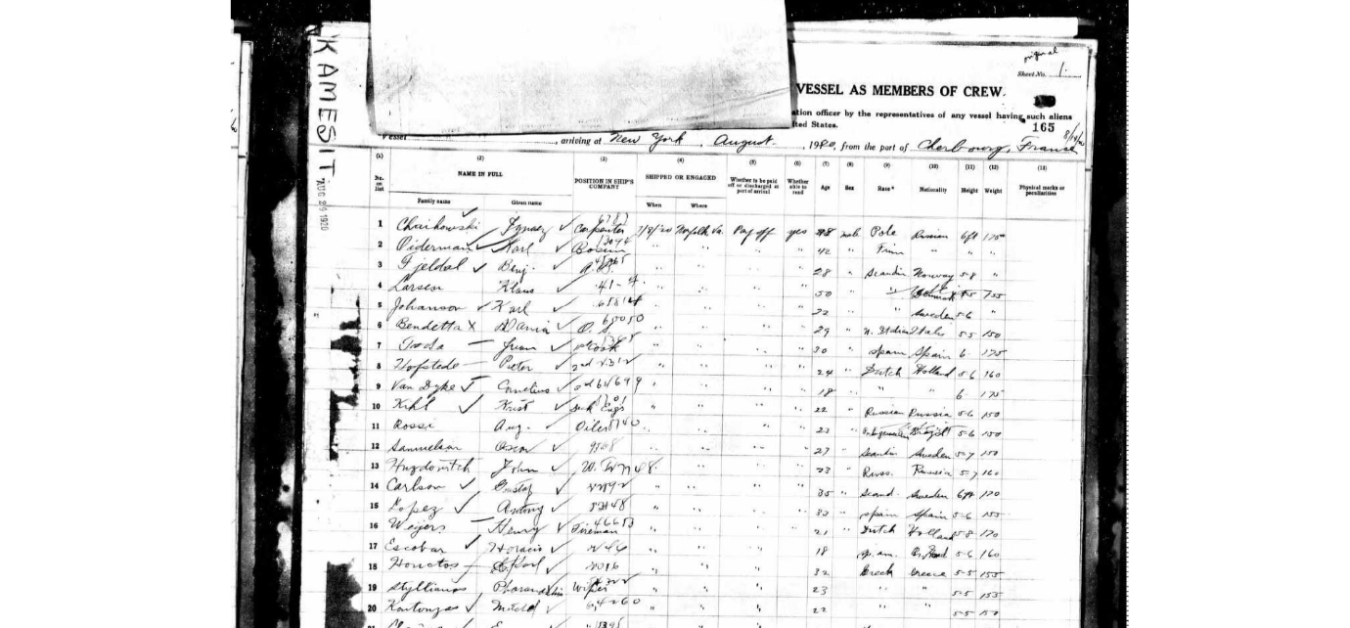

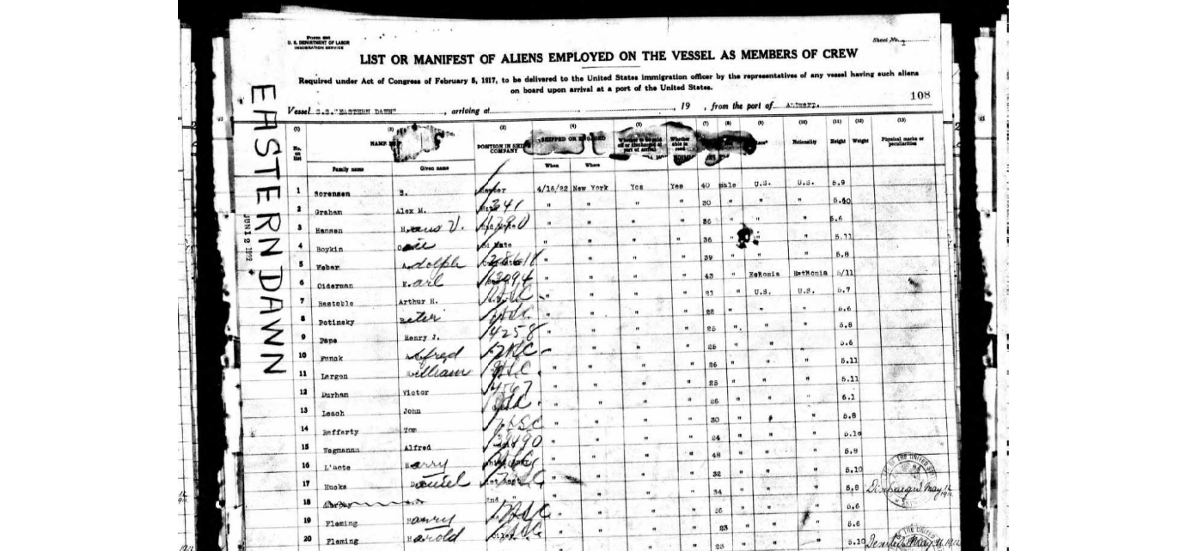

Excerpt from court case
THE EASTERN DAWN, (E.D.Pa. 1928) | 25 F.2d 322 | E.D. Pa. | Judgment | Law | CaseMine
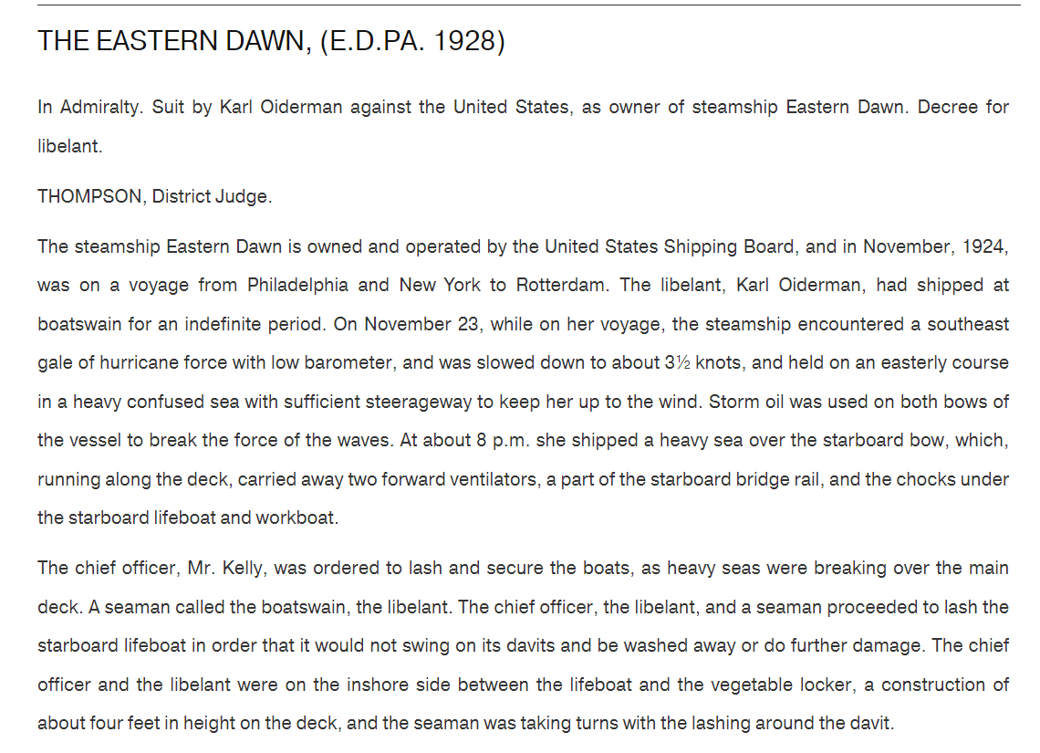
The rest can be read on the site.

Karl’s naturalization papers: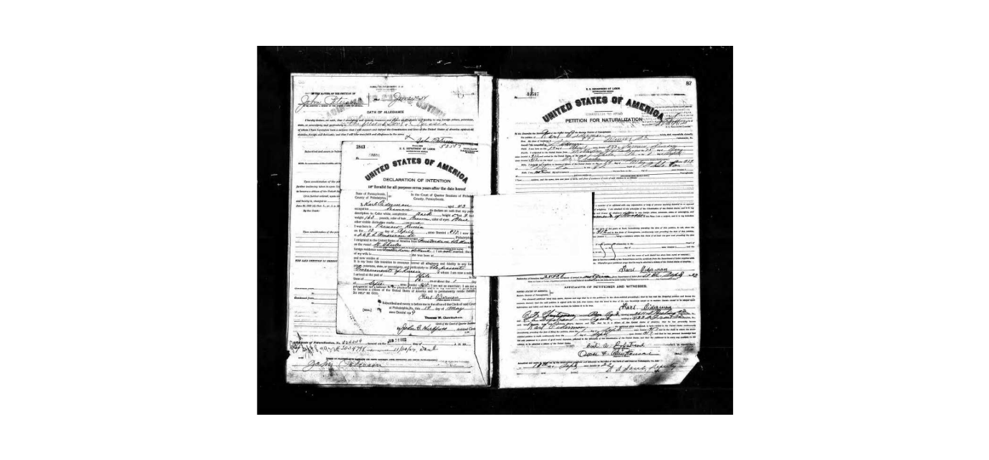 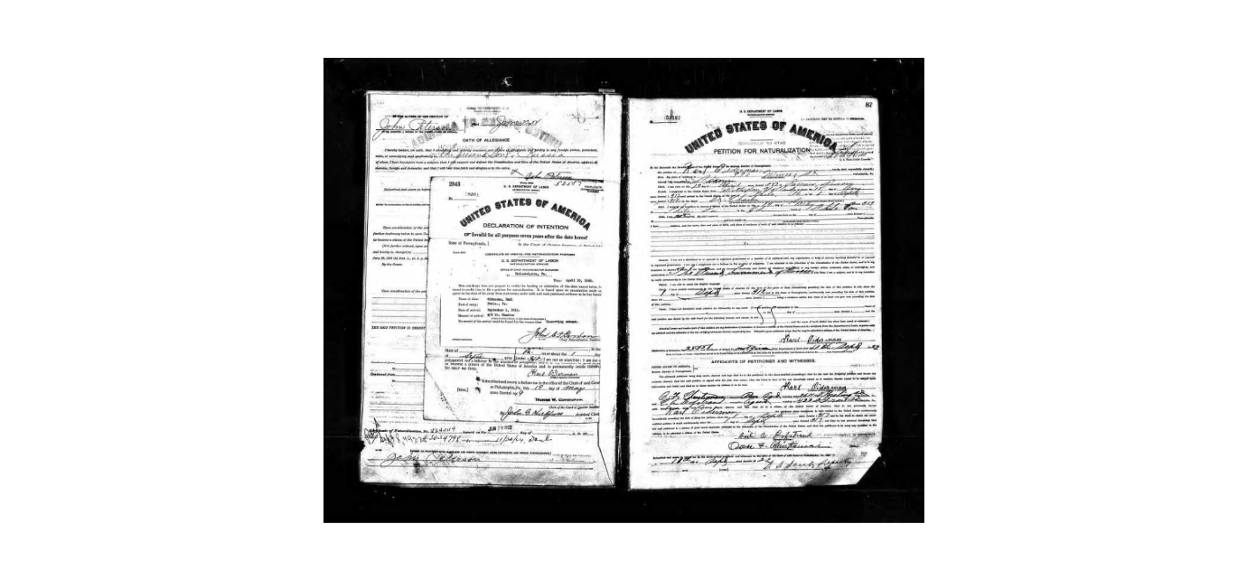
Karl’s ships
The first ship for which we have a record of Karl Oiderman serving on was the S.S. Cubadist. From Wikipedia: Cubadist was a steam tank ship built in 1915–16 by Fore River Shipbuilding Company of Quincy for the Cuba Distilling Company of New York. The vessel was extensively employed on East Coast to Cuba route during her career and disappeared without a trace on one of her regular trips in February 1920. Oiderman apparently was not aboard!
The second ship was the Kamesit. Images of the Kamesit (USS Kamesit during World War I) can be seen here:
Civilian Ships--Kamesit (Freighter, 1918) (shipscribe.com)
I couldn’t find any images of the Eastern Dawn except for a tugboat of that name, which can’t possibly be the same ship that sailed back and forth across the Atlantic multiple times a year.
Karl’s Certificate of Death in 1928, says that he was a sailor on the S.S. Delaware. I was unable to find any information on the S.S. Delaware. There was a USS Delaware that served in World War I, but she was decommissioned and sold for scrap in 1924.

