Louis H. Gross

Louis H. Gross was an African American man who died on July 3, 1914 at the age of ~70 years of diabetic gangrene after a four-month stay at the New Castle County Hospital. He was buried in the nearby cemetery. His first name is spelled Lewis in some records.
Louis first appears in the 1850 census of “Free Blacks” in Wilmington, Delaware, when he was just 6 years of age. He was living with his mother Susan, his older sisters Mary, Sally C., and Elizabeth, and his younger sister Maria L., along with several unrelated people. The older children are recorded as having been born in Ohio, but the two youngest, Louis and Maria, were born in Delaware.
Piecing together the timeline of Louis’ life:
- 1860 US census – Murderkill Hundred, farm laborer, not related to others in the household
- 1863 – Recorded in the Civil War Draft Registration Records, age 22, in Wilmington, “non-resident,” unmarried, born ~1841, “colored”; it isn’t clear if he actually served
- 1870 US census – In June of 1869 or 1870, Louis married Phoebe A. (maiden name not recorded) and in the June 1870 census they were living in District 1 in Wilmington; he was working as a day laborer; Louis was supposedly 30, and Phoebe was 22 (records list her as being born either in 1848 or 1838)
- 1880 US census – The household is living at 805 Jefferson St., Wilmington, and includes Louis, age 38, Phoebe, age 35, and two adopted children, Roddie Wilkbanks/Wiltbanks, age 9, and Sallie Wilkbanks, age 5.
- 1886 – Sarah “Sallie” E. Gross, the adopted daughter of Louis and Phoebe, dies at the age of 13 from pneumonia and the measles and is buried at Saint Peters Cemetery in Wilmington. Her COD misstates her last name as Groves. Note: Roddie Wilkbanks does not appear again in any records.
- 1883-1909 – Louis and Phoebe are still living at 805 Jefferson St. and Louis is working as a hod carrier
- 1900 US census – Louis (listed as “William”) is reported as being 53, and Phoebe as 58, married 30 years; the household includes cousin Rosanna Nelson, widow, born in August of 1822, now 77
- 1910 US census – Louis and Phoebe Gross are living on Jefferson St., now 72 and 51 (incorrect!), married for 41 years, with Phoebe indicating that she has never had any children; along with 2 boarders and the same cousin named Rosanna Nelson, age 98, widowed, mother of 2 children, both already deceased; at this time, Louis is still working as a hod carrier, and Phoebe as a washerwoman. The following year, Rosanna Nelson died at the age of 98.
- 1910 – Lewis Gross makes the newspaper for being slightly injured while jumping off a motor car before it had come to a complete stop.
- 1914 – Louis goes to live at the New Castle County Hospital/Almshouse in the spring. After a four-month residency, he dies of diabetic gangrene, and is buried in the NCCH Cemetery.
- 1930 – Phoebe Gross, a resident of the Sussex County Almshouse, dies there after a stay of at least five years. Her cause of death is simply “senility, cardio, renal, old age.” She is buried at the “Alms House and County Farm Cemetery.” There is no indication of why she was at the Sussex County Alms House, rather than the New Castle County Hospital.

Louis’ cousin Rosanna Nelson was married to Joseph Nelson, a farm laborer. In 1850, the couple, then 35 and 34, were living in Wilmington with a friend or relative named Stephen Cooper, and his wife Jane Cooper. In 1870, Joseph and Rosanna lived in White Clay Creek Hundred, where Joseph was 55 and “Hannah” was 50. In the 1880 census, we find only Rosanna, working as a washerwoman and living alone as a widow. Rosanna Nelson died on July 10, 1911 at the age of 98 of senile debility, and was mentioned in a 1912 newspaper article as being one of the elderly folks who had died the previous year. The only confirmed mention of Joseph Nelson in the newspapers is from 1868, when he was elected an elder of the African Methodist Episcopal Conference.

Louis’ Civil War Draft Registration – I could not confirm that he actually served in the military.

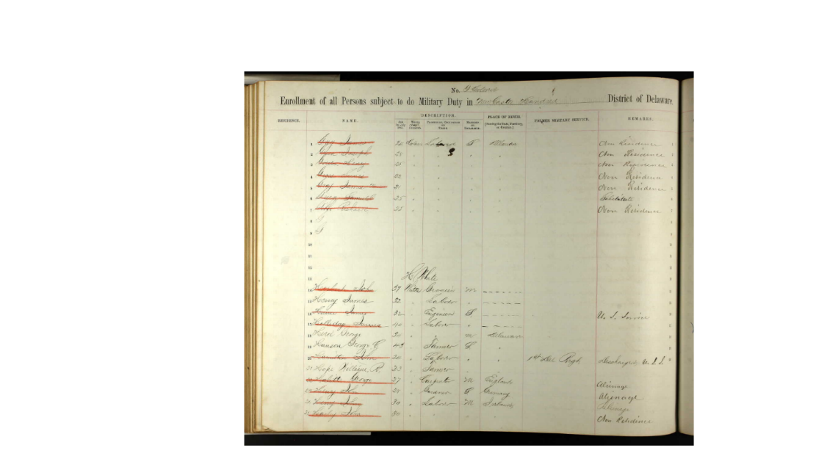

Louis’ COD
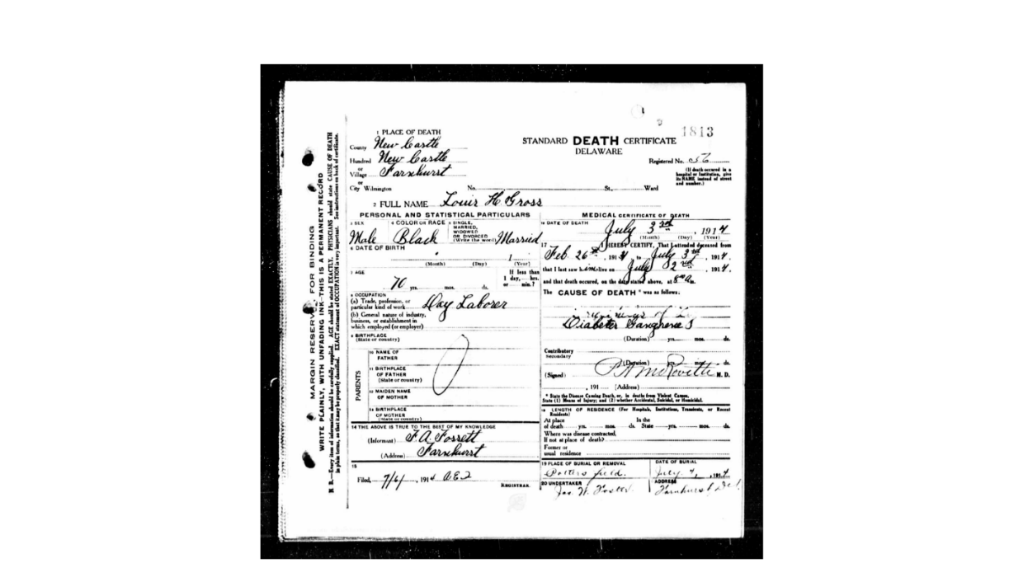

Lewis makes the newspaper: May 11, 1910

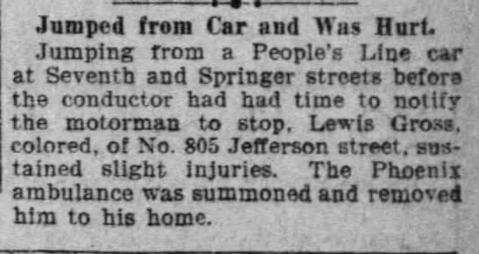

Phoebe’s COD

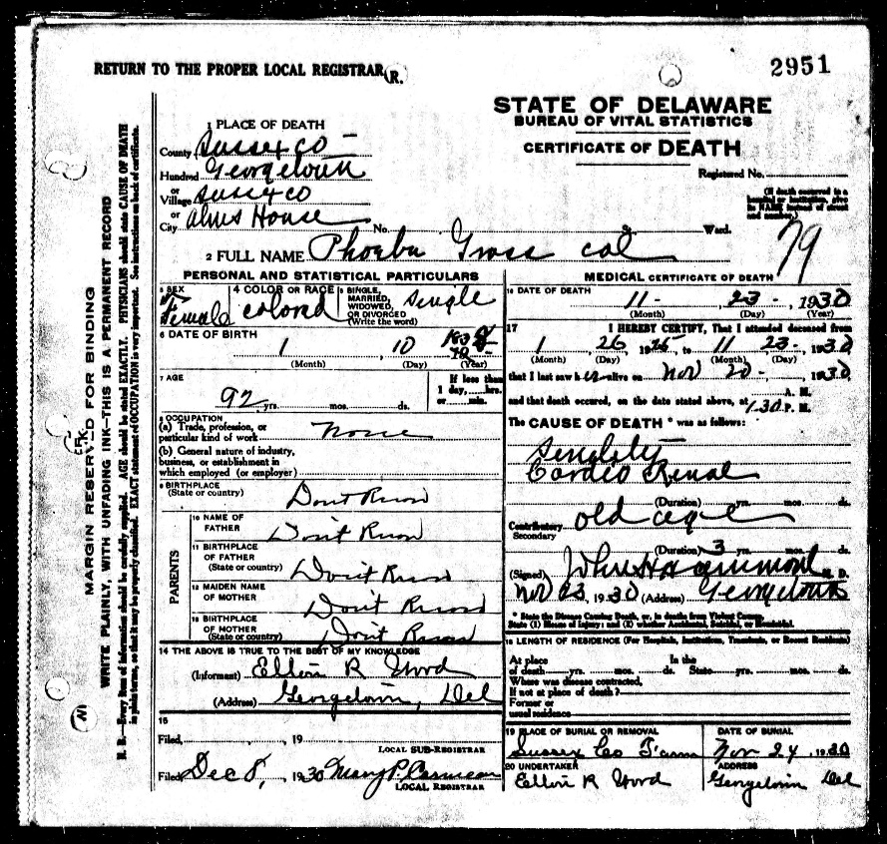

Sarah’s COD
