19 June 2014
Images of the former Moore’s Lane Potter’s Field and surrounding areas, showing the history of what happened to the Potter’s Field
Figure 1. 2013 Map of the Boulden Blvd. area with parcel outlines highlighted.
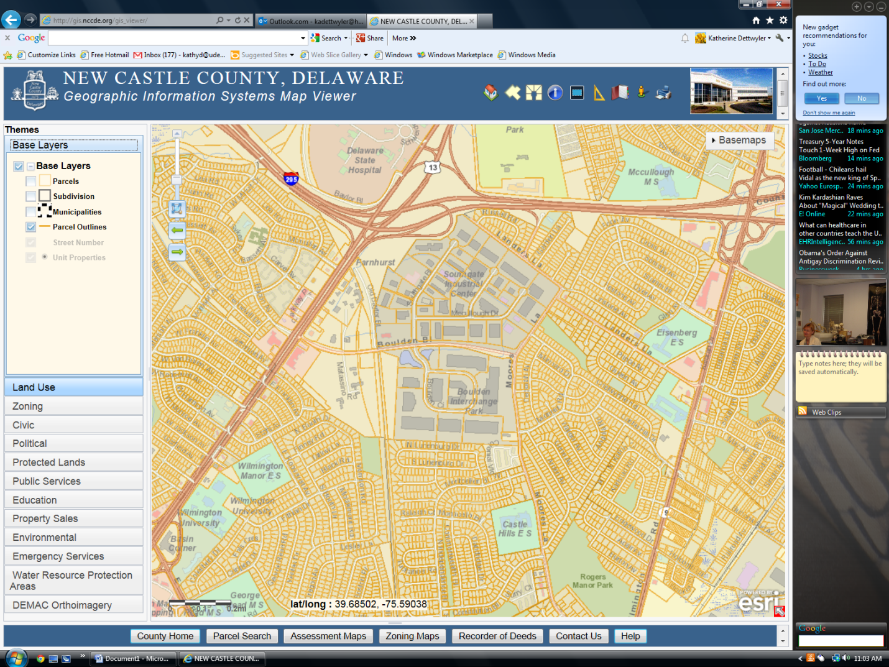
The top of the map actually faces northeast, but for clarity we will assume it faces north. The areas marked in gray, Southgate Industrial Center and Boulden Interchange Park, represent the areas where soil was excavated for the building of I-95 in the 1960s. The parts of the park at the eastern third (right side of the map), and extending approximately halfway above and below Boulden Blvd. represent where the Moore’s Lane Potter’s Field was located (see images below). At least 30’ of soil was removed from the eastern sections of the gray area. It must have been a hill, sloping down to the west, as the “pit” is shallower at the western edge of the industrial parks.

Figure 2. Orthos image from 1954 with current parcels
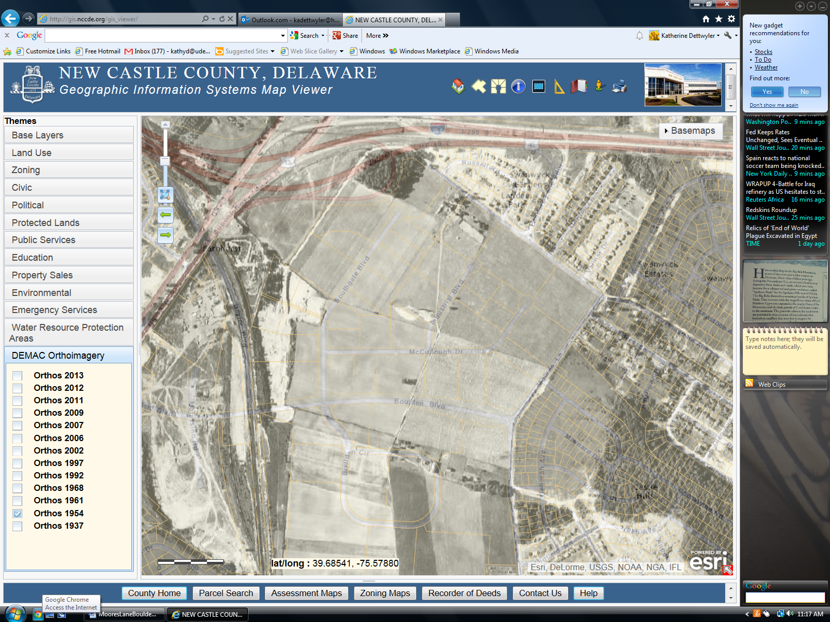
Just slightly to the lower right of center is a parcel shaped like a tilted square, with a marked indentation along the eastern border. This field is the Moore’s Lane Potter’s Field. Directly south of this field, in 1954, was the Moore’s farm with buildings and trees. If you look closely at the tilted square, you can see that Boulden Blvd. now bisects this field. You can also barely make out the rows of granite markers. The markers are much clearer in the actual computerized aerial photograph. Just to the east of the Potter’s Field was another field; this is now the Castle Hills subdivision with lots of little tiny lots, as indicated by the parcel outlines. The Boulden Blvd. Potter’s Field is the trapezoid just above where it reads “lat/long” on the map.

Figure 3. Orthos image from 1961 with current parcels
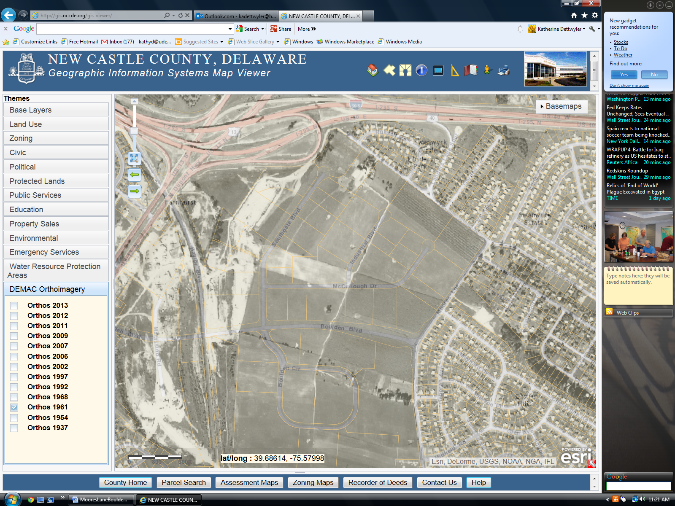
By 1961, the tilted square has become a field under cultivation. Presumably the graves have been moved by this time, as the granite markers are gone, but serious excavation of the area has not yet begun. Moore’s farm is still there, surrounded by fields. The Castle Hills houses have now been built.

Figure 4. Orthos image from 1968 with current parcels
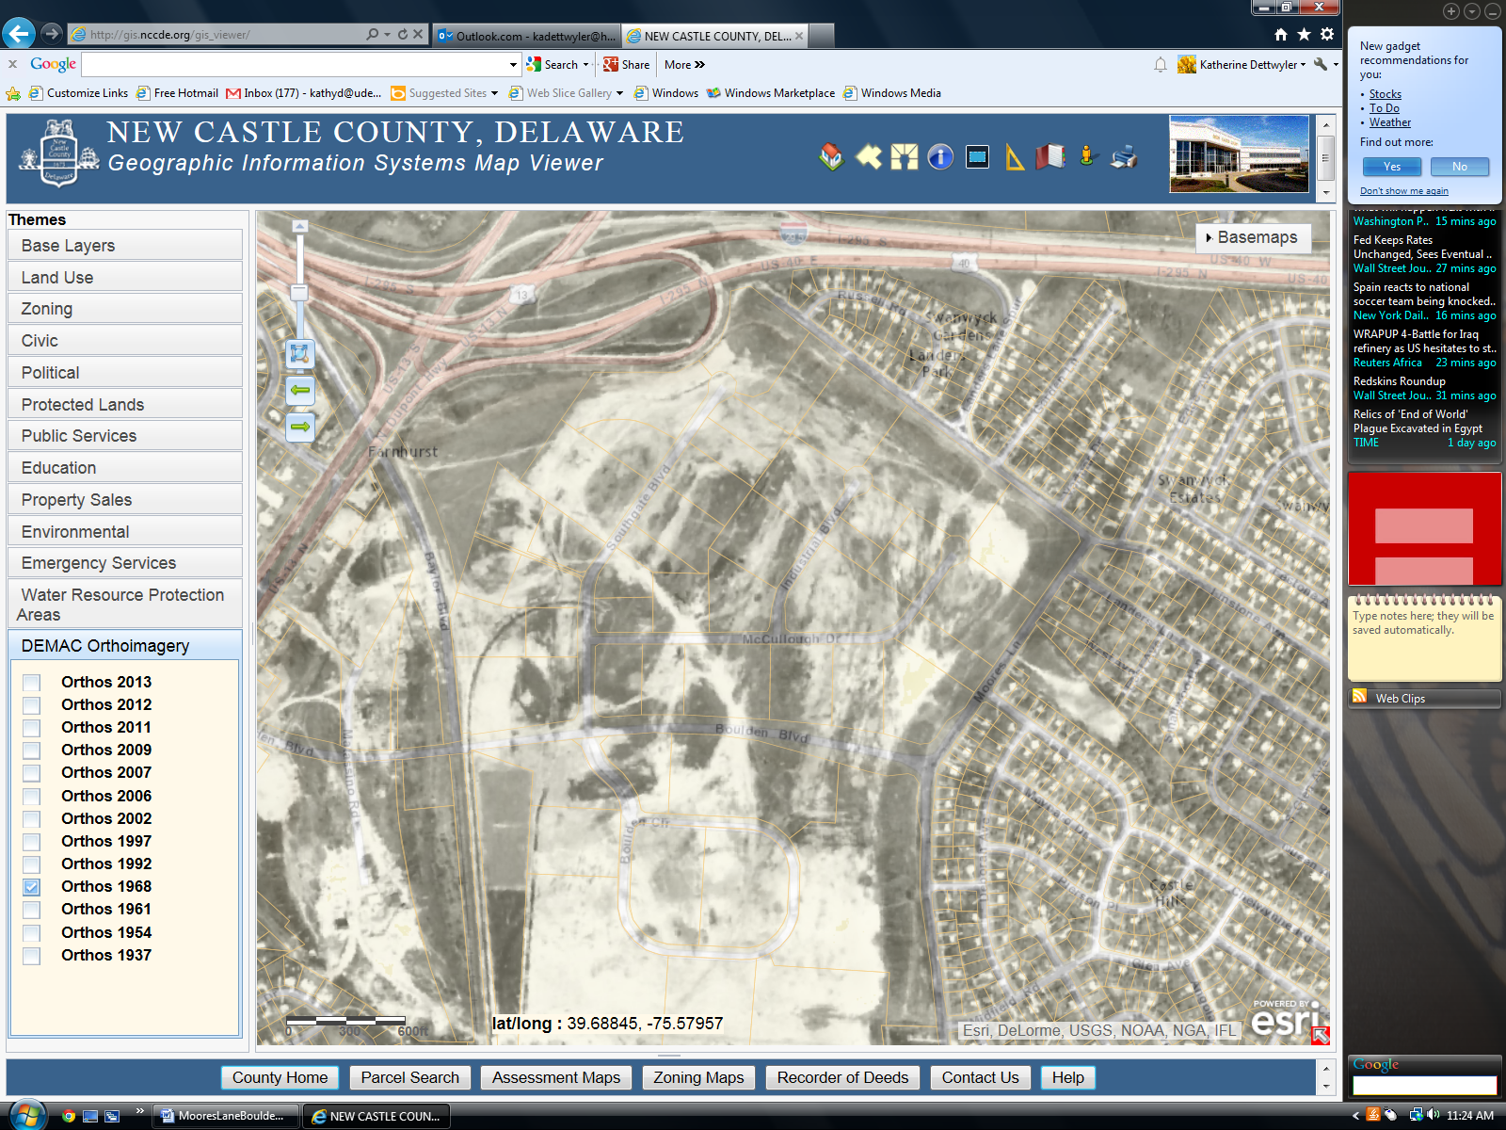
By 1968, there had been extensive excavation of the entire area that is now the industrial parks on either side of Boulden Blvd. Moore’s farm is now gone, as are the surrounding fields. As described earlier, the darker trapezoid just above “lat/long” on the map is the current Boulden Blvd. Potter’s Field. The northern half is open grass, the southern half is thick woods.

Figure 5. Orthos images from both 1961 and 1968 combined
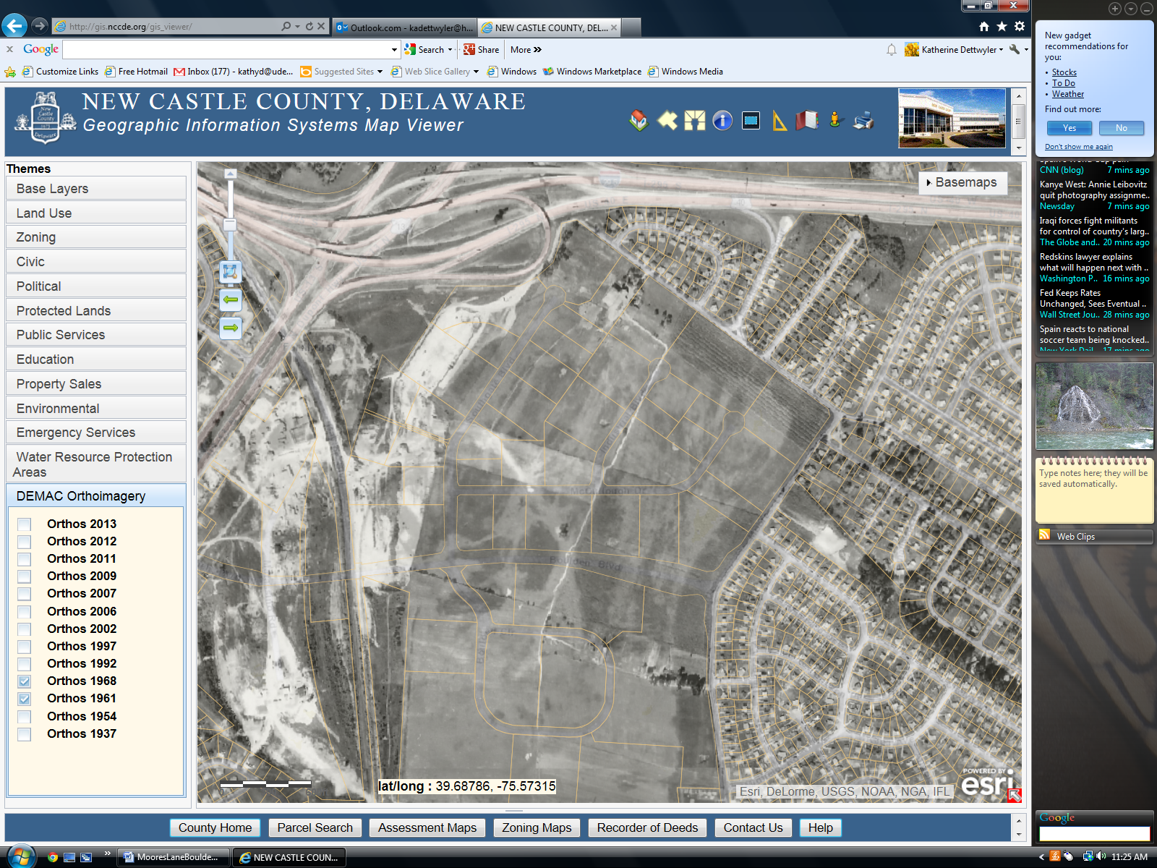
This image shows the 1961 farm field (that had been the Potter’s Field), the 1968 excavations, and the current parcels of the industrial parks. As is hopefully apparent from this image, what had been the Moore’s Lane Potter’s Field today can be found as the southeast quadrant of the Southgate Industrial Center and the northeast quadrant of the Boulden Interchange Park, with Boulden Blvd. running west to east across the middle of the former Potter’s Field, and ending at Moore’s Lane.

