All we can find out about Ruth Westbrook is that she was an African American woman, age 26, who was at the Almshouse/NCCH for 2 months and 11 days before she died of bladder cancer on August 9, 1925. There is no information about what symptoms brought her to the NCCH or how it was determined that she died of bladder cancer. She is listed as being married, but there is no information about a possible husband. She came from Virginia, according to her COD. An African American woman of this name was mentioned in the local newspapers in 1923, accused of assaulting a woman named Edith Johnson. This Ruth Westbrook pled guilty and was sentenced to 3 months in jail. We can’t confirm if this is the same woman. There is a household in the 1920 census for Wilmington, Delaware that includes Jas. Westbrook, age 34, and Ruth Westbrook, age 29, who are African American, but the age is wrong for this to be our Ruth Westbrook. Of course, the age on the census may be incorrect. Either way we cannot tell.
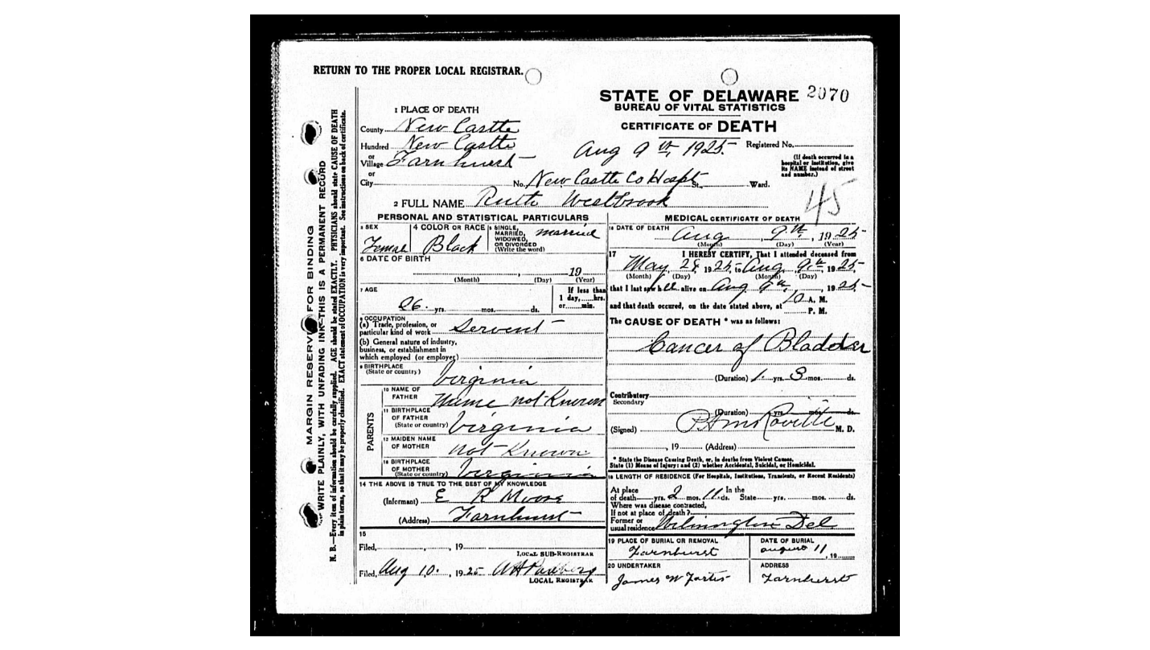

Evening Journal 1/29/1923
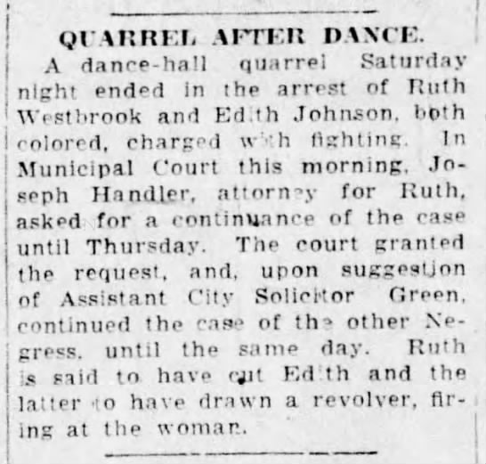

Evening Journal 3/14/1923
