Samuel Waters
Samuel Waters was an elderly African American man who spent the last eight years of his life living in the New Castle County Hospital (Almshouse), from the age of 72 until his death at age 80 from tuberculosis, on August 31, 1928. There is very little that can be said about him with certainty, as there were several individuals of this name (Waters is a common African American surname) and about this age who lived in New Castle County during the second half of the 19th century and early 20th century. Unfortunately, it isn’t possible to determine which of these gentlemen is the one buried in the NCCH Cemetery. Samuel Waters was buried under marker #2009.
We can rule out Samuel Wesley Waters, 1851-1910, who was the son of the Rev. Samuel Griffin Waters, a well-known and highly-respected minister of the Delaware African Methodist Episcopal (Colored) Church. Samuel G. Water, the elder, was married at different times to both Henrietta Fountain and Latitia (unknown maiden name) and had many children, including sons named Joseph and Samuel, and a daughter named Mary Latitia, who married Rev. William H. Coffey, a very influential church leader who worked in Pennsylvania, Rhode Island, and Connecticut.
One of the other individuals named Samuel Waters lived in Middletown, Delaware. In the 1900 census for Middletown, we find this Samuel Waters, born in April of 1850 in Maryland, living with his wife Mary, also 50, and their three daughters and two grandsons. This is probably the same couple who are mentioned in the Delaware land records [I admit I find great difficulty deciphering the handwritten land records for Delaware].
Another individual named Samuel Waters lived in Representative District 13 (south of Wilmington, running northeast to southwest). In the 1920 census we find this Samuel Waters, age 71, born about 1849 in Virginia, living with his wife George Anna, age 53, and their son Dennis, age 18. From various obituaries, it seems that Dennis had a brother named Jerome Waters and a sister named Linda White. It isn’t clear if Jerome and Linda were also the children of this Samuel and George Anna. Typically, there are no birth records to confirm the information.
Additionally, there was a man named Samuel Waters who lived in or near Wilmington who was written up in the newspapers on a number of occasions for minor infractions of the law.

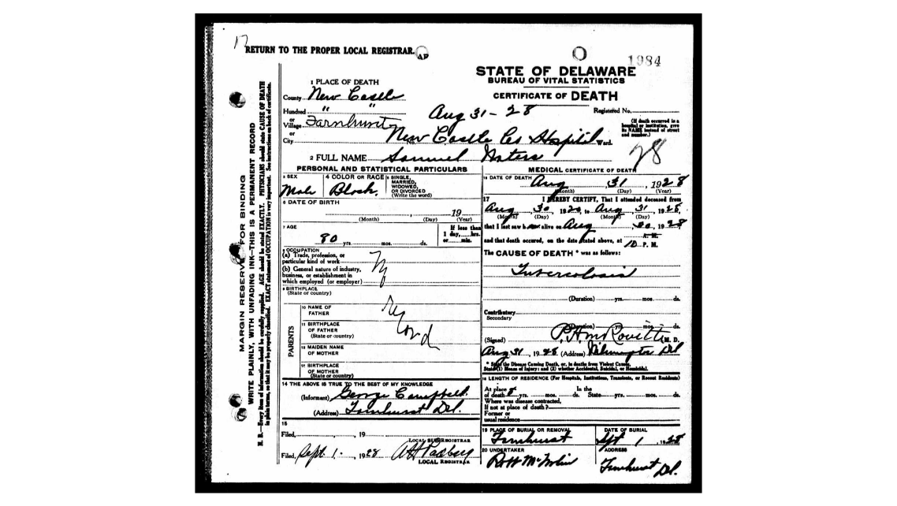

1900 census Middletown, DE

Name: | Samuel Waters
Age: | 50
Birth Date: | Apr 1850
Birthplace: | Maryland, USA
Home in 1900: | Middletown, New Castle, Delaware
House Number: | 1
Sheet Number: | 15
Number of Dwelling in Order of Visitation: | 335
Family Number: | 340
Race: | Black
Gender: | Male
Relation to Head of House: | Head
Marital Status: | Married
Spouse's Name: | Mary Waters
Marriage Year: | 1875
Years Married: | 25
Father's Birthplace: | Maryland, USA
Mother's Birthplace: | Maryland, USA
Can Read: | No
Can Write: | No
Can Speak English: | Yes
Neighbors: | View others on page
Household Members | Age | Relationship
Samuel Waters | 50 | Head
Mary Waters | 50 | Wife
Bessie Waters | 22 | Daughter
Hagar Waters | 20 | Daughter
Lester Waters | 17 | Daughter
Richard Waters | 2 | Grandson
William Waters | 2/12 | Grand Son (Grandson)

1920 census Rep. Dist. 13, DE

Name: | Samuel Waters
Age: | 71
Birth Year: | abt 1849
Birthplace: | Virginia
Home in 1920: | Representative District 13, New Castle, Delaware
Street: | Daletown
House Number: | X
Residence Date: | 1920
Race: | Black
Gender: | Male
Relation to Head of House: | Head
Marital Status: | Married
Spouse's Name: | George Anna Waters
Father's Birthplace: | Virginia
Mother's Birthplace: | Virginia
Able to Speak English: | Yes
Occupation: | Laborer
Employment Field: | Wage or Salary
Home Owned or Rented: | Owned
Home Free or Mortgaged: | Free
Able to Write: | No
Neighbors: | View others on page
Household Members | Age | Relationship
Samuel Waters | 71 | Head
George Anna Waters | 53 | Wife
Dennis Waters | 18 | Son

This Samuel Waters was born in Virginia, George Anna was born in Maryland, Dennis was born in Delaware. In 1920, he was a laborer. Dennis’ obituary says his mother’s name was Elizabeth, but that may have been a former with of this Samuel Waters.

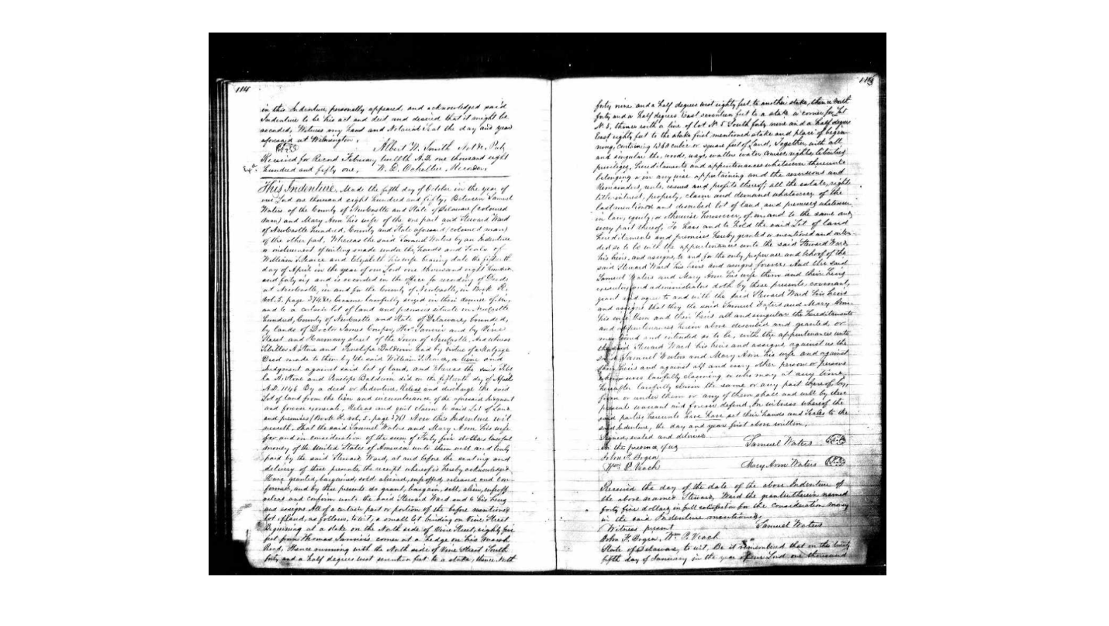
Delaware Gazette and State Journal 31 Mar 1892 DE Methodist Episcopal Conference (colored) at Salisbury, MD

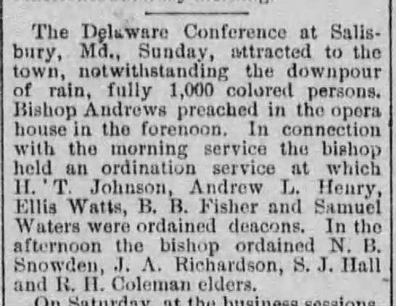

Morning News 10/20/1894

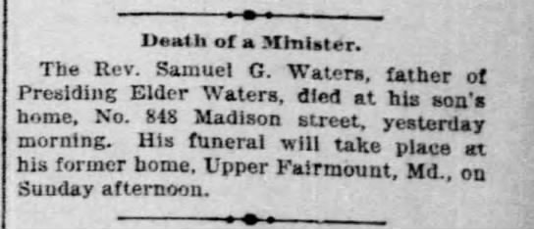

Evening Journal 10/20/1894

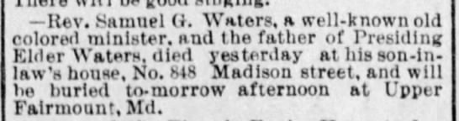

73 years of age when he died in 1894, at the home of his son Joseph.

News Journal 8/31/1901

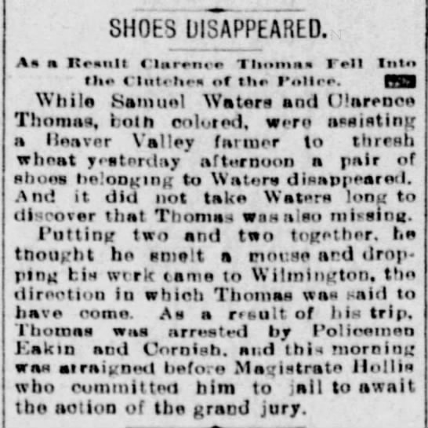
Morning News, 10/23/17
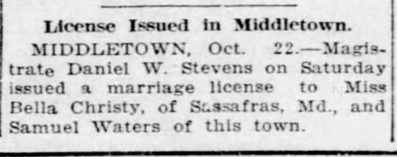
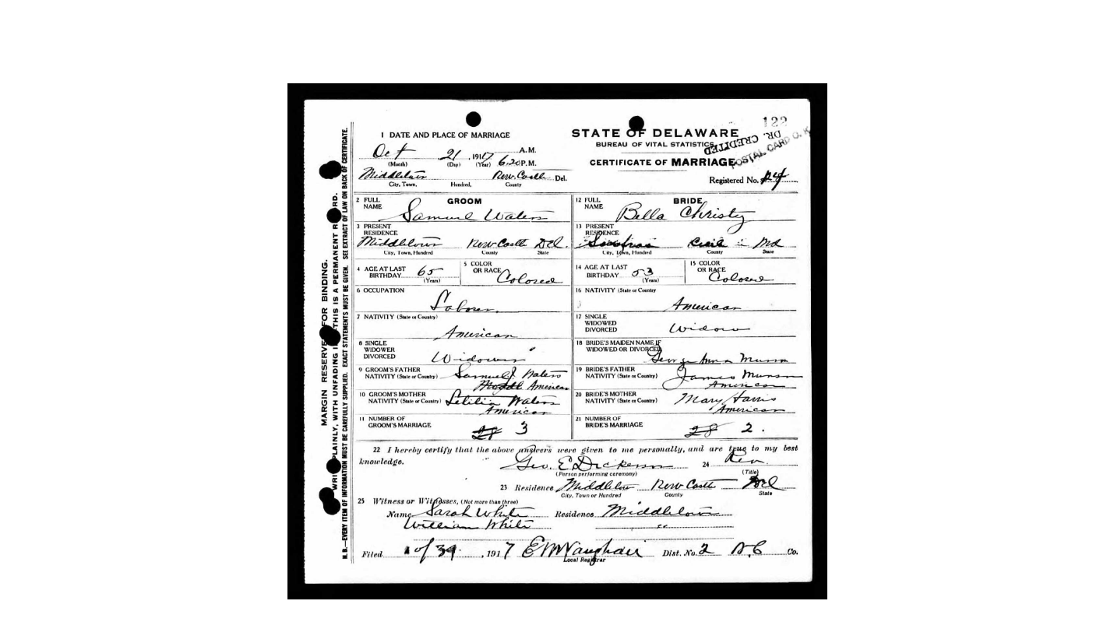

1930 census, Dennis Waters was 25, living in Middletown, supposedly married to Black J. Waters, working as a chauffeur for a private family, wife was 22, working as a cook for a private family. They’ve been married for 3 years.

Dennis Waters was born in October 1903 and died in October 1982, age 79.

4/24/23 News Journal Dennis Waters of Middletown gets a marriage license

Morning News 10/12/1982

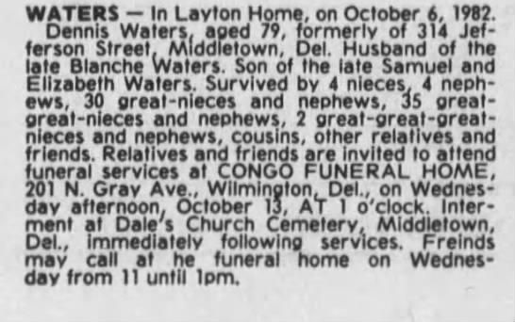

Morning News 4/1/1958 Dennis cut on face
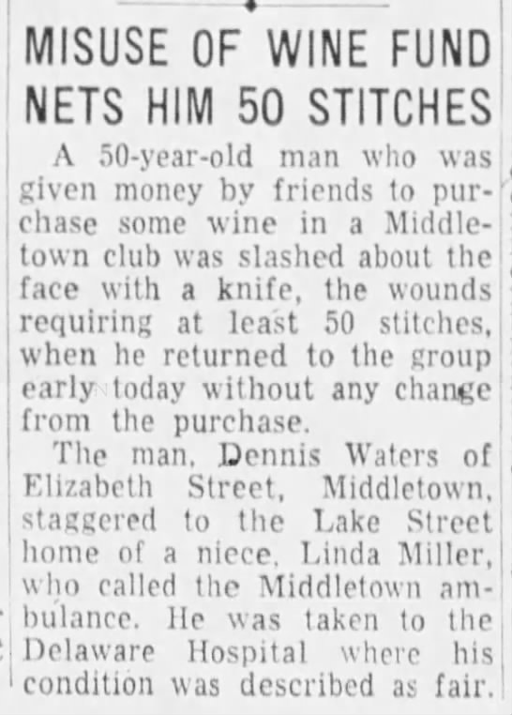

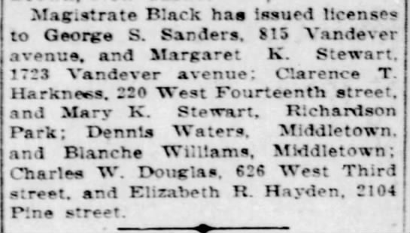

Jerome Waters, brother of Dennis Waters
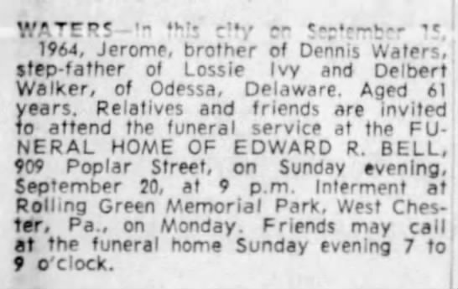

Sister of Jerome, Linda White of Delaware City 8/21/1956 Morning News
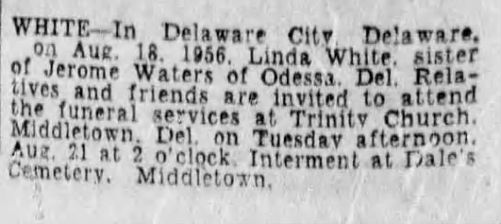

Morning News 7/6/1963 Wife of Jerome

Dale United Methodist Church Cemetery
https://www.findagrave.com/cemetery/2175047/dale-united-methodist-church-cemetery
