Sarah Elbert

Very little information could be found about Sarah Elbert, an African American woman who died on May 28, 1909 in bed at home at 813 French St. in Wilmington. Her cause of death is recorded as “syphilis and blood poisoning” – which were considered to be death from natural causes. Born in December of 1846 or 1848, Sarah was ~62 years old when she died. According to the few documents available, Sarah was originally from Maryland. Her middle name was Emily, and her maiden name was either Nichols or Diamond. She was married to Alexander Elbert, who predeceased her, dying sometime before 1896, when she is listed in a Wilmington City Directory as being the widow of Alexander.
Apparently there were two Alexander Elberts living in Delaware, as there is another man by that name who married a woman named Bessie Hunter in 1896, and died in 1913.
We know that Alexander and Sarah Elbert lost a daughter, Maggie, age 13, to consumption in 1889. Maggie was born in 1876 in Kent County.
A delayed birth certificate was filed by a woman named Mary Patton for her brother James Diamond Elbert, saying he was born on February 28, 1885, in Dover, Delaware, and was Alexander and Sarah Elbert’s 6th child.
In 1900, Sarah was living as a boarder at 103 Walnut St., and indicated that she had given birth to five children (not six) and all were still alive. She died in 1909 and was buried in the Potter’s Field at Farnhurst. There is no other information available about her, but we can trace her son James down through the years.
In 1896, James D. Elbert was a cook at Merritt House in Wilmington. In 1905, he is listed in the Philadelphia city directory as a waiter, living at 1336 Bainbridge. Sometime before 1909, he moved to Atlantic City, New Jersey, where he first worked variously as a musician and as a “track dresser,” laying and maintaining railroad track. In the 1910 census he was still single and living with another family as a boarder. By 1917, he is married to Margaret, and registered for the World War I military draft. At that time he was working as a musician at the Dunlop Hotel on the boardwalk in Atlantic City, New Jersey. He claimed to be supporting his wife and his grandmother.
By 1924, James is working as a policeman for the city of Atlantic City, a job he will have for the rest of his life. Apparently, he and Margaret had no children. During World War II, in 1942, he again registered for the military, listing Mae Calowell/Caldwell as his contact person. She lived in New York City, but I couldn’t find any information about her. His wife Margaret was still alive at the time.
James died in January of 1952, in Philadelphia, Pennsylvania. His death certificate informant was his wife Margaret. He died of an aortic aneurysm and his COD says he was buried in the Pleasantville Cemetery in Atlantic City, NJ.

Death certificate for Sarah’s daughter Maggie, age 13. 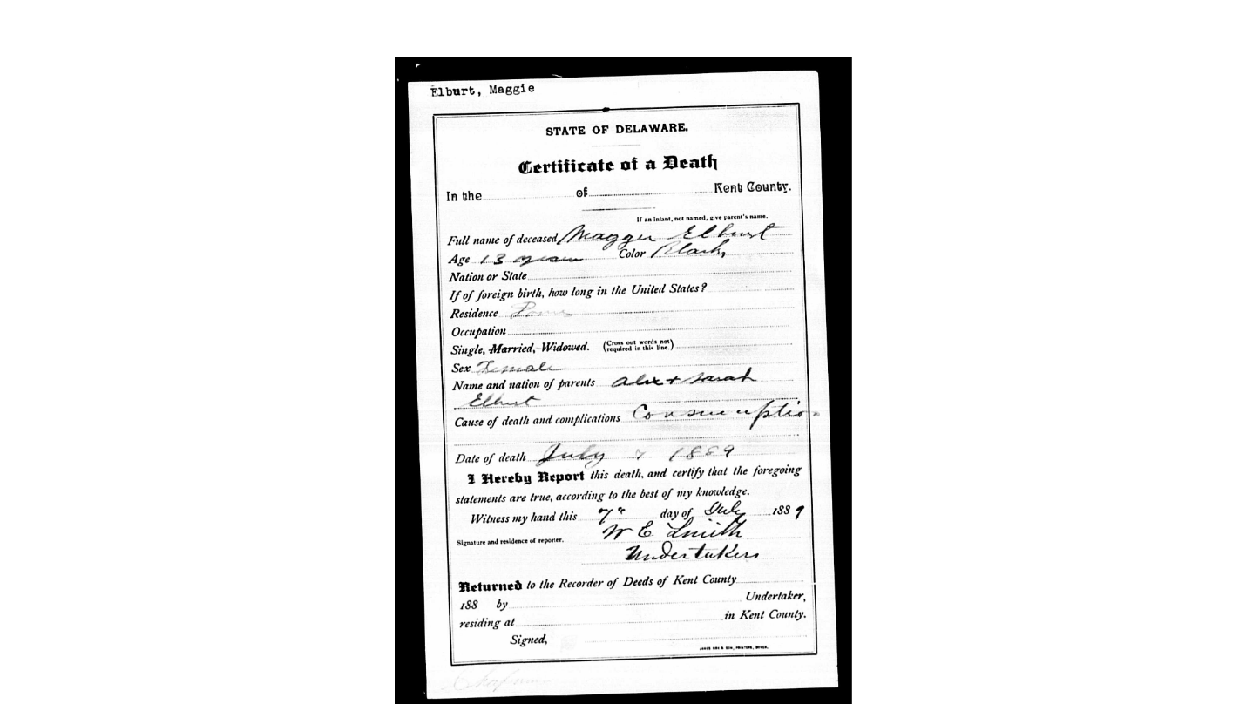

Birth certificate for James Diamond Elbert, 1885 or 1887
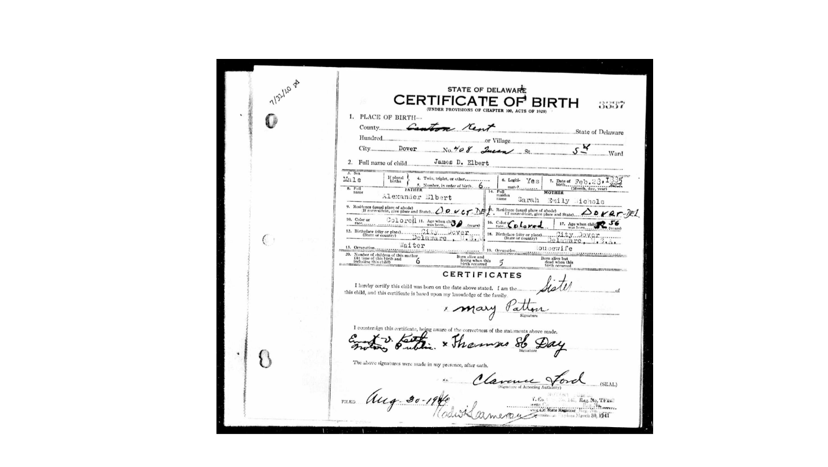
Photos of the Dunlop Hotel on the boardwalk in Atlantic City, where James D. Elbert worked as a musician

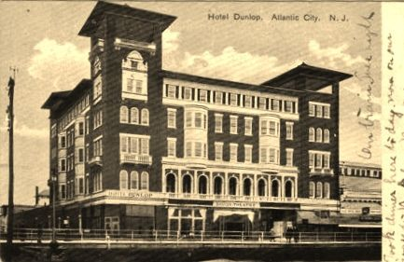

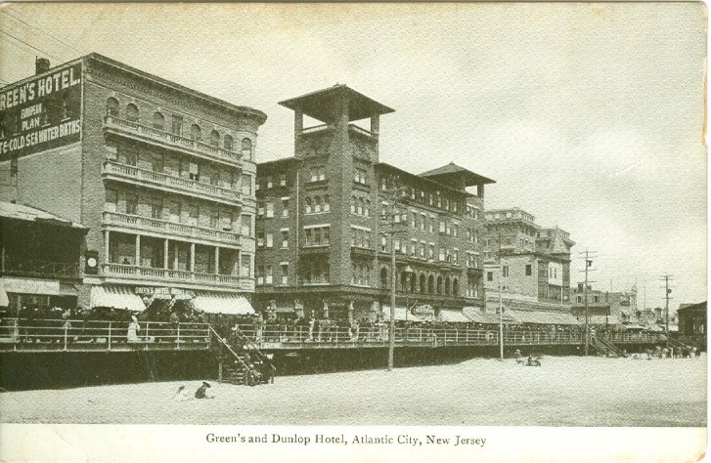

James Diamond Elbert’s World War I Registration card
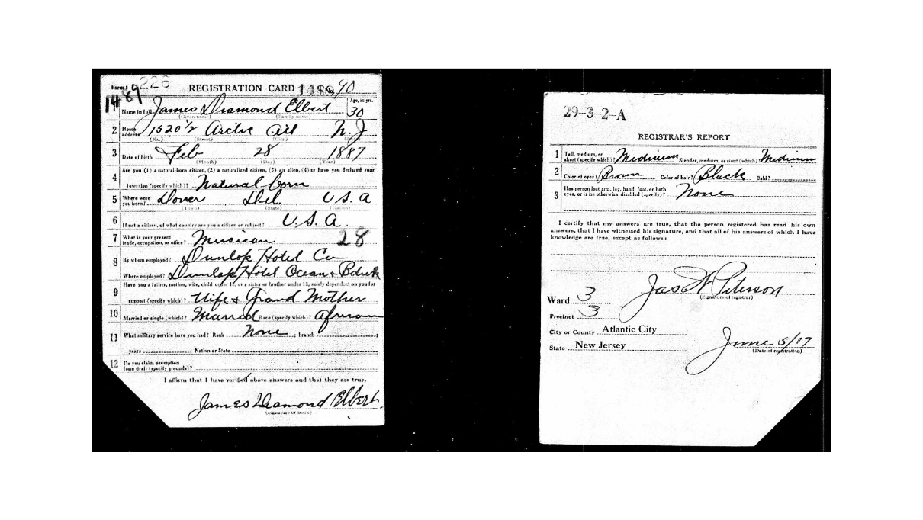
James Diamond Elbert’s World War II Registration card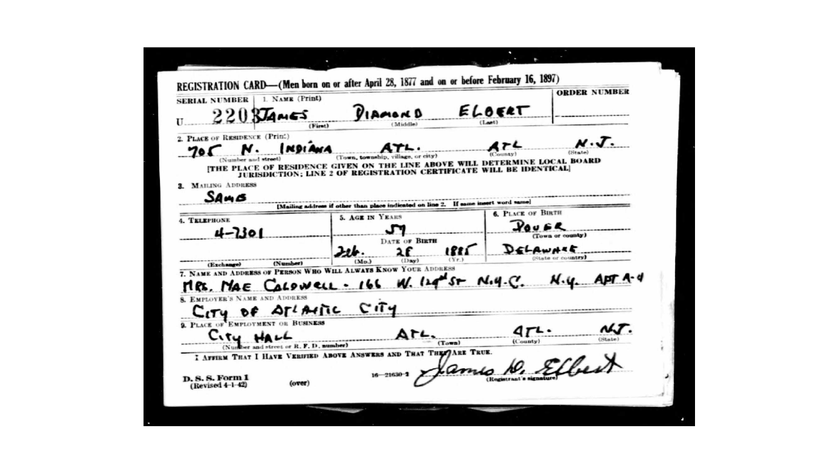 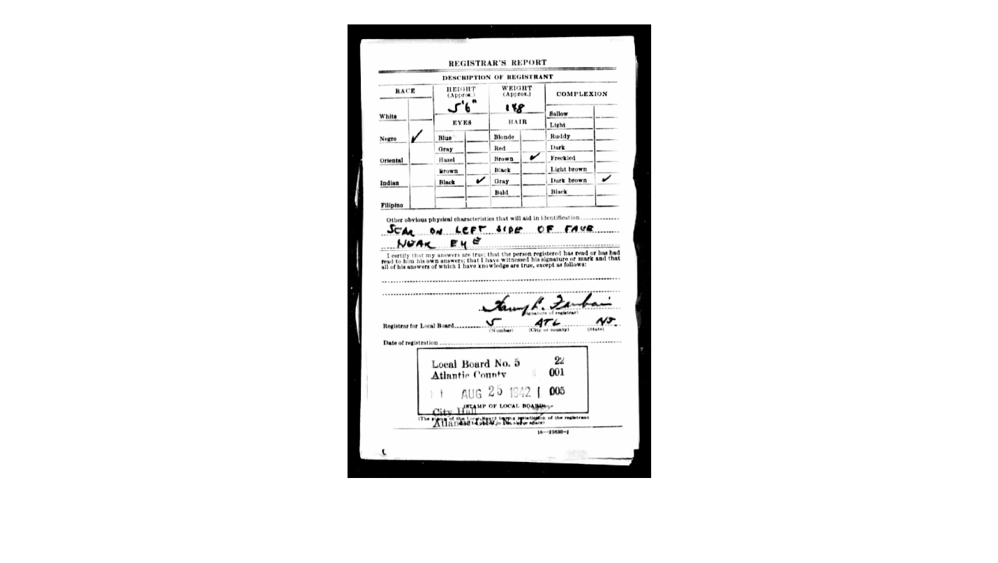

James’ Certificate of Death, 1952
