William Johnson
William Johnson was an African American man, single, aged about 40-45, who died from burns received when the “cabin” he was sleeping in caught on fire. It was suspected that he had been smoking in bed. Two other men also sleeping in the cabin managed to escape. The cabin was located at Poplar and D Streets. A Coroner’s jury ruled his death an accident. His Certificate of Death states that he was born in West Virginia and worked as a laborer. Alas, his name is too common for us to confirm any other information about him. His COD indicates that the cabin was located in “the dumps.” Currently, Poplar and D Streets in Wilmington do not intersect.
Certificate of Death
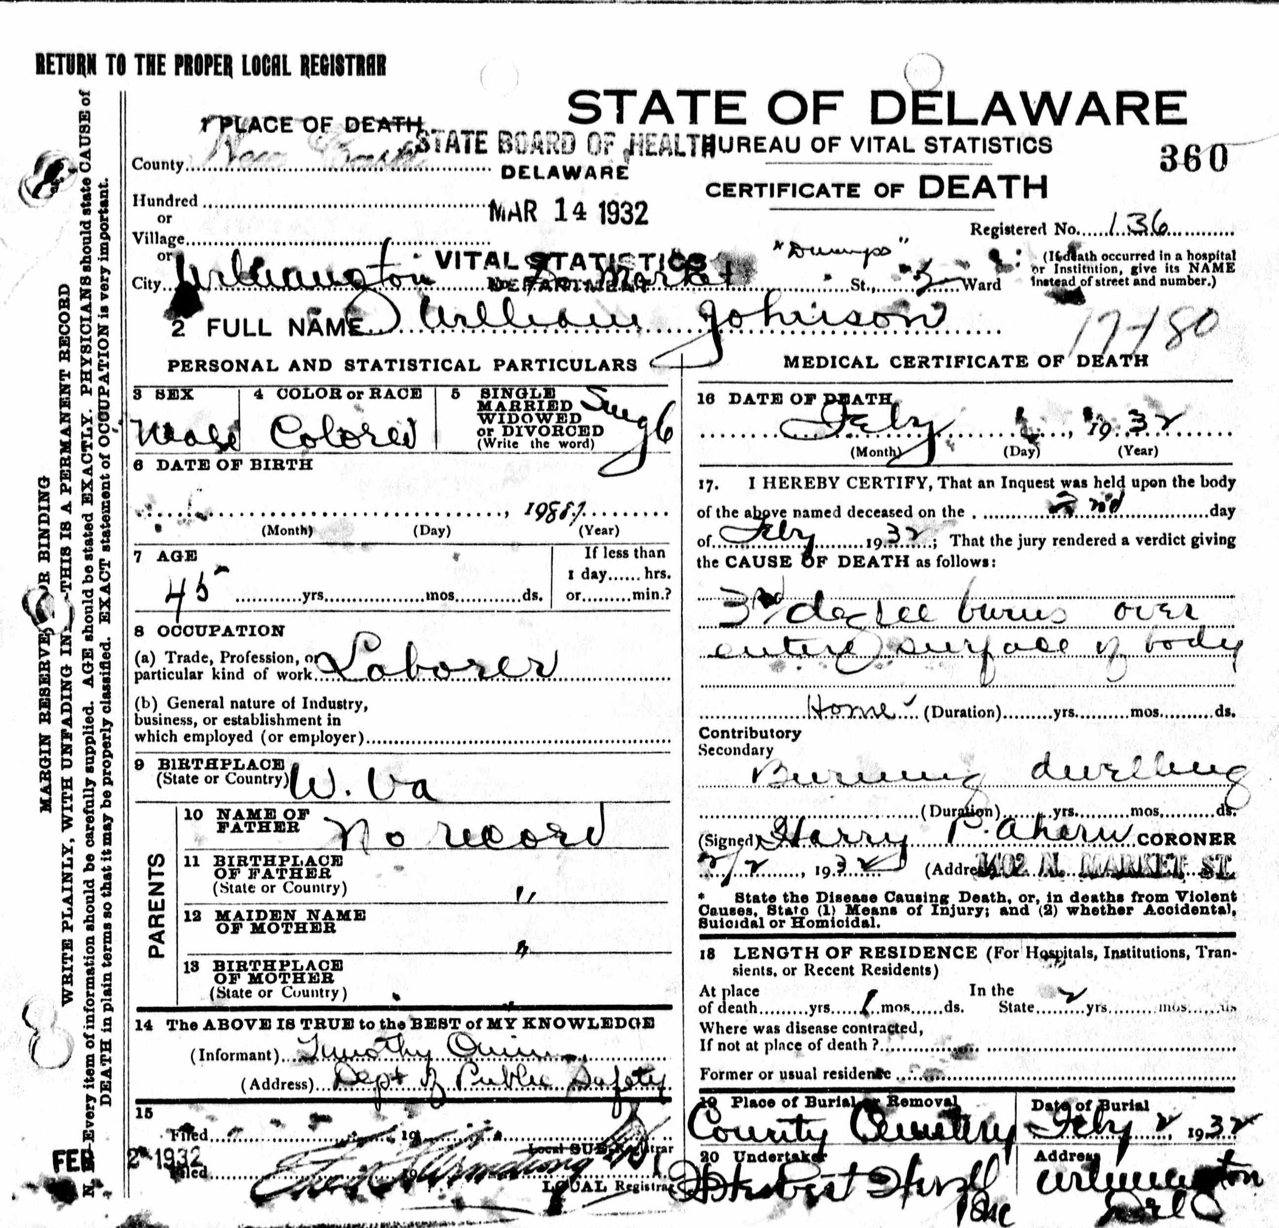
Morning News, February 2, 1932
