William Patterson and Joseph Jackson

We know almost nothing about these two young African American sailors except that they were wrestling each other, fell off the schooner “Mary Baxter” as it was passing by Wilmington, Delaware on its way to Philadelphia on October 22nd, 1892, and drowned. They disappeared together under the water, and their bodies were recovered several days later. According to the newspaper stories about the incident, both men were buried at the NCCH Cemetery, but only William Patterson’s name can be found in the records. Patterson’s COD says he was 30-35 years of age.
It isn’t clear where they were from, although one newspaper report says they were engaged in Philadelphia (to serve on the Mary Baxter) . It also isn’t clear why no one came to claim their bodies, or it may be that Joseph Jackson’s body was claimed and removed from the NCCH Cemetery.
Several of the newspaper stories from the incident are excerpted here:
- 1892, Oct 25, Morning News: “Chief of Police Francis yesterday received a telegram from Captain Henry Wagner of the schooner “Mary Baxter,” who is now in Philadelphia, stating that when his boat was passing this city on the Delaware River, about noon on Saturday, Joseph Jackson and William Patterson, colored, fell overboard and were drowned.” Another story from the same date reports that the men were “skylarking.” The boat was carrying sand. The term “skylarking” refers to horseplay, joking around, playing tricks or practical jokes.
- 1892, Nov 2, Morning News and News Journal: The two men’s bodies were found in the river near New Castle on November 1. Both were interred in the “almshouse burying grounds” by Undertaker Clewell. “Deputy Coroner Giles was here yesterday investigating the case and deemed an inquest unnecessary. Both Jackson and Patterson were powerful negroes and weighed at least 180 pounds each.”

The schooner “Mary Baxter” continued in service until April 24, 1901, when it was accidentally struck by the German tank steamship “Manhattan” in the channel off of Billingsport, New Jersey. The crew of the “Mary Baxter” were saved by the crew of the “Manhattan.” In 1901, the “Mary Baxter” was serving as a fishing schooner.

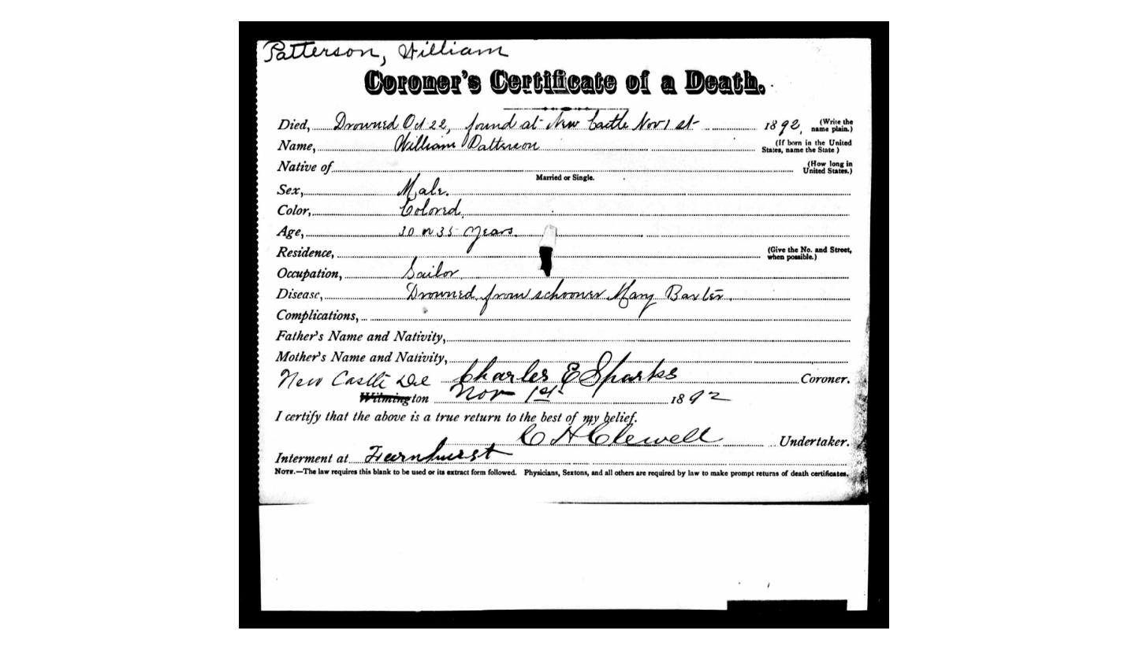

Evening Journal, 11/1/1892
